
Section: Introduction
Module : Workshop methodology


Preparing for this workshop
“These workshops are based on this approach: Do more, talk less”
Each module is intended to be a small, self contained set of exercises that give you familiarity with a specific concept.

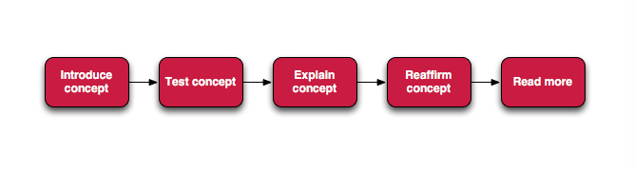
You try:
Goal: To familiarise yourself with the concept by self discovery
When you see these sections, you should use the table provided to complete a task. We do not provide step by step details, you need to figure it out.
Check your results:
This section will provide a way to validate whether you managed to complete the task successfully.

Name | Value
Line thickness | 1px
Outline style | Dashed black line
Fill colour | Green
Maximum scale | 1:50 000
Default | Save style as default

More about the training concept
In this section we will provide more in-depth details on the concept if needed. They will still be brief – your instructor will give more details if needed.

How you should approach the exercises
Here are some key things to consider when approaching these training materials :
- Use the latest 'LTR' version of QGIS.
- Try to solve the problem yourself first.
- If you get stuck ask your class mates for help – it's not called 'cheating' it is called 'networking'.
- If you managed to solve it, help your class mates who are stuck.
- If you can't get it to work with your class mate's help, Google it
- If you can't find it in Google, ask your trainer

The exercises are intended to get you started with a concept. We encourage you to do more than just what is in the exercise. Poke around, explore, break things, test the limits of QGIS and your own capabilities rather than staying inside the neat little box that the exercise provides.


Check your knowledge:
In this section we will give you a follow up task to 'cement' your knowledge.
- When you are stuck you should:
- ask your trainer first
- ask your fellow trainees first
- give up
- The data for this course is:
- A GIS raster dataset where each pixel represents the depth of a flood
- A GIS vector dataset where each polygon represents an area of high, medium or low flood depth
- A GIS vector dataset where each polygon represents a building with high, medium or low occupancy rate
- InaSAFE is a tool for creating hazard data:
- True
- False
Answers: 1c, 2b, 3f


Further reading:
You can read more about hazard data at http://foo.bar

