
Section: InaSAFE-Realtime
Module : Earthquake realtime


Downloading realtime earthquake products for offline use

“The Realtime Earthquake website publishes impact reports and shakemaps for download”
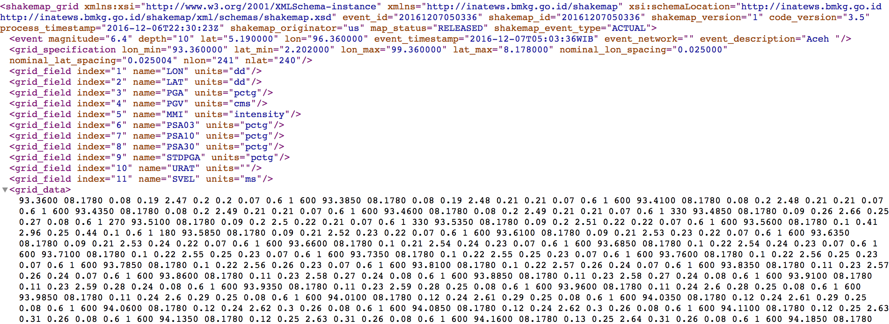
When a shakemap arrives in the realtime system, the system runs an InaSAFE ‘earthquake on population’ analysis and publishes the result to the realtime website as a downloadable pdf and the shakemap as a downloadable xml document. You can download the report or shakemap for any earthquake on the system by clicking on the download icon in map popups or the Action column.
You try:
Goal: To download realtime earthquake products for offline use
1. Find the Pidie earthquake
2. Download the Pidie earthquake report and open it in another app (not your browser)
3. Download the Pidie Grid XML
4. Open the Grid XML document in a browser or text editor. It should look like the graphic above. Can you figure out what the information means?
Check your results:
Swap your list with the person next to you and see if they had any different answers.
Question | Clue
1 | Pidie is in Aceh

More about the earthquake realtime products
Just to be sure you found the icons where you can download a report or Grid XML – they are the download icon in the Shake Event popup in the map and in the Action column in the Earthquakes table. If you hover over them you will see ‘Download’.
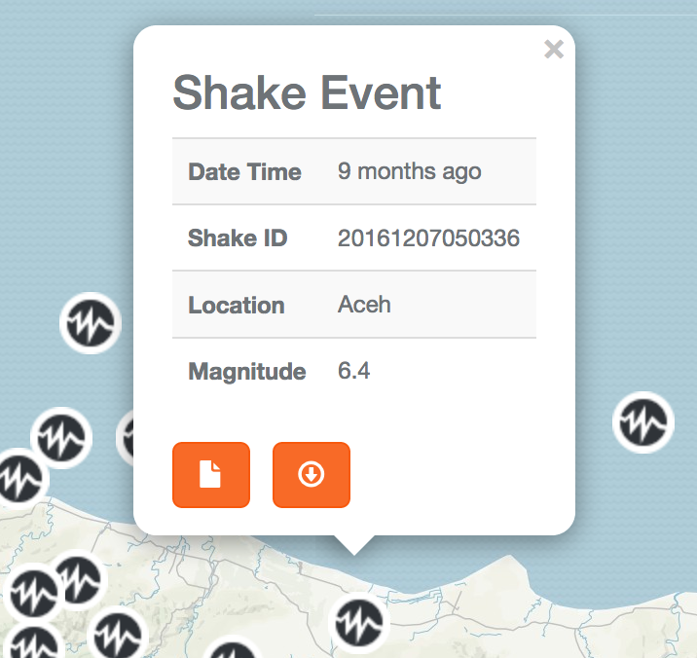

You looked at the report in the previous exercise. So more on the Grid XML (or shakemap) here. This file is generated by BMKG and is a standard way of representing the intensity and other attributes of an earthquake over a surface. InaSAFE Realtime used this to perform the impact function of ‘earthquake on population’ and then made it available ‘as is’ for you to download and use for your own analysis. You can use it in any software that can read a shakemap. In our case that would be InaSAFE desktop, which has a tool to convert shakemaps to GIS raster data sets.


Check your knowledge:
- After I download a shakemap (Grid XML) I can use it to map
- Intensity (MMI)
- Peak acceleration
- Peak velocity
- all of the above


Answers (to move to answer sheet)

Check your knowledge

1d

