
Section: Vector Analysis
Module : Intersection and Dissolve Basics


Geoprocessing operations basics in Context
“Geoprocessing are a group of tools that are geared up for doing analysis” When dealing with vector data the tools include buffer, clip and dissolve.
This module is very broad and we will look at some of the more common operations that are done using these tools.

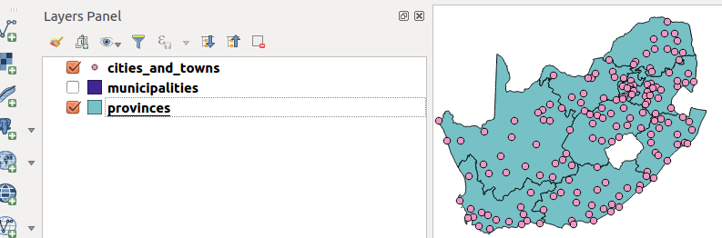
You try:
Goal: To learn how to use geoprocessing functions.
* Open the project geoprocessing from appendix3-local-data
* Create a filter on the Municipalities layer.
* Go to vector menu and choose research tools and choose select by location
* Choose the spatial predicates mentioned.
* Specify the Input layer as cities and additional layer as polygon boundary
* Create a new column called province in the cities layer.
* Use field calculator to update the selected records to match the province name in the municipalities layer.
* Repeat the above procedure for each of the nine provinces and remove the municipalities filter after the last province.
* Select all the municipalities that make up a province example WC and dissolve them to create a WC province layer. Do this for all provinces
* Union all the individual provinces layers generated above to create a single Province layer

Name | Value
Filter Example | "province" = 'WC'
Spatial Predicate | Intersects,within
Attribute: Province | Text, lenght 10
Filter Column | "province"

More about geoprocessing algorithm
Geoprocessing algorithms are the building blocks for most vector analysis. When doing spatial selection there is greater need to understand and differentiate concepts like within,intersect,disjoins etc. The most common geoprocessing algorithms available in QGIS are:
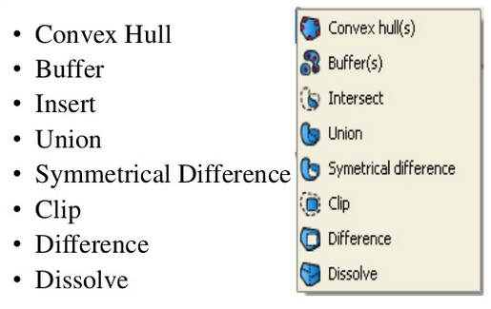


Check your knowledge:
- What is geoprocessing:
- It is a tool that is used to manipulate data.
- A collection of algorithm that do vector manipulation to produce new output.
- A type of GIS dataset that is available in QGIS.
- Which of the following statements is true:
- A filter is applied in situations when you want to view a subset of the records.
- Filtering is a non GIS concept.
- A filter applies when dealing with only a polygon layer.
- Is select by location an example of a spatial operation:
- True
- False
Answers: 1c, 2a, 3t


Further reading:
http://gisgeography.com/geoprocessing-tools/
http://nates-intro-to-qgis.readthedocs.io/en/latest/geoprocessing.html
https://www.slideshare.net/swethaashok28/geoprocessing-in-qgis

