
QGIS, InaSAFE and GeoSAFE
Tim Sutton (tim@kartoza.com)
21-24 November, 2017

Overview:
This course will cover how to effectively use QGIS, InaSAFE and GeoSAFE to analyse the potential impacts of natural disasters in Mozambique.

Presented by:
The course is funded by WorldBank/GFDRR and presented by Kartoza



About your presenter:

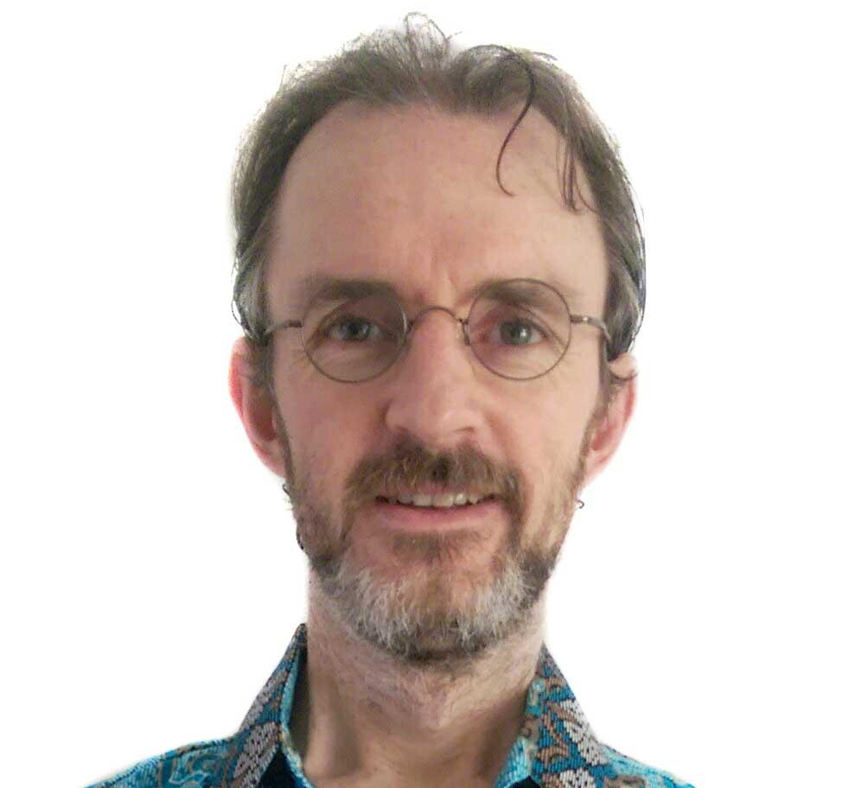 | Based in Swellendam, South Africa, Tim has nearly 20 years experience in the use of GIS. Originally trained as a Nature Conservationist, Tim became involved in GIS through his work at the provincial conservation agency in the Western Province of South Africa. Tim joined the QGIS project in December 2002 and has been actively involved in the project ever since. Tim currently serves as the QGIS project chairman.  Goal in life? Tim’s goal is is to put the tools for informed spatial decision making into the hands of everyone on earth.  @timlinux on Twitter

Requirements for the course:
- Your own laptop / computer running a recent version of your favourite operating system.
- QGIS 2.18 LTR installed on your laptop. You might struggle if you have an older version. We will provide installers at the workshop for Windows and MacOS, but it will be helpful if you can install the software beforehand.
- A working internet connection will be useful, though for most exercises is not required.
- Your concentration, and attention - we will cover a lot of material in a short space of time, so get a good night’s sleep and come ready to learn!
- We expect that you already understand basic concepts in QGIS such as adding layers, basic symbology, saving projects, etc. but will show these if needed.

Day 1 – Focus on QGIS
Orientation

- Meet and greet with the participants.
- I explain the approach that we will follow over the next two days (do more speak less)
QGIS
- General:
  - A short (20 minute) presentation describing the QGIS project
  - Quick tour of the QGIS User Interface
- Working with vector layers:
  - Adding layers efficiently in QGIS
  - Single symbol styling in QGIS
  - Class based styling in QGIS
  - Querying and filtering attribute tables
  - Adding and removing columns in attribute tables
  - Querying and filtering spatial data
  - Clipping and extracting vector data to create new datasets
  - Creating and digitising vector data
- Working with raster layers:
  - Pseudocolor styling rasters in QGIS
  - Querying and filtering raster data
  - Clipping and extracting raster data to create new datasets

Day 2 – Focus on InaSAFE:

Theory:

- What is InaSAFE?
- What is hazard data?
- What is exposure data?
- What is aggregation data?
- What are minimum needs?

Practical:

- Defining keywords with InaSAFE
- First analysis with InaSAFE
- Fetching data from OpenStreetmap for use in InaSAFE
- Group exercise – preparing and running an analysis in teams
- Preparing a minimum needs profile
- Running an analysis with your own data
- Reporting issues and getting help

Day 3 – Focus on GeoNode and GeoSAFE:
Theory:

- A tour of GeoNode with QGIS (and how it differs from GeoNode with GeoServer)
- A tour of GeoSAFE (and how it differs from InaSAFE desktop)

Practical:

- Preparing data for GeoNode with QGIS and InaSAFE
- Uploading a layer to GeoNode with QGIS Styling and Keywords
- Running an analysis with your own data
- Downloading and review of the analysis reports
- Downloading and review of the analysis result dataset in QGIS
- Reporting issues and getting help

Theory:

- Roadmap for GeoSAFE
- Roadmap for GeoNode with QGIS Server

Day 4 – Workshop (morning only):
Practical:

In this session we will review any difficulties, cover any questions raised during the course and have a mentored session when participants can try out the various tools we have demonstrated and get help as they need it.

