
Section: Vector Analysis
Module : Buffer Basics


Buffers in Context
“A buffer is an area around a particular map feature.” A buffer is mainly used in proximity analysis and can be combined with other vector processes in complex workflows to solve spatial problems
In this module, we will learn about the concept of creating a buffer and explore the different type of buffers that exist.
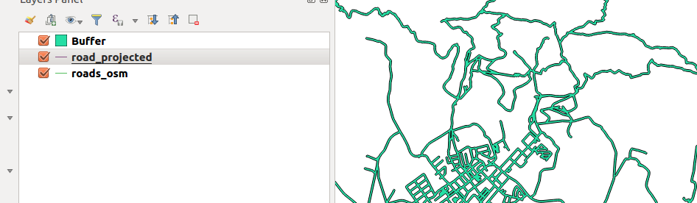
You try:
Goal: To learn how to generate buffers.
(1) Open a new project and load the vector
(2) Under vector menu choose geoprocessing and fixed distance buffer.
(3) Select the default and run the analysis.
NB: Why does your results look funny.
(4) Remove the buffer layer generated above.
(5) Save the layer roads_osm as a new layer and use the specified CRS.
(6) Using the new layer generated above, Create a buffer using ‘Fixed distance buffer’. Do not tick the ‘Dissolve buffer’ option
(7) Run the fixed distance buffer again with the projected layer and tick the ‘Dissolve buffer` option.
NB: Explain the difference in results between the two processes.
(8) Add a new column to the layer generated in step 5. Use the listed specifications for the column
(9) Use field calculator to update the new column and insert the expression to update it.
(10) Create a buffer using variable distance buffer algorithm.
NB: What can you inferr about the two algorithms. Fixed distance buffer and variable distance buffer



Name | Value
Layer | roads_osm
CRS | UTM 33S
Expression | Rand(10,80)
Dissolve Buffer | Yes
Distance | 20m
Column | Buffer_distance (integer)

More about
Buffers should be created with data that is projected. If the data is in (EPSG:4326) the results will not be true. The buffer distance indicates the actual distance in meters. A buffer can be created that each geographic entity will have its own distance specified or all features have the same distance. An example of applications that use buffers frequently is site suitability(Choosing the best site for an establishment), to establish a sphere of influence.


Check your knowledge:
- Which example best suit the need to use a buffer:
- Can be used anytime and anywhere. It does not have to be specific to a problem.
- When you want to style the layers differently.
- A communication company wanting to find out which areas do not have cellphone coverage.
- When you are given the buffer distance in kilometers how can you use them accurately in a GIS:
- Use them as they are
- Do a standard conversion between kilometers to metres and use the result
- Divide the kilometers by 1000 to get the exact distance.
- Can you create a buffer with data in decimal degrees:
- True
- False
Answers: 1c, 2b, 3f


Further reading:
https://docs.qgis.org/2.14/en/docs/gentle_gis_introduction/vector_spatial_analysis_buffers.html
https://wiki.osgeo.org/wiki/Buffer_with_QGIS

