
Section: InaSAFE Realtime
Module : Earthquake data preparation

How earthquake data are prepared for InaSAFE Realtime
“In this module we will explain how earthquake data are extracted from BMKG shakemap products and prepared for use in InaSAFE Realtime.”
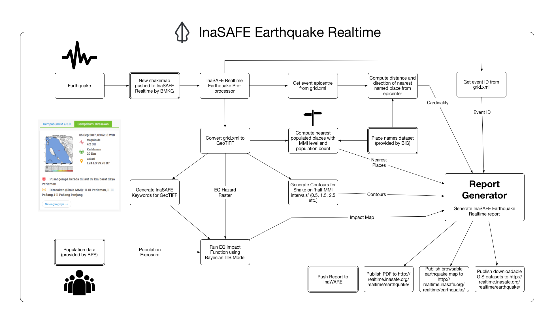
In earthquake realtime we run a file drop service that BMKG push shakemap products to soon after an earthquake event. Once a shakemap has been uploaded, a filesystem watcher will detect the presence of the new file and unpack the product and generate a number of products. This process is described in the diagram above. The various products are combined with standard exposure and contextual datasets to produce a report. The report is then published on the InaSAFE realtime web site and pushed to InaWARE. All the derived products use the same shake event ID in their names so that the products can easily be cross referenced back to the original shakemap product provided by BMKG.
You try:
Goal: To understand the various outputs created by Earthquake Realtime
Use the table on the right and the diagram above to list the various derivative products from the original shakemap.
Check your results:
Swap your list with a neighbouring group and see if they had the same results as you.

Products

More about the Earthquake Realtime data
Shakemap TIFF: The original shakemap provided by BMKG is a USGS format XML file and cannot be used directly in a GIS application. InaSAFE Realtime extracts the shake matrix to a comma delimited text file, then converts that file into a GeoTIFF by using GDAL’s gdal_grid command.
Contours: The contours generated are calculated on the ‘half MMI’ breaks so that the range from one contour to the next is e.g. 0.5 MMI to 1.5 MMI.
Epicenter: This is extracted as a point from the shake grid. The epicenter is used for describing the locality of the event.
Nearest affected places: This is a list of nearby settlements that is generated by InaSAFE Realtime and includes details of the population size, settlement name and MMI level the place was exposed to.
Impact map: This is the generated PDF report produced by InaSAFE Realtime. The report includes most of the above elements.

It is important to clarify that although the system is called ‘InaSAFE Realtime’, there is in fact a delay between the actual shake event and the generation of the report. This is a result of the processing overhead as the data moves through different organisations and servers and processing gets carried out. The report is typically available less than 20 minutes post event, but sometimes may take longer.

After the analysis has completed and the reports are generated, the report and data are made available on the realtime platform. The report is also published on InaWARE where it can be viewed by operations staff after the shake event.

Check your knowledge:
- InaSAFE Realtime produces instantaneous reports following a shake event.
- true
- false
- Mark all the correct statements:
- Nearest affected places are provided as part of the standard shake dataset from BMKG
- InaSAFE realtime products use the same event ID as the original shakemap
- When a shake event happens, there is a waiting period before the InaSAFE realtime report becomes available.

Further reading:
http://realtime.inasafe.org/realtime/earthquake – the InaSAFE Flood Realtime Web Site
https://github.com/inasafe/inasafe-django – main repository for InaSAFE Realtime Source Code
http://www.gdal.org/gdal_grid.html – The tool used to generate a GeoTIFF from the shake data

