Section: Data Providers in QGIS
Module : Adding and removing columns

Adding and removing columns in attribute tables
“Underlying each vector layer in QGIS is a flat table – the columns of which can be removed or added.”
Behind every vector layer in QGIS you will find a data table (attribute table). The data in this table describe the attributes of each feature. Depending on the origin of this data, the table can be a relational database table or view, a file based table (e.g. .dbf or .csv) or remote data (e.g. a WFS layer). When QGIS has the needed permissions to edit the actual structure of that table, you can use it’s field management functions to do so. In this exercise we will take a look how.
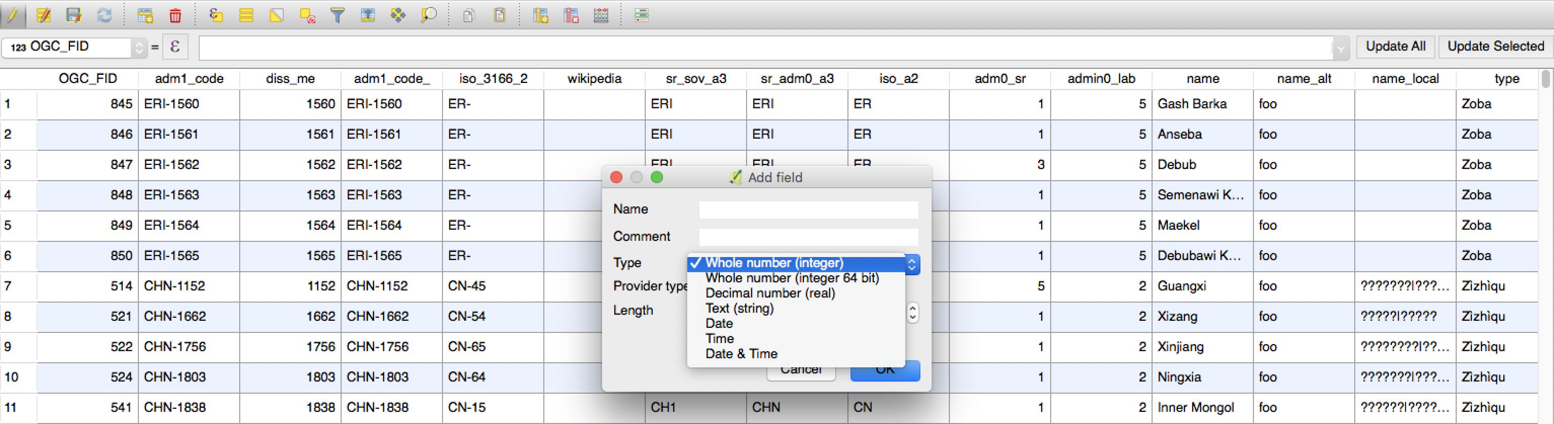
You try
Goal: To add and remove columns from a layer’s data table

- Load the Countries layer from Natural Earth
- Open the attribute table for the layer

- Enable the editing mode
- Use the delete fields function to remove the columns listed in the specification table below
- Use the new field column to add a new column called ‘visited’ giving it the options listed in the specification table below
- Save your table edits

Name | Value
Countries layer | ne_10m_admin_0_countries in the ne.sqlite database in appendix1-naturalearth-data
Fields to delete | name_alt, name_local
Field to add
- name | visited
- comment | Have I visited this country
- type | text
- length | 3

Check your results
Scroll across to the right of the table – do you see your newly added column?

More about column management
- You can also manage the columns for the data table in the layer properties dialog.
- Some formats (e.g. shapefile) place limits on the number of columns you can have and on the length of the field names you can use – in particular shapefiles limit you to 10 characters
- You need to ensure you have the needed permissions to add and remove columns – especially if the data source is a relational database.
- Think carefully before you delete a column – once the data is gone there is no ‘undo’ option to get it back!
- You should choose an appropriate type for new columns when you add them – the following are supported:

Type | Notes
Whole number (integer and 64 bit integer) | Use 64 bit when you need to store large whole numbers
Decimal | Use when storing floating point numbers
Text | Use for free-form text – be sure to choose an appropriate length
Date | Use for storing dates (without time)
Time | Use for storing times (without dates)
Date & time | Use when you need to store both date and time


Check your knowledge
- True or false: After removing a column, you can press undo to get it back again?
  - true
  - false
- Indicate which statements are correct:
  - there is no limit to the number of columns you can have
  - when creating a column some column types require that you set the field length
  - the only place to manage fields / columns is the table view


Further reading:
https://docs.qgis.org/2.18/en/docs/user_manual/working_with_vector/attribute_table.html

