
Section: InaSAFE Realtime
Module : Earthquake Reports


Understanding reports generated by Earthquake Realtime
“In this module we will explore the reports produced by earthquake realtime.”
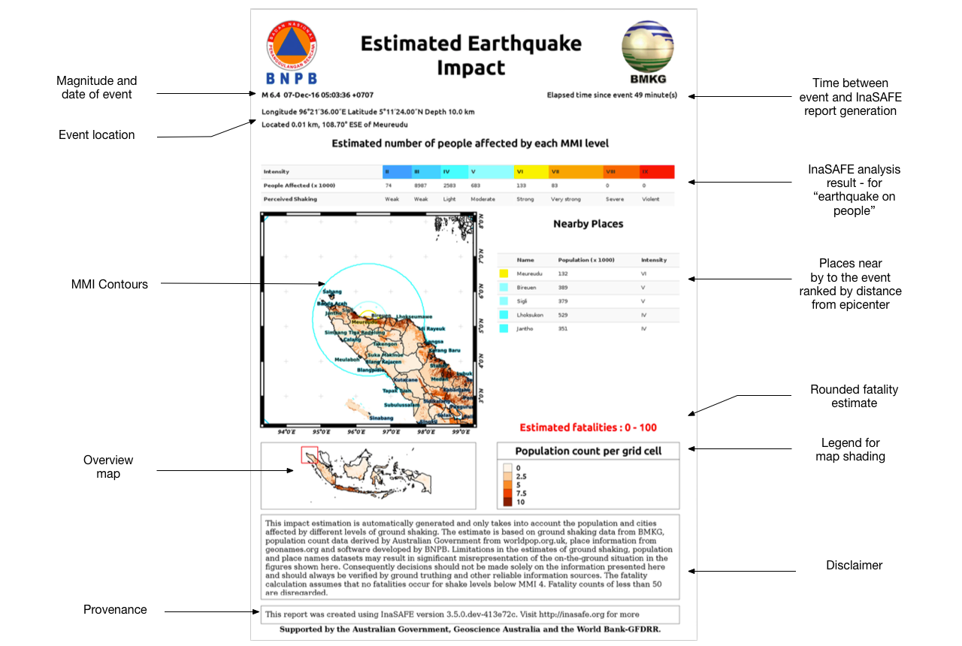
InaSAFE Earthquake Realtime will generate a report for each event. The report is a PDF file that can be downloaded and printed / shared easily. The elements included on the report are standardised. The map will be centered on the event epicenter and you can see where in Indonesia the event took place in the overview map.
You try:
Goal: To review an earthquake event report.
Look at the provided report
“8-earthquake-example-report” and answer the questions in the table, right.
Check your results:
Swap your list with a neighbouring group and see if they had the same results as you.

Name | Answer
What is the closest settlement to the epicenter?
How many people were subjected to level 6 or greater shaking?
Is the information in the report 100% accurate?
What date did the event occur on?

More about the Earthquake Realtime Reports
The reports used in Earthquake Realtime were designed in collaboration with BMKG and BNPB and are designed to show key information that will be useful during post disaster response activities. The various datasources used in the earthquake analysis are described in the separate module on earthquake data preparation. The system is designed so that the contextual data (population, named places etc.) can be updated easily.

InaSAFE Realtime collates the various pieces of information using special InaSAFE Realtime code for earthquake datasets, but it also uses a standard Impact Function from InaSAFE Desktop to compute the actual fatality and affected counts

The report itself is essentially an InaSAFE ‘earthquake on population’ analysis, based on version 3.5 of InaSAFE. In this case only tabular results are shown from the impact function analysis, the map displays only hazard and exposure data. The impact function used in the analysis is the ‘ITB Bayesian Earthquake Impact Function’. This impact function uses past Indonesian earthquake events to model what the fatality rates at different MMI levels will be.

It should be emphasised that the report is a set of estimates and there are many factors that can influence the accuracy of these estimates including things like: quality and accuracy of the input data used, quality of the data used to develop the fatality model, human behaviour patters, time of day and so on. As well as producing a PDF report, InaSAFE realtime also publishes the grid.xml and (for events after February 2017) other generated layers produced in the analysis as GIS datasets. In our next training session, we will explore these data in more detail – and look at how you can produce your own reports using these data.

Because there is a standardised identifier for earthquake events, these reports can be cross referenced (based on the event ID) from other platforms. We make use of this capability to push the PDF report to InaWARE.


Check your knowledge:.
- Why would time of day of an event potentially influence the accuracy of results?
- Models were developed based on a standard time of 12pm
- People may be out of buildings during the day (e.g. working) and present (e.g. sleeping) in buildings at night.
- Mark all the correct statements:
- A fatality estimate of 0 - 100 estimates up to 100 fatalities
- More than 100 fatalities could also occur with a fatality estimate of 0 - 100


Further reading:
An Empirical Fatality Model for Indonesia Based on a Bayesian Approach by W. Sengara, M. Suarjana, M.A. Yulman, H. Ghasemi, and H. Ryu submitted for Journal of the Geological Society

