
Section: Labelling
Module : Geometry functions

Geometry functions in Context
“The field calculator allows for manipulating fields and values. The geometry functions are a special type of functions which are used to manipulate the geometry of layers. The geometry functions can be used in multiple places like labelling and symbology ”
In this module we will look at how we can use the geometry functions in labelling features.
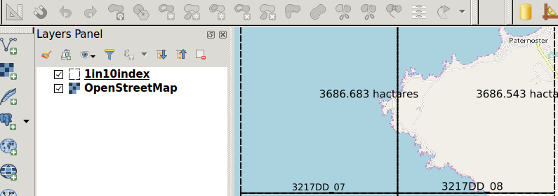
You try:
Goal: To learn how to use the geometry functions to label polygons
Data: 1in10index in appendix3-local-data
* Load the vector layer above.
* Symbolise the vector layer using the values defined in the table.
* Add a background layer from OSM.
* Go to label settings and choose rule based label
* Choose label with Expression and use the label_col.
NB: Change the label_col to show the area in hectares and replace metres with ‘ha’
What is the use of the labelling function above ?
* Click on the placement settings and choose data defined setting.
* Click on the X and choose edit from the drop down that appears.
* Insert the expression x_defined in the dialog.
* Repeat the previous step using Y and determine what function to use.
* Add another rule and label with the location_label. On the placement use ‘Permiter’. Click on the text and choose size. Use the size_exp in the expresion for size.

Name | Value
Vector stle | Fill type = transparent, outline style =dash line
label_col | round($area ) ,3 ) || ‘ metres’
x_defined | x( centroid( $geometry ) )
size_exp | rand(8,14)
location_label | substr( location,1,6 ) || ' ' || substr( location,8,8)

More about
Geometry functions are very useful as they allow on the fly computation of values. This reduces the need to have to create multiple layers or attributes to hold certain values. When using the geometry functions in labelling you have to take into consideration the number of features that are in the layer as this tends to make it slow.

Check your knowledge:
- What is a geometry function:
- A type of vector data.
- A type of symbology mechanism that can be used for rasters and vector layers.
- A type of function that allows new values to be computed based on existing geometry of the layer.
- When using the geometry functions to calculate area does the data need to be in a projected co ordinate reference system:
- Yes, you can only get accurate area interpretation when the data is projected.
- No, A GIS should be able to handle this.
- I do not know.
- Can you use geometry functions with raster layers:
- True
- False
Answers: 1c, 2b, 3t

Further reading:
http://docs.qgis.org/2.14/en/docs/user_manual/working_with_vector/expression.html#geometry-functions
https://docs.qgis.org/2.14/en/docs/user_manual/working_with_vector/field_calculator.html

