
Section: InaSAFE
Module : User Mailing list

Join the InaSAFE user mailing list
“Adding yourself to the user mailing list will provide a way to ask for help from experts and other users.”

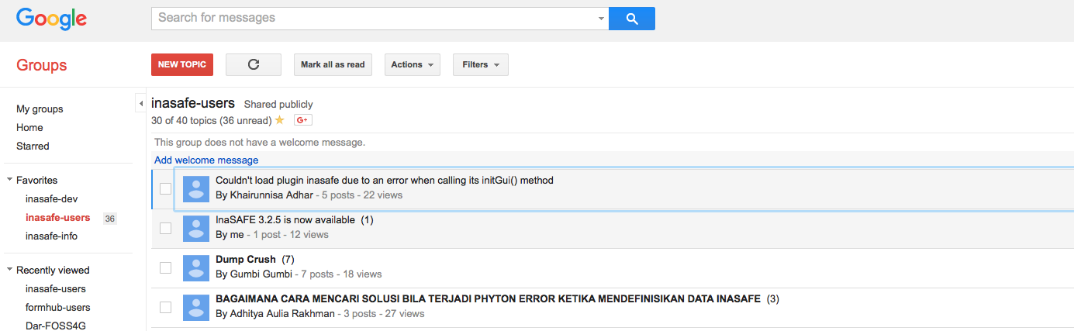

InaSAFE User’s Mailing list
Joining: If you experience problems using InaSAFE or QGIS, have suggestions on improving the software or simply would like to get in contact with other InaSAFE users, join our google group by sending an email to: inasafe-users+subscribe@googlegroups.com

Unsubscribing: You can unsubscribe from the list at any time by sending an email to:
inasafe-users+unsubscribe@googlegroups.com

Language: You are welcome to write your help requests in your own language – we will translate your message if needed or get a native speaker to reply to you if available.

Archives: You can view the message archive of this forum on the InaSAFE users group page at https://groups.google.com/forum/?fromgroups#!forum/inasafe-users

Note: You do not need a google account to use this forum/mailing list!

Facebook

Indonesian users can also get help in their own language via the Indonesian QGIS forum: https://www.facebook.com/groups/forumQGISindo/

