
Section: InaSAFE
Module : Hazards

Hazards in InaSAFE
“In the context of InaSAFE a hazard is any natural or human caused event or series of events that may negatively impact the population, infrastructure or resources in an area.”
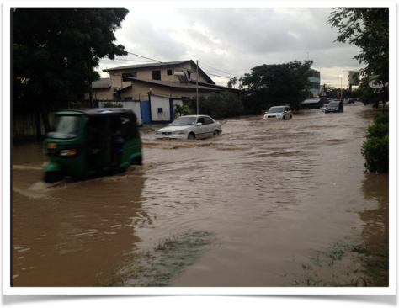
Flooding in Dar es Salaam - Image courtesy Paul D. Stephens
It is important to note that InaSAFE is not a hazard modelling tool. That means that you need to source your hazard data from elsewhere and bring it along ready to use in InaSAFE. Hazard datasets need to comply with these modes, categories and geometries:
Hazard Modes | Hazard Categories | Hazard Geometries
a) Continuous hazard data | c) Single event data | e) Vector polygons
b) Classified hazard data | d) Multi-event data | f) Single band rasters

You try:
Goal: To be able to identify suitable data for use in InaSAFE.
You are working in a disaster agency and receive a dataset. Evaluate the dataset in terms of its suitability for use in InaSAFE. Use the letter prefixes from the table above to indicate what the mode, category and geometry is for each dataset. Put a question mark if there is no match, and “yes” or “no” to indicate it the data is suitable. The first item is completed for you as an example.
Check your results:
Swap your list with the person next to you and see if they had any different ideas about which of these data sets are valid hazard data suitable to use in InaSAFE.
Dataset | OK?
A MODIS raster dataset with multiple bands showing flooded areas for a recent flood event. | AC? No
A shapefile containing flooded areas from a flood last month with a flood depth for each area.
A shapefile containing flood prone areas produced from combining the last 10 flood events.
A single band raster where each cell depicts a flood hazard category of high, medium or low.
A point vector layer showing places where volcano eruptions have taken place.

More about hazards
Here are some examples of natural hazards:
a flood (caused by overflowing rivers, storm surge etc, localised precipitation that cannot drain effectively, or by engineering failure such as a dam or levee breach) | an earthquake and the resulting ground shaking that is produced by it
a volcano and the resulting lava flow from a volcano | ash fall from a volcano
a tsunami | a drought

Some examples of non-natural hazards (note that we do not currently have hazard definitions for any non-natural hazards):
a chemical spill | a nuclear plant failure
an industrial fire / explosion

In cases where a hazard type is not defined, InaSAFE can still be used to estimate the impact of ‘Generic’ hazards. For hazards not defined in InaSAFE we need to know the hazard level such as ‘high’, ‘medium’, ‘low’. To use InaSAFE you will need to understand the basic concepts of a hazard so that you can correctly create metadata for each hazard type. InaSAFE relies on this metadata in order to determine what processing steps need to be carried out during the analysis.

Check your knowledge:
- Hazard data in InaSAFE can be any valid GIS dataset.
- true
- false
- Mark all the correct statements:
- InaSAFE will create sophisticated hazard models for you using state of the art hazard modelling algorithms
- Hazard data is easy to obtain from OpenStreetMap
- Hazard data does not need to be current – we can use old hazard data too.
Answers:

Further reading:
See the detailed overview of InaSAFE hazards in the tutorials folder.
See the hazards section in the InaSAFE technical documentation at: http://manual.inasafe.org or in the application help.

