

Section: Overview
Module : Community

Participating in the GeoSAFE Community
In this module we look at ways in which members can get help with GeoSAFE and how you can help grow GeoSAFE by reporting bugs, issues or feature requests and also fixing some of them.
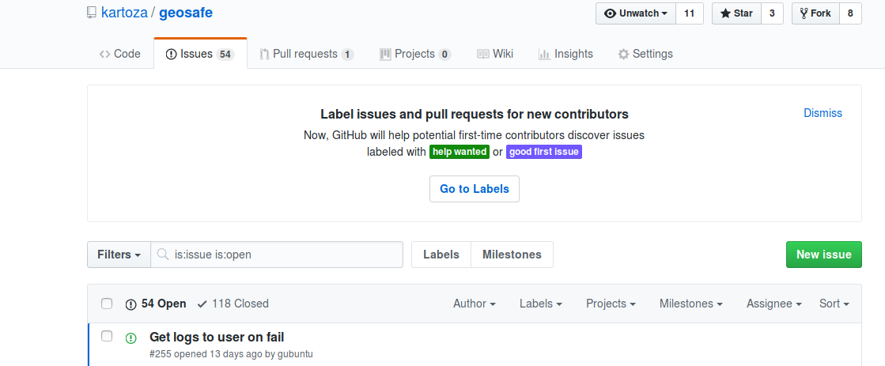
You try
Goal: To find out how to get help or report issues with GeoSAFE.

* Log into the GeoSAFE instance.
* Add data with metadata and then navigate to the analysis menu from GeoSAFE.
* Check if the layer does not appear in the layer list for Hazard/Exposure.
* If layer does not exist then reload the layer and check if the metadata has been uploaded with the layer or the contents of metadata if it has InaSAFE keywords 3.5
* After selecting the hazard / exposure combination and you notice the Run anlysis button is inactive. (Check from InaSAFE documentation about valid combination types)
* For other generic errors report then on the options specified below.

Name | Value
Github issues | https://github.com/kartoza/geosafe/issues
Gitter chat | kartoza/geonode
InaSAFE documentation | InaSAFE website
InaSAFE issues | Inasafe github repository
Check your results

The image below gives a graphic description of the permisable combination between the different layer types available for InaSAFE.
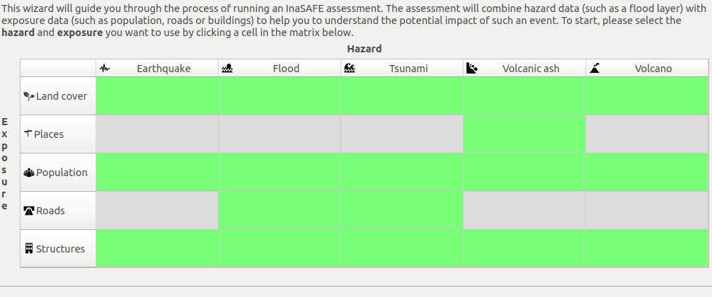
Layers loaded into GeoSAFE instance with proper keywords should be immediately visible in GeoSAFE analysis list page. Before running an analysis you should check to see if the hazard/exposure combination is permisable in InaSAFE.

More about GeoSAFE
GeoSAFE is an Open Source Project.
Advantages of having GeoSAFE as open source.
- Intergrated management
- Simple licence management
- Abuandant support
- Scaling and consolidation
- Abuandant support

With GeoSAFE users can use the software without paying for anaything and other software developers involved can get involved by making changes so that the software improves in efficiency.

Check your knowledge
- When you have errors associated with metadata what is the best procedure?
- Delete the layer and give up. Try a different layer.
- Regenerate keywords in InaSAFE and reupload the metadata.
- Edit the metadata in Geonode.
- I am a compentent developer which is the best way to colloborate?
- Send an email to the GeoSAFE team and give them advice on how to sort out some problems.
- It is not possible to contribute to the project
- Navigate to github and get the code that is used to run geonode and do modifications.
- Geosafe is a private project?
- Yes

Further reading:
https://github.com/kartoza/geosafe/
http://docs.inasafe.org/en/training/socialisation/inasafe_concepts.html

