
Section: Analysis
Module : Digitizing


Digitising in Context
“Data collection methods have become more sophisticated and readily available with gps and mobile phones. Digitizing exists as a method for converting historical data into digital formats and creating new data sets.”
In this module we will learn the basis of creating new datasets and extenting existing datasets using digitising. We will learn how to produce datasets that are topologically correct.

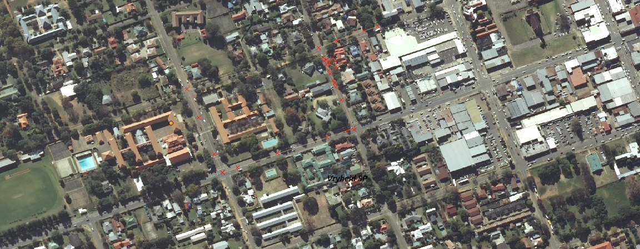
You try:
Problem:
You are a city official and need to undertake a study to find new roads,park and traffic lights in your town. Create a roads,traffic lights and parks asset register. Associate each traffic light with an image captured at that location. Show the image either in the attribute table or as an action.

Goal: To learn the basis of digitization for point,roads and polygons.
Data: Create a new vector layer (polygon,line) to digitize into.
* Load the administrative layer of your town and the raster layer for your town
* Zoom to a reasonable scale before starting digitizing
* Capture at least two roads intersections and two adjacents parks

Name | Value
Vector Layer | Multi line, Multi Polygon
Digitising | Advanced digitising toolbar
Topology | Snapping Options, Trace
Traffic lights Pictures | Actions

More about digitising
Digitizing can be on a new vector layer or an existing layer. When digitizing a layer snapping should be activated so that the new features created adhere to the topology rules. If a dataset is not topologically correct then spatial operations cannot be undertaken.

During ditising you can toggle advanced digitizing tool bar to leverage all the advanced functionality of digitizing. Some extra plugins are available with digitizing functionality.
The advanced digitizing toolbar enables functionality based on the type of layer. Layer can either be multiline,multipoint and multipolygon.


Check your knowledge:
- What is the main use of snapping when digitizing:
- To make roads layer look nice
- To ensure spatial relationship between datasets is maintained properly
- It is not necessary
- Which of the following can be a problem in manual digitizing :
- Hand eye cordination
- Availability of suitable hardware and software
- Boredom
- Can digitizing be used to create data from historical maps:
- True
- False
Answers: 1b, 2a, 3t


Further reading:
https://docs.qgis.org/2.14/en/docs/gentle_gis_introduction/topology.html
http://wiki.openstreetmap.org/wiki/Relation:multipolygon
http://wiki.openstreetmap.org/wiki/Relation:multilinestring

