
Section:Analysis
Module : Raster Analysis


Raster Analysis in Context
“ Raster analysis are operations performed to alter the cell values of the raw data. The output are a result of computations on a cell-by-cell basis. The value of the output for one cell is usually independent of the value or location of other input or output cells”
In this module we learn how to perform raster analysis and how raster and vector analysis can be combined to solve real world problems.

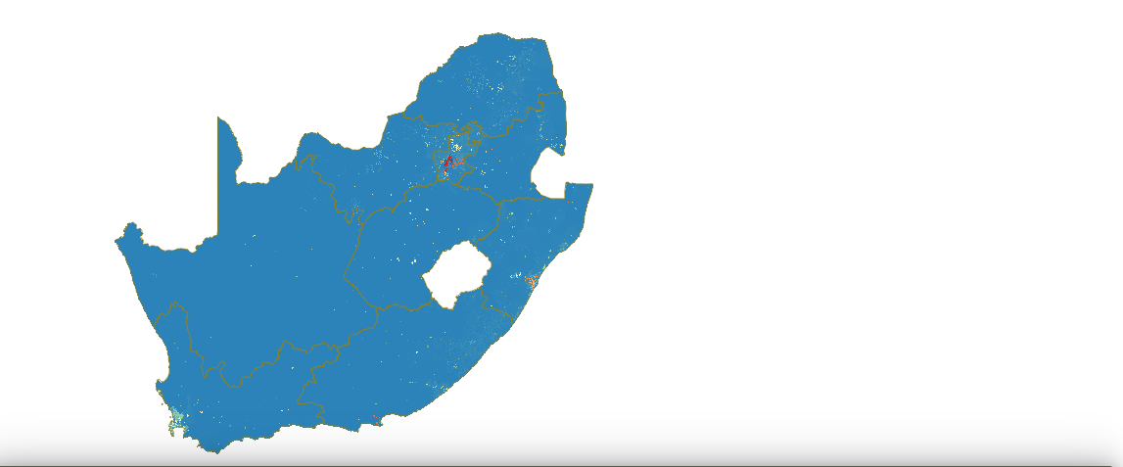
You try:
Problem:
You are a disaster manager in your region and you are required to produce a map which shows the population density of each main administrative regions of your country.
Data: administrative regions from openstreet and country population raster from worldpop . On your map label the administrative region using the population density and name of region.
Goal: To calculate the population density of each administrative area
Vectors:
* Load admin boundaries of your country
* Reproject vector layer to appropriate CRS
* Symbolize reprojected layer
* Calculate area of each region

Name | Value
CRS | UTM (ZONE),EPSG:3857
Spatial Operation | Zonal Statistics
Map composer | Map Elements
Expressions | $area

You try:
Rasters:
* Load the raster layer.
* Change rendering settings for rasters.
* Enable contrast enhancement to stretch to MinMax.
* Reproject Raster layer
* Symbolize the new raster layer.

Processing:
* Enable processing tool bar.
* Run Zonal statistics.
* Using the vector layer that has been reprojected calculate
the population density
* Label each administrative region with
it’s name and population density.
* Create a map using the new layers loaded

More about population density and producing maps
In order to undertake spatial analysis all layers need to be projected and be in the same CRS. Population density is the number of people per unit of area. To produce a nice map all map layers should show nice cartography. When creating a map in map composer it is imperative that a map shows all the fundamental elements of a map example scale bar.


Check your knowledge:
- What is population density and how is it calculated:
- Population Density is the number of organisms per unit volume
- Population Density = Number of People/Land Area
- Population density is a type of GIS operation available in QGIS
- What will happen if you run your analysis with data that is not projected:
- QGIS will give an error message
- QGIS will run the analysis and produce correct output
- QGIS will run but the results will not be correct
- QGIS can be used to understand population dynamics:
- True
- False
Answers: 1b, 2c, 3t


Further reading:
https://docs.qgis.org/2.14/en/docs/user_manual/plugins/plugins_zonal_statistics.html
https://docs.qgis.org/2.14/en/docs/training_manual/vector_analysis/reproject_transform.html

