
Section: Overview
Module : GeoNode with QGIS server


What is GeoNode?
GeoNode is a ‘geospatial content management system’. It is an out-of-the-box, fully featured ‘spatial data infrastructure’ (SDI).
It hosts documents and GIS layers as basic content types. Layers can be styled, viewed and downloaded. Layers can also be combined in a composite content type called a Map. Content can be shared or restricted based on users and groups and GeoNode has tools to share content via social networks. GeoNode provides OGC web service endpoints and is also an OGC CSW-compliant metadata clearinghouse.
GeoNode is an Open Source platform built with Open Source tools including Django, a Python-based web application framework, PostgreSQL+PostGIS spatial database and either Geoserver or QGIS map server backends and it can be modified and integrated with other software.

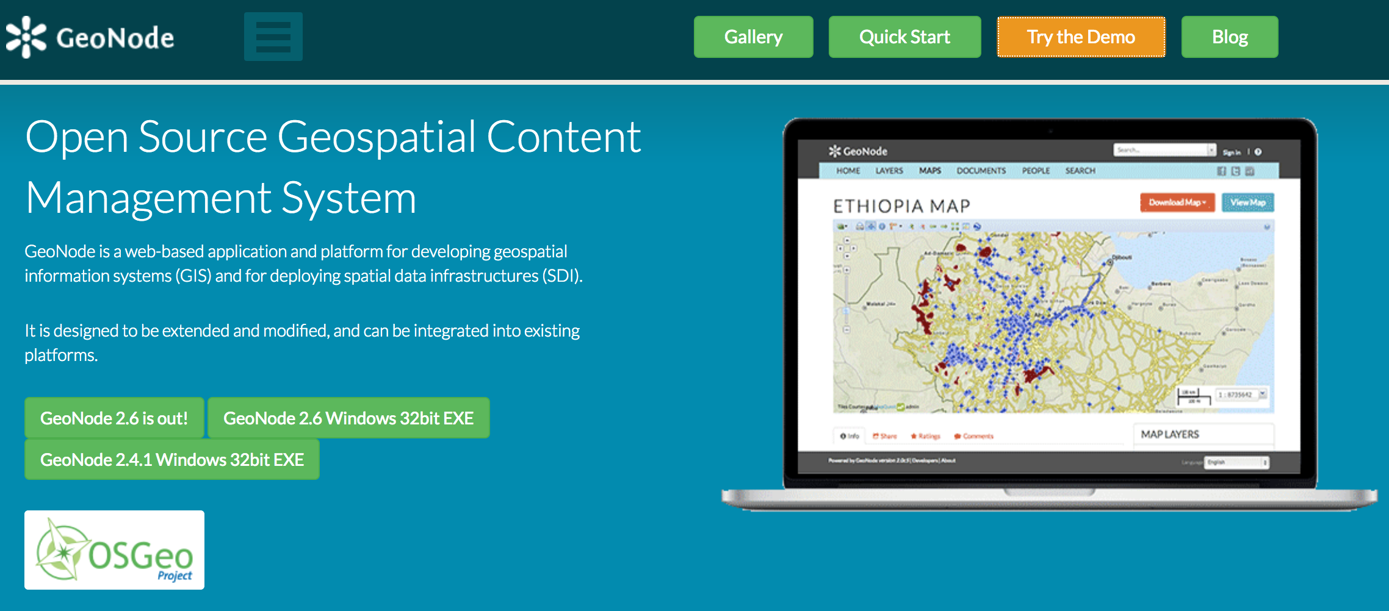


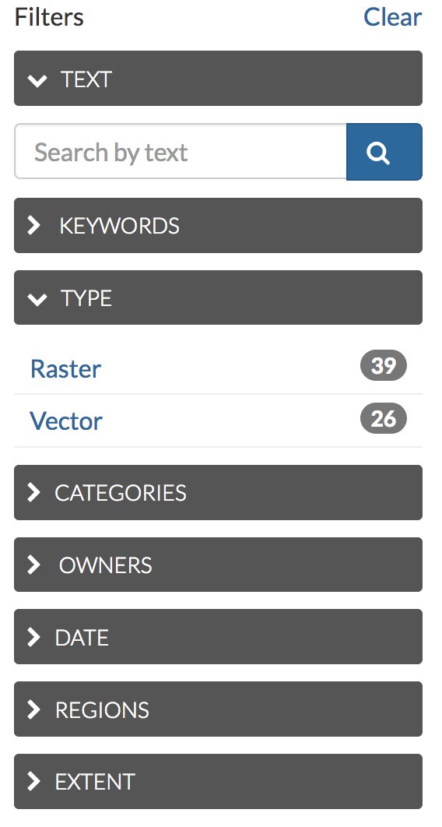
Spatial data discovery
- Powerful spatial search engine
- Federated OGC services
- Metadata catalogue

Import and Manage
- Publish raster, vector, and tabular data
- Manage metadata and associated documents
- Securely or publicly share data

Interactive Mapping
- Create multi-layer interactive maps
- Share and embed maps in web pages

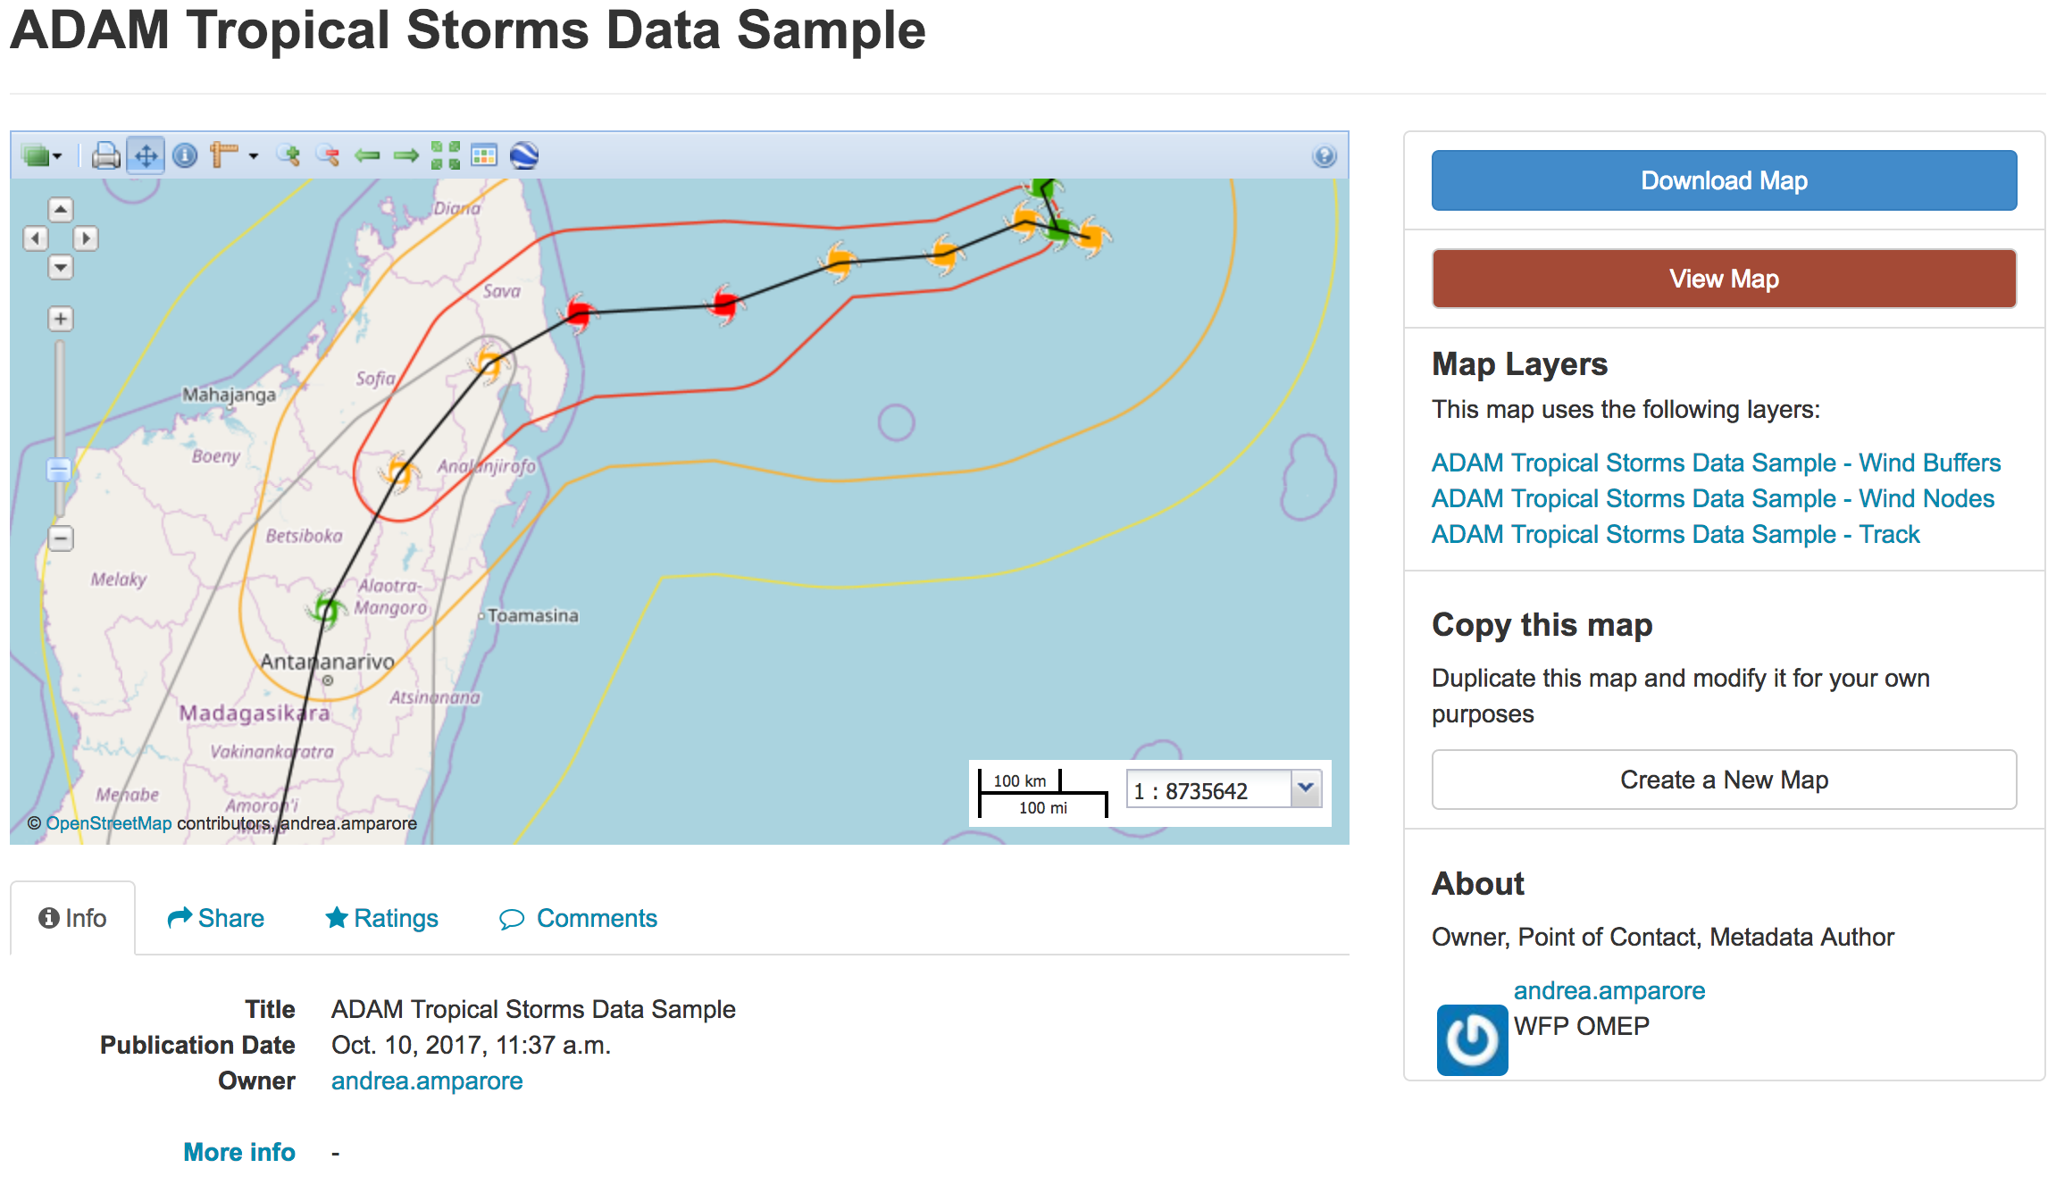
How GeoNode with Geoserver differs from GeoNode with QGIS server
- GeoExplorer GIS client
- Graphical style editor
- Versioned geospatial data editor


Further reading:
http://geonode.org

http://docs.geonode.org/en/master/tutorials/index.html

http://training.geonode.geo-solutions.it/

https://geonode.wfp.org/trainings/4/

GeoNode with QGIS server demo: http://geonode.kartoza.com

