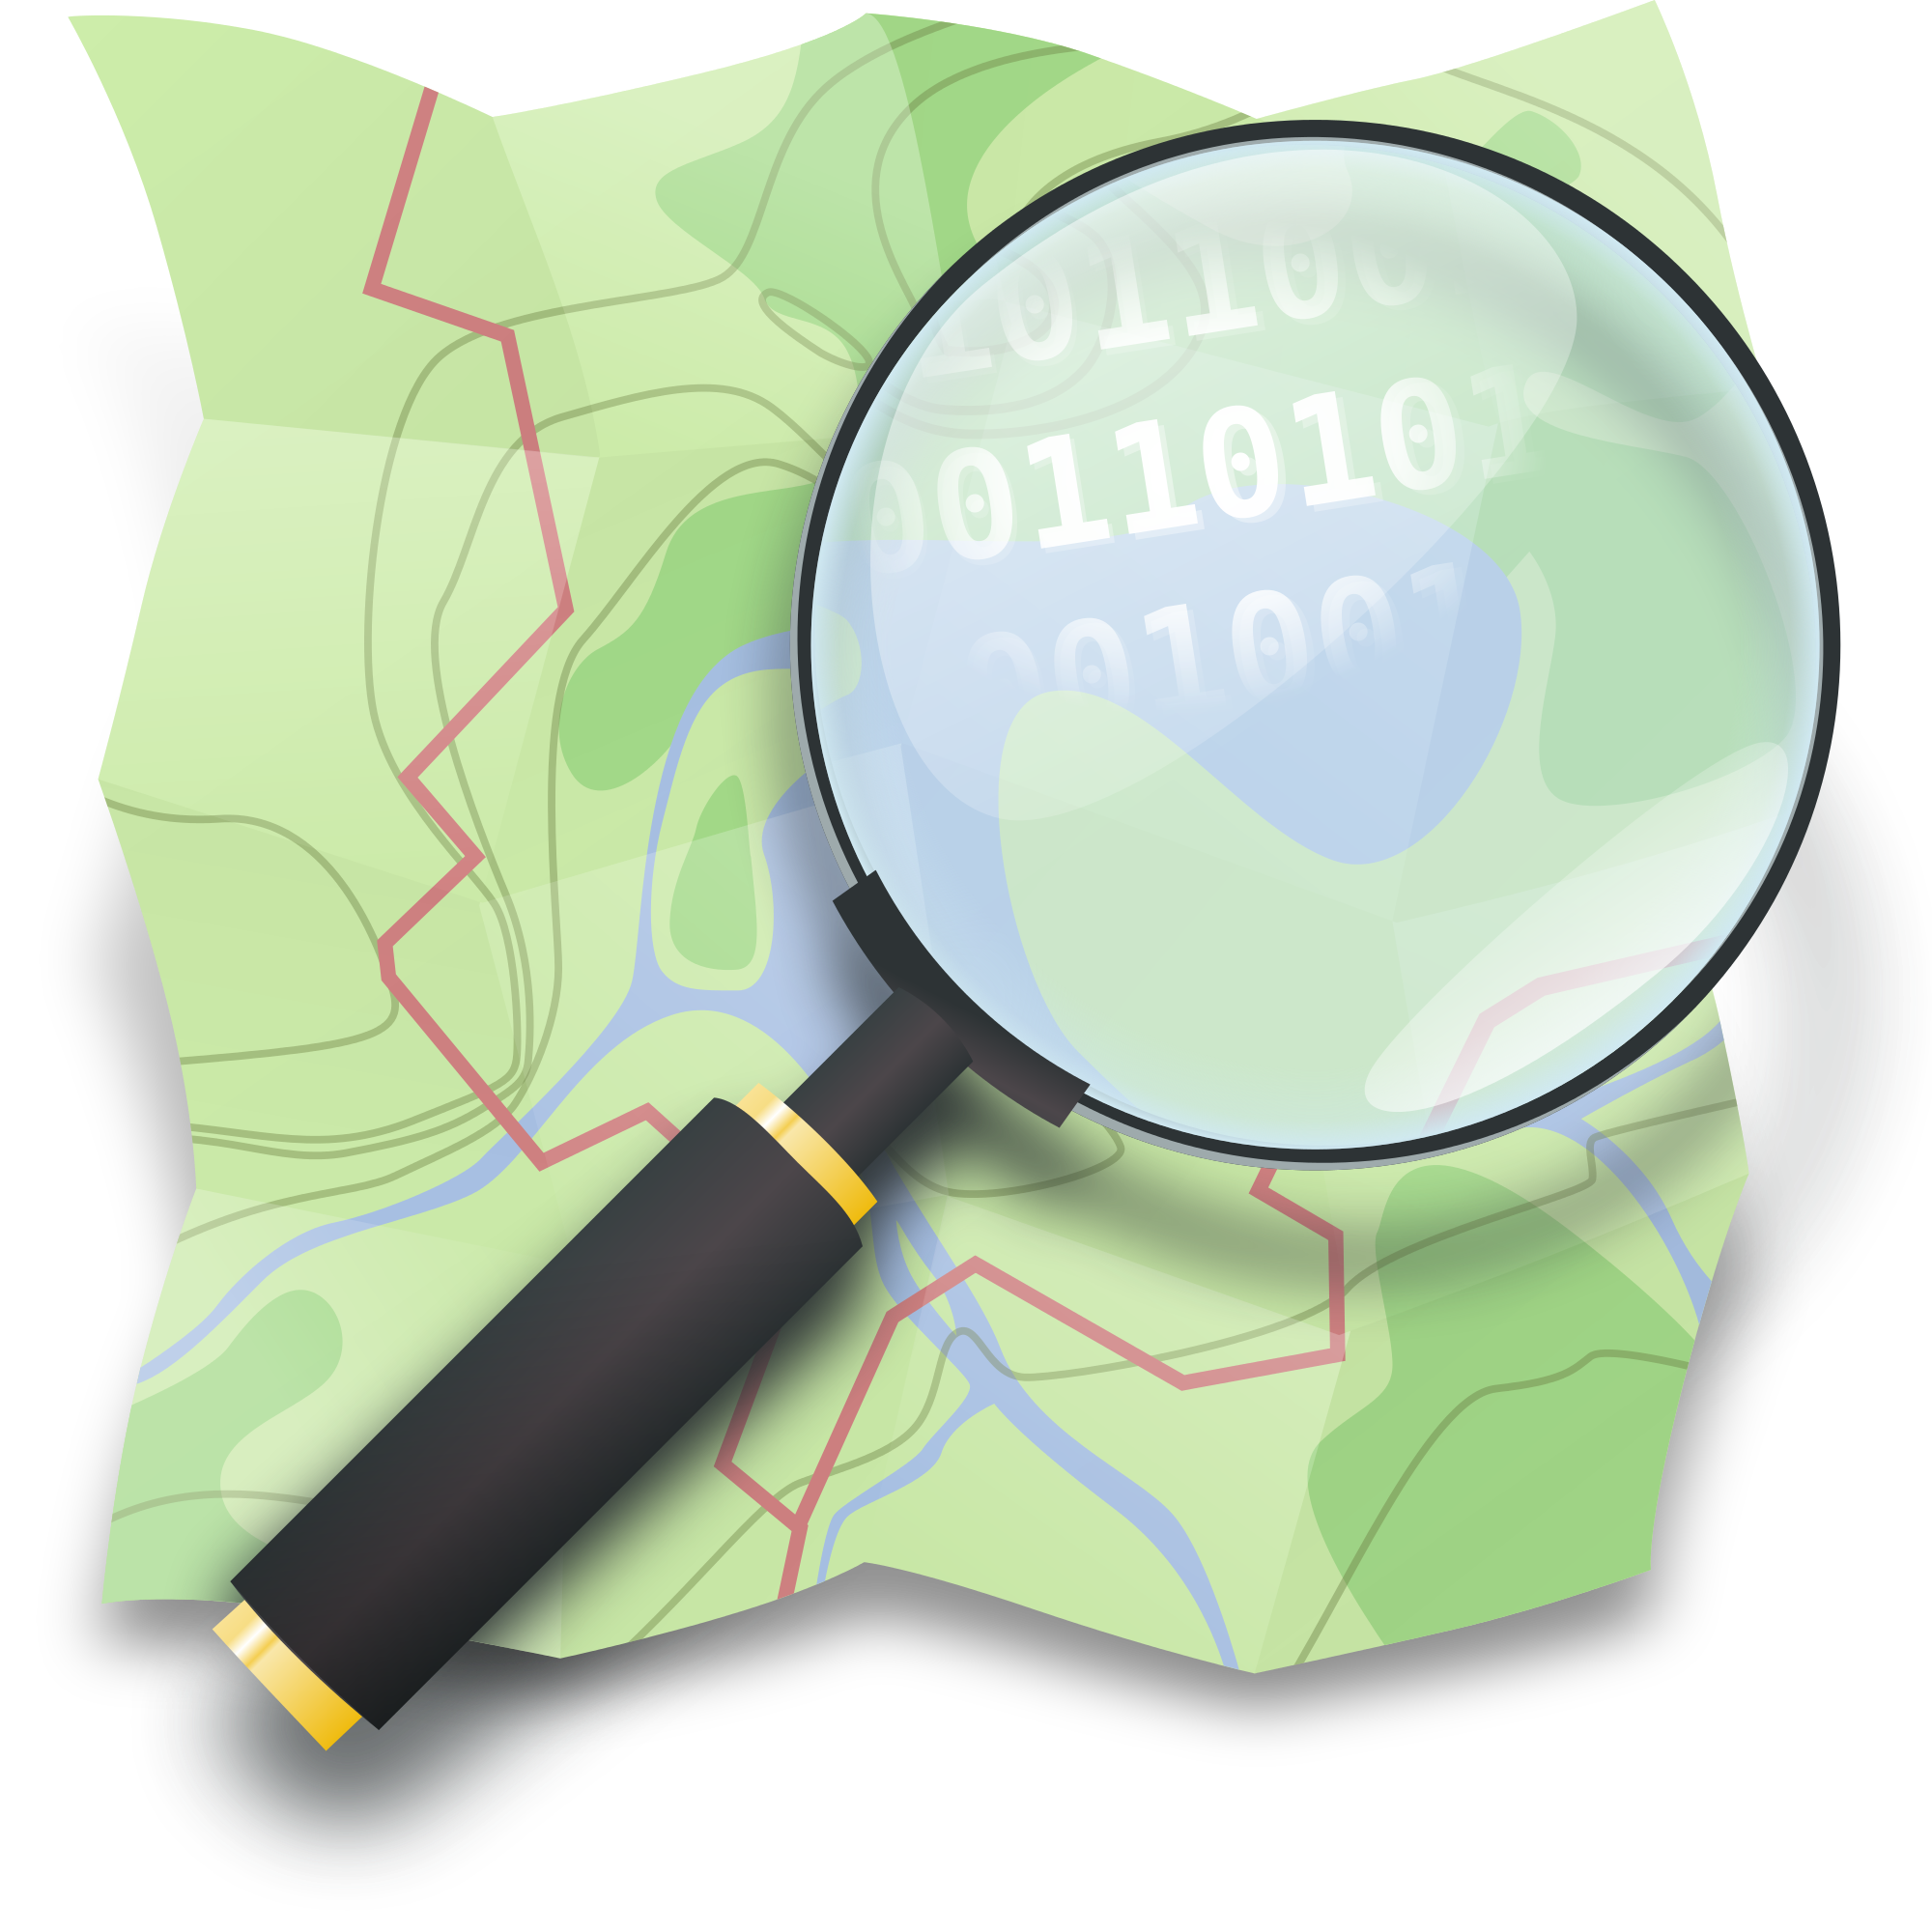
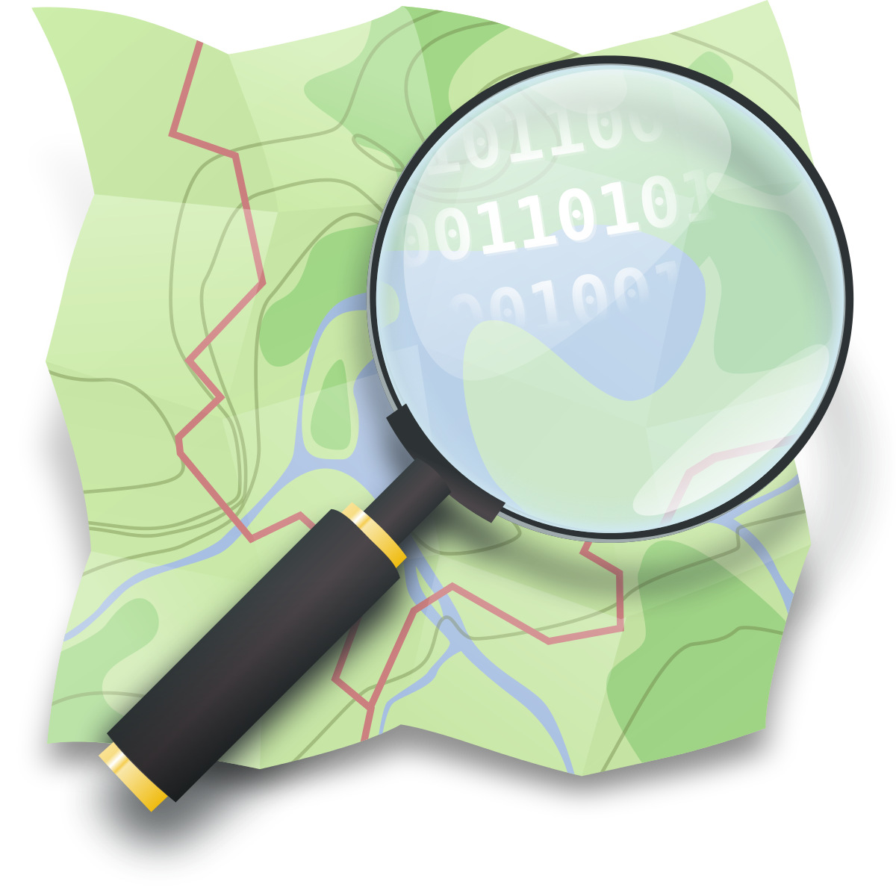
Section: OpenStreetMap
Module : Introduction to OpenStreetMap


About the OpenStreetMap project
OpenStreetMap (OSM) is a collaborative project to create a free editable database of the world. This crowdsourced data is made available under the Open Database License (ODBL). The project is supported by the OpenStreetMap Foundation, a non-profit organisation based in England.
Data is collected from scratch by volunteers performing ground surveys using tools such as a handheld GPS unit, a notebook, a digital camera. Now, we can also use some externat datasource such as satellite imagery or local dataset.
You try:
Goal: Check the content of the OSM database and how data are structured.

* Go on osm.org and zoom in your area (a few houses for instance).
* Check the link called “Copyright” on the right top corner. Write down what can you legally do with OSM ?
* Does the map look complete? Is your house on the map? Is there every shops? Is there every roads, even small paths?
* Display the layer “Map Data” and click on some blue objects on the map. These are called features.
* Click on a building, observe its tags on the left panel. Write down on your bloc-note some tags.
* Do the same operation with a road and with a landuse.
* Look at the OSM wiki how we tag highways and buildings.
* Form a small group and explain how these tags work and what kind of geometry is associated with these OSM objects. Let’s sum up this together.

Name | Value
Website | Www.openstreetmap.org
Layers | Display “Map Data”
Key “building” | http://wiki.openstreetmap.org/wiki/Key:building
Key “highway” | http://wiki.openstreetmap.org/wiki/Key:highway

More about
OpenStreetMap is not only a map, it’s big database with vector data. A feature is describing an object from the real world using some tags. These tags are composed of a key and a value. These keys are normalized by the OSM community and are described on the OSM wiki. The value is also normalized except a few one like the value of the “name” key. As an example, so as to describe a road, we should use at least the first tag. All other tags are optionnals:
Key | Value
highway | residential
name | Nelson Mandela Street
surface | concrete
oneway | yes

On the OSM database, you can find three kinds of geometric objects:
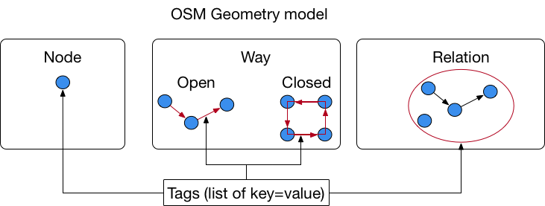


Check your knowledge:
- OSM is a database where:
- You can store vector data.
- You can store raster data (satellite imagery).
- You can use it for free if you mention the OSM attribution in your results and you respect the license.

- If you need to map some features which are specific to your country:
- Check on the OSM wiki of some similar objects are mapped already.
- Create your own keys/values without documenting them.
- Talk to your local OSM community and try to establish some common tags.



Further reading:
http://learnosm.org/en/beginner/
http://wiki.openstreetmap.org/wiki/Elements to know more about OSM objects
http://wiki.openstreetmap.org/wiki/Tags about tags

