
Section: Integration
Module : QGIS


Accessing GeoNode content from QGIS
GeoNode is built with QGIS Server or Geoserver, both of which provide OGC web services (OWS). External clients are able to interact with GeoNode via these OGC services.
In this module we will look at how GeoNode with QGIS Server backend interacts with external application to view the data and manipulate it.

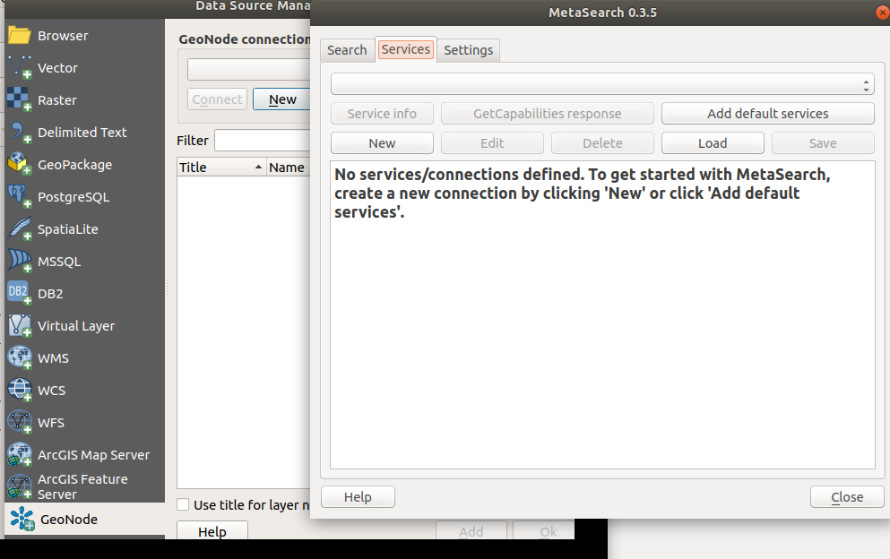
You try
Goal: To explore GeoNode data in QGIS using various tools available in QGIS

* Install the OGC connector from QGIS plugins.
* Establish a new connection in OGC connector by clicking new and enter a name for the service and Site URL
* Click on service info. The request does produces a document which has a list of all available layers and their extents (Get capabilities document)
* Click on the Search Tab in OGC connector.
* Type in the name of the Layer in the Keywords dialog. Do not type anything to get a full list of all available Layers and documents.
* Select the Layer from the listed layers.
* Select from the OGC services the format you need to access the layers as.
NB: WFS and WCS are sometimes slow because they depend on the size of the image being accessed from GeoNode.
* For WFS add the layer and edit the attributes or geometry using QGIS tools.
* Visualize the layers in the map canvas.

Name | Value
OGC connector | MetaSearch
QGIS GeoNode | Available in QGIS 3
Site URL | http://geonode.kartoza.com/
Layer | Name of layer available in GeoNode
OGC services | WFS/ WMS/ WCS
QGIS tools | Field Calculator, Digitising

Check your results
After importing the layer in QGIS using WFS you should be able to see the attributes of the layer and be able to toggle edit so that you can manipulate the geometry. With WCS you should see the raster layer added in QGIS as either geotiff or any other format you have specified. For all WMS layers in QGIS you cannot edit them.

More about GeoNode OWS
MetaSearch is a QGIS plugin to interact with metadata catalogue services, supporting the OGC Catalogue Service for the Web (CSW) standard. MetaSearch provides an easy and intuitive approach and user-friendly interface to searching metadata catalogues within QGIS.
GeoNode is based on CSW (Catalogue Service for the Web) specification, that defines common interfaces to discover, browse, and query metadata about data, services, and other potential resources.


Check your knowledge
- What kind of OGC service do you use if you need to edit the raster?
- WFS allows me to edit the properties of the raster and any changes are then pushed to GeoNode.
- WCS allows me to edit the properties of the raster and any changes are then pushed to GeoNode.
- The raster cannot be edited in QGIS, you need to re-upload the raw raster in GeoNode after making your modifications.
- What is produced when you click service info in MetaSearch and what details does it contain?
- It produces the layer which can be loaded directly into QGIS.
- It produces a list of all the available layers in GeoNode and the links to access them.
- It produces a list of all geospatial data available in GeoNode excluding documents.
- Where can you download the GeoNode client as shown on the image above?
- It is available in the plugin repository for developers of QGIS.
- It will only be available in QGIS version 3 and higher.

- It will also be available in QGIS 2.18.

Further reading:
https://live.osgeo.org/en/quickstart/pycsw_quickstart.html
http://www.opengeospatial.org/
https://docs.qgis.org/2.6/en/docs/user_manual/plugins/plugins_metasearch.html

