
Section: Overview
Module : Maps


Creating, Viewing and Managing GeoNode Maps
Maps in GeoNode are collections of layers that you can share.
The basic element in GeoNode is a layer. A layer has a style, it has metadata and you can interact with it. But you might want to bring some layers together to illustrate something. To do that you simply create a map by choosing the layers you want. Then you can view and interact with it and share it with your audience.
In this module, we will look at to create maps using GeoNode data and explore the interaction options available for users with maps. This module assumes you have sample data uploaded into GeoNode already

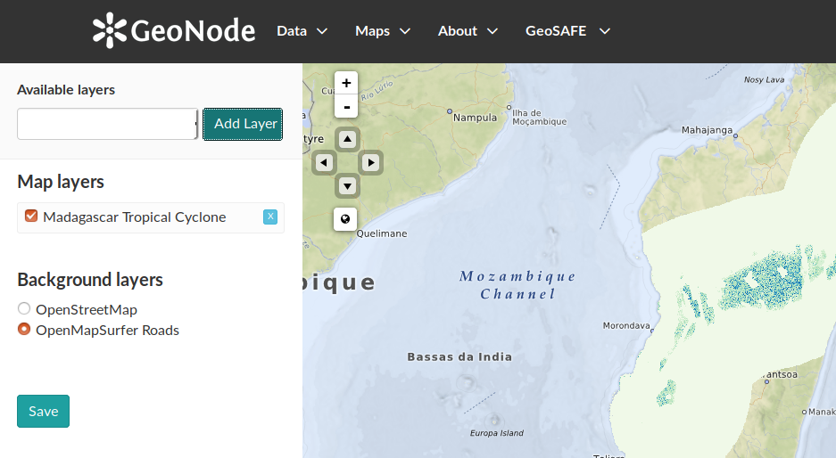
Goal: To learn how to create and explore maps in GeoNode
* Log into GeoNode
* Navigate to the Maps Page and select Create Map.
* Select the Layer you want to use to create a map.
* Add the Layer to the map. You can add multiple layers to the same map.
Hint: When adding multiple layers it is encouraged to add layers which have extents that are in close proximity. e.g. layers from the same countries.
* If you have multiple layers, change the rendering order so that layers gets drawn correctly and are visible.
* Select a Map Background
* Use the Navigation tools to change the extent of your map.
* Save your map. Give it a title and a description.
NB: You can also create a map even when not logged it but the map cannot be saved.
* Navigate to Maps menu and choose explore maps.
* Select the map you need to explore.
* Explore the Map Interactions tools.

Name | Value
GeoNode | Local GeoNode instance
Layer | GeoNode data
Map Background | OpenStreetMap or OpenMapSurfer Roads
Navigation tools | Left, centre, right, up, down
Rendering order | Bottom gets drawn first and top last
Map Interaction tools | Download, Edit map, View map, Change permissions, Copy map, Embed map, Publish WMS

Check your results
After creating a map and saving it the map should be visible in the layer list and map list. When you navigate to the map you should be able to see options to change the map you created.

More about Maps in GeoNode
You have just created a map from the Map interface. You can also start from a Layer page by clicking on ‘Create a map using this layer’ and then continue as before.

GeoNode consists of a set of core tools and libraries which allow GeoNode to be a rich SDI (spatial data infrastructure). GeoNode includes GeoExplorer, a web application based on the GeoExt framework that allows creation and publishing of maps. Maps created in GeoNode can be used in other applications by using the embedded functionality, including:
- Download Map – Allows the created map to be downloaded as:
  - QGIS layer file (.qlr)
  - Data layers
  - OGC Web Map Context file
- Edit map and its metadata.
- Change permissions of the map to ensure that the map is visible to your intended audience.
- Copy map – Use the existing map as a template to create new maps.
- Embed map – This allows the map to be used in other websites.


Check your knowledge
- Why would you create a map after logging in vs when not logged in?
- The ability to store your map on the GeoNode instance is only available when logged in.
- When not logged in it is easy to create maps as you do not need to bug the administrators of the site for login details.
- There is no difference for users.
- Why would you not create a map with layers from South Africa and Brazil?
- Because they do not look nice.
- Because the two countries have different profiles (economy and geography) so it does not make sense to show them together.
- The map produced will have a large extent and the layers will not overlap.
- The default GeoNode install provides two types of background layer. How would I go about adding another background layer like Google Satellite?
- You are not allowed to do that in GeoNode, It infringes the software licence terms.
- You need to be a developer and change a few lines of code to incorporate this.

- You can write an issue for the GeoNode community and the next version they release will meet your needs.

Further Reading:

http://docs.geonode.org/en/master/tutorials/users/managing_maps/create.html

http://docs.geonode.org/en/master/tutorials/users/managing_maps/

