
Section: Vector Analysis
Module : Buffer Basics

Buffers in Context
“A buffer is an area around a particular map feature.” A buffer is mainly used in proximity analysis and can be combined with other vector processes in complex work flows to solve spatial problems
In this module, we will learn about the concept of creating a buffer and explore the different type of buffers that exist.
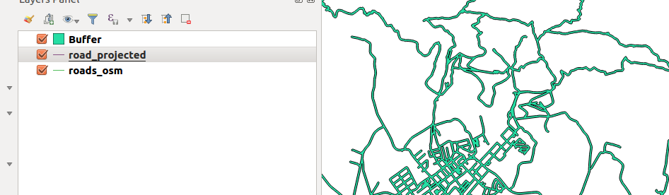
You try:
Goal: To learn how to generate buffers.
(1) Open a new project and load the vector
(2) Choose fixed distance buffer.
(3) Select the defaults on the buffer dialogue and run the analysis.
NB: Explain why your buffer covers the whole screen and looks big ?.
(4) Remove the buffer layer generated above.
(5) Save the layer as a new layer and use the specified CRS. Name it roads_3857.
(6) Using the new layer generated above, Create a buffer using ‘Fixed distance buffer’. Do not tick the ‘Dissolve buffer’ option
(7) Run the fixed distance buffer again with the roads_3857 and tick the ‘Dissolve buffer` option.
NB: Explain the difference in results between the two processes ?
(8) Create a new integer column named buffer_distance on the layer generated in Step 5
(9) Update the column in Step 8 using the distance_expression.
(10) Use the variable buffer distance and choose the buffer_distance as the column for distance.
NB: What can you infer about the Fixed distance buffer and variable distance buffer ?

Name | Value
Layer | roads_osm
CRS | UTM 33S
distance_expression | Rand(10,80)
Dissolve Buffer | Yes
Distance | 20m

More about
Buffers can be done on points,lines and polygons. Buffers involves measuring distances outward from a features. In most cases buffers are measured in uniform distances from the feature. In some cases we can have buffers that have irregular distances and lines can also have single sided buffers.

The buffer distance can be a uniform value or each feature can be assigned a buffer distance which results in a variable buffer. The buffer distance represents numerical values which are defined in map units according to the Coordinate Reference System (CRS).

Buffers helps in solving real life problems. They are used as a tool in evacuations for disasters where people depict the zones for safety i.e. during a chemical spillage buffers can be used to draw zones to show areas that are more likely to be affected.

QGIS has got a powerful expression builder which can be used in any analysis to do work. In this exercise we used the function Rand which generates numbers between a specific threshold and used the generated numbers as buffer distance.

Check your knowledge:
- Which example best suit the need to use a buffer:
- Can be used any time and anywhere. It does not have to be specific to a problem.
- When you want to style the layers differently.
- A communication company wanting to find out which areas do not have cellphone coverage.
- When you are given the buffer distance in kilometres how can you use them accurately in a GIS:
- Use them as they are
- Do a standard conversion between kilometres to metres and use the result
- Divide the kilometres by 1000 to get the exact distance.
- Can you create a buffer with data in decimal degrees:
- True
- False
Answers: 1c, 2b, 3t

Further reading:
https://docs.qgis.org/2.14/en/docs/gentle_gis_introduction/vector_spatial_analysis_buffers.html
https://wiki.osgeo.org/wiki/Buffer_with_QGIS

