
Section: Map Composition
Module : Atlas Creation


Atlases in Context
“An atlas in QGIS is a series of maps designed to provide a cohesive map series on a topic or region”
If you need to create a series of maps it is very boring and error prone to do it manually. Fortunately, QGIS provides a mechanism to generate a map series easily. A coverage layer is used to manage the atlas generation process. One page is generated per coverage feature. You can compile all the maps into a single PDF document or a series of PDF's or images.
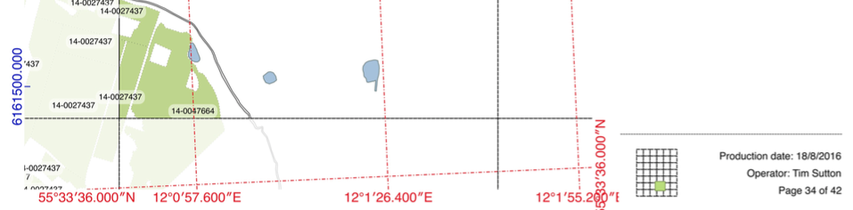


You try:
Goal: To produce a map series showing water resources in the context of agricultural lands.
- Use the data provided with this tutorial to add agricultural fields, lakes, streams and the grid to your map.
- Note that the map should be in a projected CRS. In this case you’ll notice the canvas is already in UTM for Denmark.
- Create a legend preset with just the grid visible - call the preset 'Grid'
- Create a map composer layout
- Enable atlas in the atlas tab
- Set atlas coverage layer to 'Grid'
- Enable 'single file export when possible'
- Add a map ('map0') approx 180mm x 180mm
- Set the map scale to 7500
- Enable 'controlled by atlas'
- Set to use 'fixed scale'
- Create two grids as per table, right (grid1, grid2)
- Add a table
- Link the table to the agricultural_fields layer
- Enable table feature filtering: Show only features intersecting with atlas feature
- Modify table attributes to show only first 3 attributes
- Add an overview map ('map1'), linked to map0
- Lock layers for map item and set to use preset 'Grid'
- Lock layer styles for map item
- Add three labels as per the table, right (page label, operator label, production label)
- Add a map title label

Name | Value
Grid layer symbol renderer | Inverted Polygon
Grid layer sub renderer | Rule based
Grid layer rule name | Mask
Grid layer rule | $id = @atlas_featureid
Grid layer symbol | Simple fill, white, 50% transparent
Page label | Page [% @atlas_featurenumber %] of [% @atlas_totalfeatures %]
Operator label | Operator: [% @user_full_name %]
Production date label | Production date: [%format_date( now(), 'd/M/yyyy')%]
Map0: grid1 | Rename grid1 to UTM  Set CRS to UTM  Grid spacing x & y: 500m  Labels on left, top  Left labels vertical ascending  Label text and lines in blue
Map0: grid2 | Rename grid2 to LatLong  Set CRS to EPSG:4326  Grid spacing x & y: 0.008 degrees  Labels on right, bottom  Right labels vertical ascending  Label text and lines in red

More about atlas production
The process of building an atlas in QGIS is fairly simple: Prepare a project in QGIS. Then create a map composition. In the map composer enable map composer and indicate which layer will be the coverage layer. A coverage layer is a polygon layer that contains areas to be included in the atlas. When generating the atlas, QGIS will sequentially zoom to each feature in the coverage layer and render a map page for that feature.

QGIS provides a number of special variables for you to use when creating your atlas:
@atlas_feature – The current feature from the coverage map. You can use this to access any attributes from the current atlas feature record.
@atlas_featureid – The ID of the current feature in the coverage map.
@atlas_featurenumber – The sequential feature number of the current coverage feature.
@atlas_filename – the name of the file that will be created when rendering the current atlas page
@atlas_geometry – the geometry of the current coverage feature in your atlas.
@atlas_pagename – the generated name (if any) for the current page.
@atlas_totalfeatures – total number of coverage features for the atlas

You can combine these elements in labels on your map so that each page has textual elements specific to that coverage area. Another thing you can do with the atlas variables is mask away the surrounding coverage areas so that only the current area is highlighted.
In the map composer, you can enable preview mode (icon in red box above). Pressing the forward and backwards arrows will update the composer layout preview to the next or previous coverage feature.

Note: When you want to print or export your atlas, you must use the print / export button on the atlas toolbar, not on the main map composer toolbar.

Check your knowledge:
- An atlas is:
- A very well built man who holds a globe over his head
- A series of maps generated in sequence
- A way to create an animated slide show based on a QGIS map
- What will happen if you delete one of the grid polygons from your coverage layer?
- QGIS will give an error message
- The atlas will not mask the surrounding features
- The atlas page for that feature will be skipped

Answers: 1c, 2c

Further reading:
http://www.qgistutorials.com/en/docs/automating_map_creation.html
https://docs.qgis.org/2.14/en/docs/training_manual/forestry/forest_maps.html

