
Section:Vector Analysis
Module : Table Joins and Relations


“Attribute table joins is the process of combining two tables based on columns containing the same attribute values.”

In this module we will look at the various types of table joins that can be achieved in. In order for two tables to be linked they has to be a common values between two tables. The columns that are to be linked can have different names but contain represent the same values

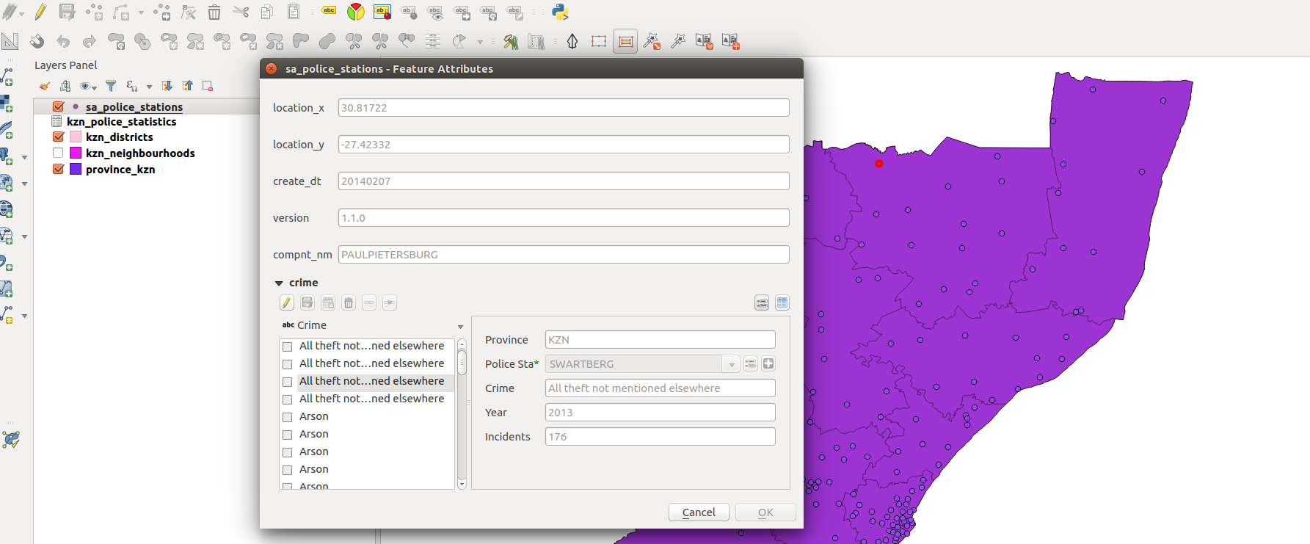
You try:
Goal: To learn the basics of attribute joins and distinguish between 1 to 1 join and 1 to many joins
Problem: You are an estate agent and you need to identify the crime patterns that occur at two police stations near a new residential location.
TO DO:
* Load the layers specified into QGIS
* Create a new column in crime.csv using Field calculator and update the column using the expression
* Create a join between the two tables and check you results.
* Remove the table join and create a relation between the two
Check your results:
Check if all records from non spatial table are visible in the spatial layer.
Compare when you use a relation if all records pull through.
Name | Value
Spatial Operation | Expressions editor  QGIS
Table operations | 1-1 Join  1- Many Join
Layers | crime,police_station,districts
Expressions | Upper(name)
Function | Relations

More about
Attribute table joins allows us to pull information from another table by using column with values that are common between the two tables. This is sufficient when each row these tables are distinct. In situations when there are rows which are not distinct in one of the tables creating a table join does not satisfy the requirement as this kind of relationship is termed 1 to many. When there is 1 to many relationships we need to define a relation between the two tables.


Check your knowledge:
- Describe a table join:
- A spatial operation that is only available in QGIS
- When one combines two tables using column values that are available in both tables.
- A type of GIS layer
- Which of the following is True:
- When doing table join between two columns the attributes do not matter what case they are in. They can be either upper case or lower case
- You can only do a join between a spatial layer and a non spatial layer
- When you want to show the relationship between two tables that have 1 to many relation you create a relation.
- Table joins can be used when the two tables use column with identical names:
- True
- False
Answers: 1b, 2a, 3f


Further reading:
http://docs.qgis.org/2.14/en/docs/user_manual/working_with_vector/vector_properties.html#joins-menu
http://www.digital-geography.com/qgis-tutorial-ii-how-to-join-data-with-shapefiles/#.WQHDlDclHQo

