
Section: Analysis
Module : Continuous and classified data


Continuous and classified data in Context
“Classified (or discrete or categorical) data represent named groups of values, for example, high, medium and low hazard. Continuous data represent a continuously varying phenomenon such as depth in meters or population counts.”
In this module we will both of these and their visualisation and application.

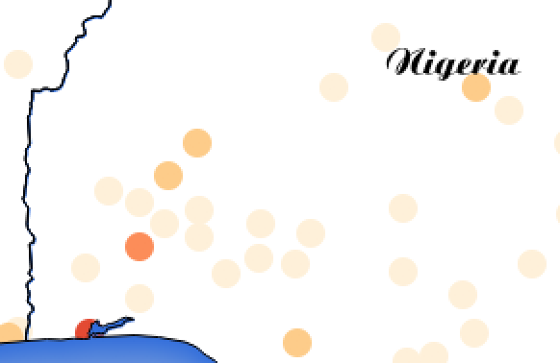
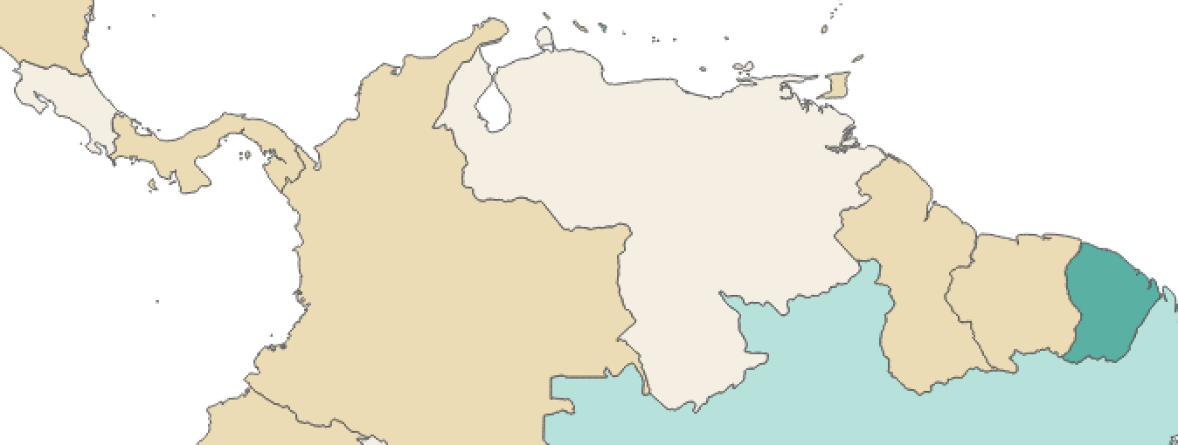
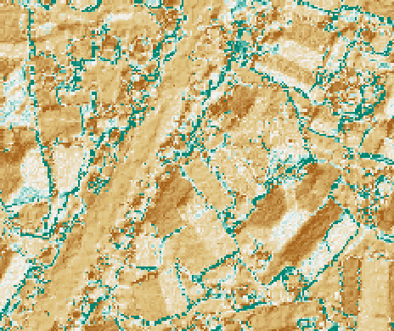
Population
Economy
Hillshade
You try
Goal: Explore and map continous and classified data

* Load the Countries and Populated Places layers from Natural Earth
* In the Countries layer, inspect the data in the ‘pop2015’ field. Style the layer accordingly.
* In the Countries layer, inspect the ‘economy’ field. Style the layer accordingly.
* Load tandale_hillshade.tif. Look at it carefully and explore the cell values. Try to style it differently.
* Challenge: try to turn some continuous data into classified data using tools available in QGIS (this must result in a new data set, not just a style)

Name | Value
Countries layer | ne_10m_admin_0_countries in the ne.sqlite database in appendix1-naturalearth-data
Populated places layer | ne_10m_populated_places
tandale_hillshade.tif | In InaSAFE/exercise-data

Check your results

Do you get anything like the maps in the screenshots above?

What do the values in the hillshade layer represent?

More about classified and continuous data
While many phenomena that we want to map or analyse exist as continuous data, grouping or classifying values works well when you wish to reduce data preparation complexity or deal with local variances in the interpretation of data. For example, a flood depth of 50cm may represent a high hazard zone in an area where people commonly have basements in their houses, and a low hazard zone in areas where people commonly build their houses on raised platforms.


Check your knowledge
- If you take continuous data and classify it in a style, does that make the data classified? (yes or no)
- Is a binary (0/1 or yes/no) field classified or continuous?
- Can a text field be continuous? (yes or no)

Further reading:
https://en.wikipedia.org/wiki/Continuous_and_discrete_variable

