
Section: Data conversion
Module :Raster to vector conversion


Vectorisation in Context
“Vectorization is the process of converting a raster into a vector.”
In this module, we will learn how to convert mask a raster layer and then convert the AOI(area of interest) into a vector. Vector geometry is easy to manipulate. Because of the ease of using vector geometry, we sometimes convert raster into a vector so that we can proceed with analysis.

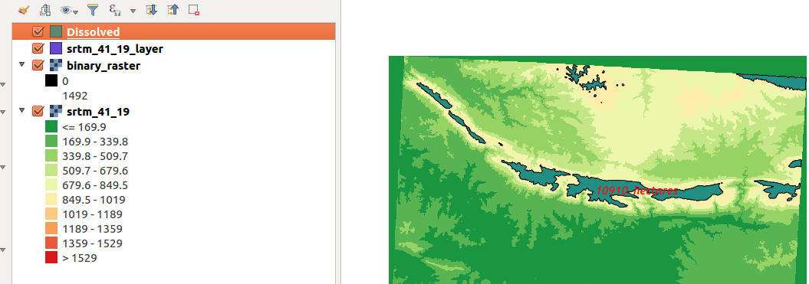
You try:
Goal: To learn how to create a binary mask in QGIS and convert the binary raster into a vector and calculate the tottal area.
DATA:appendix3-local-data/STRM
* Load the raster layer specified.
* Use the raster calculator to creater a mask showing cells greater than 1000m. Use the specified formula. Name the result Binary_mask.tif
* Open the layer generated above and assign a additional no data value 0.
* Convert the mask layer to vector.
* Dissolve the vector layer and edit the result to add a colum for calculating area.
* Use the expression for calculating the area and convert the total area to hectares.
* label the resultant polygon with the area

Name | Value
Raster Layer | srtm_41_19
Expression | $area
Raster Operation | ( "srtm_41_19@1" >= 1000 ) * "srtm_41_19@1"
No Data value | 0

More about
If you want to process data that is in various formats it is usually easy to convert between formats so that overlaying can be done easily. Because each raster cell represents a specific value we can use the raster calculator to derive new results from our raster and when we convert it to vector we can then do a complicated analysis.


Check your knowledge:
- When is it necessary to convert a raster to vector:
- When the raster layer is a satellite image
- When we have derived new information and such that further analysis require data to be combined with other vector sources.
- It is not recommended to convert a raster to vector.
- Which of these statements is true about raster to vector conversion:
- Each cell value in a raster corresponds to a specific polygon in a vector
- Vectorisation can only be done on a raster that has been classified or a raster layer that is a mask.
- Vectors generated from rasters are not normal vector data.
- Can you calculate total area for raster cells greater than 100m without converting to vector:
- True
- False
Answers: 1b, 2b, 3f


Further reading:
https://docs.qgis.org/2.14/en/docs/user_manual/working_with_raster/raster_calculator.html
https://docs.qgis.org/2.14/en/docs/user_manual/working_with_vector/field_calculator.html

