
Section:RasterAnalysis
Module : Raster operations


Raster Analysis in Context
“ Raster analysis are operations performed to alter the cell values of the raw data. The output are a result of computations on a cell-by-cell basis. The value of the output for one cell is usually independent of the value or location of other input or output cells”
In this module we learn how to perform raster analysis and how raster and vector analysis can be combined to solve real world problems.

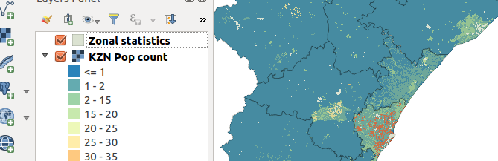
You try:
Problem: You are a disaster manager in your region and you are required to produce a map which shows the population density of each administrative area.
Data: appendix3-local-data – kzn_pop_count.tif,districts.shp
* Load the layers into a new project
* Project the vector and raster to the specified CRS
* Symbolise the projected layers and remove the raw ones (unprojected layers)
* Run the spatial algorithm and save the output as distict_projected.
* Change the transparency of the above result layer to 70. Move it to the top of the raster layer.
* Toggle the distict layer so that it does not render
* Toggle edit distict_projected and use field calculator to create a column density with the values given on the table.
* Enter the formulae for density to populate the density column
* Label the density_projected layer with the calculated density.
* Create a map to show your results
Name | Value
CRS | EPSG:3857
Spatial algorithm | Zonal Statistics
Column attribute | density,Decimal size 10,precision 6
Density | Number of people/$area

More about population density and producing maps
In order to undertake spatial analysis all layers need to be projected and be in the same CRS. Population density is the number of people per unit of area. To produce a nice map all map layers should show nice cartography. When creating a map in map composer it is imperative that a map shows all the fundamental elements of a map example scale bar.


Check your knowledge:
- What is population density and how is it calculated:
- Population Density is the number of organisms per unit volume
- Population Density = Number of People/Land Area
- Population density is a type of GIS operation available in QGIS
- What will happen if you run your analysis with data that is not projected:
- QGIS will give an error message
- QGIS will run the analysis and produce correct output
- QGIS will run but the results will not be correct
- QGIS can be used to understand population dynamics:
- True
- False
Answers: 1b, 2c, 3t


Further reading:
https://docs.qgis.org/2.14/en/docs/user_manual/plugins/plugins_zonal_statistics.html
https://docs.qgis.org/2.14/en/docs/training_manual/vector_analysis/reproject_transform.html

