
Section: Analysis
Module : Vector Analysis


Spatial Analysis in Context
“Spatial analysis is the process of examining the locations, attributes, and relationships of features in spatial data through overlay and other analytical techniques in order to address a question or gain useful knowledge. Spatial analysis extracts or creates new information from spatial data.”
In this module we will try explore various techniques that are used when solving a geographical problem.

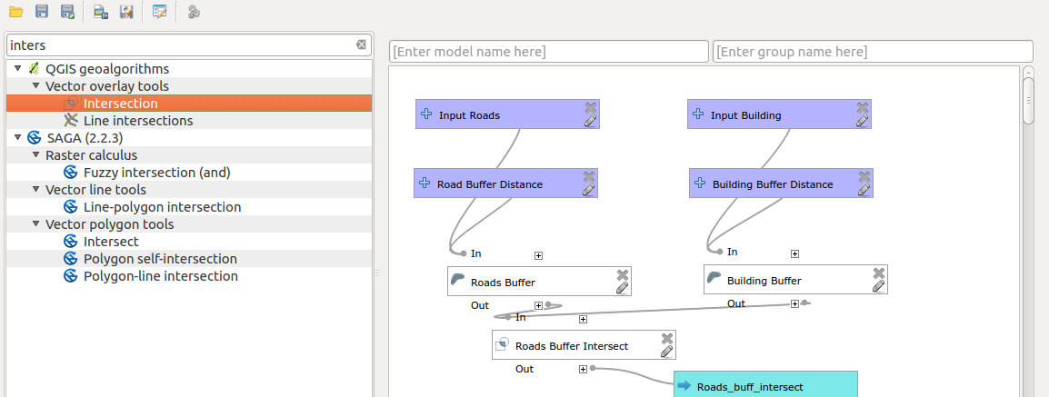
You try:
Problem: You are a salesperson in your local town and you have clients who are interested in buying houses in a suburb in the town. The client has certain criteria that needs to be satisfied.
Data: Download osm data representing the town you stay eg. Swellendam. Use the tools available in QGIS or plugins
The following is the criterion:
a) The property must be in your town eg (Swellendam)
b) The client wishes to be more than 1km from a railroad.
c) Close to main primary road. Maximum distance 500 m.
d) Be a maximum distance of 50m from a school
e) The building must be of type ‘house’.
Goal: Create a model in graphical modeller to automate the work flow.
Hint: Use the items mentioned on the table on the right.
NB: Spatial analysis require that data be projected first. Use the specified CRS when projecting the data.

Name | Value
CRS | EPSG:3857
Buffer | Fixed Distance Bufer
Spatial Operations | Clip, Intersect,select by location
Dissolve Buffer | Yes

More about
Spatial analysis ranges from performing simple analysis using simple geoprocessing algorithms to performing complex work flow. Knowing the CRS of a layer is important before undertaking spatial operations. Spatial analysis should always be done in a projected coordinate reference system. The order in which operations are done is also critical as it affects how the results will appear.


Check your knowledge:
- What is spatial analysis:
- Producing a pretty map.
- Adding a csv layer into QGIS.
- A GIS dataset that has been significantly altered by an algorithm to add columns and rows in which useful information can be deduced.
- Which of these represent a spatial operation:
- A GIS vector dataset that has been projected to another CRS.
- Finding features that occur within a geographic entity.
- Deleting columns from an attribute table.
- GIS can be used to solve real life problems:
- True
- False
Answers: 1c, 2b, 3t


Further reading:
https://infogeoblog.wordpress.com/2013/01/08/geo-processing-in-qgis/
http://gracilis.carleton.ca/CUOSGwiki/index.php/Automating_Vector_and_Raster_Workflows_using_the_Graphical_Modeler_in_QGIS
https://docs.qgis.org/2.14/en/docs/training_manual/processing/modeler_twi.html

