
Section: InaSAFE
Module : Introducing InaSAFE


About the InaSAFE project
“Before we start training you to use InaSAFE, let’s make sure you understand the purpose of the software!”

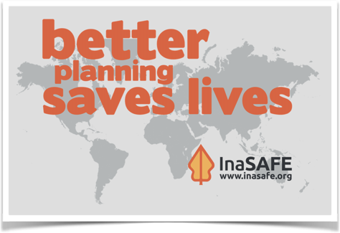
The InaSAFE project (http://inasafe.org) was started to provide a tool for disaster managers who want to understand what the potential impacts of a disaster will be. Initially the focus of activity was in Indonesia - a country that is highly vulnerable to different disasters including floods, tsunamis, volcanoes, earthquakes and other localised disasters such as landslides and wildfire. InaSAFE has since been adopted for use in many other countries - it is not ‘Indonesia specific’. The underlying goal of InaSAFE is to encourage and facilitate better planning for disasters - our slogan is “better planning saves lives”.

InaSAFE is supported by the Government of Australia, the World Bank / GFDRR and the BNPB Disaster Agency in Indonesia.
You try:
Goal: To think about what a tool that helps you to plan for disasters should do.
Form a small group of max 4 people in a group and use the table on the right to come up with some ideas about what a disaster preparedness tool should do.
Check your results:
Swap your list with a neighbouring group and see if they had any ideas in their lists that were missing in yours. As we work through the InaSAFE training exercises, use this list to check back and see how well it will cater for your specific situation.

Name | Expectation
Disasters | Make a list of disasters that affect your country or community.
Vulnerabilities | Make a list of things that are vulnerable to disaster.
Planning | What things could / do you do to be prepared for a disaster?
Data | What data would you need to prepare for disasters?

The approach taken by InaSAFE
In InaSAFE we have gone through a detailed design process to come up with a tool that:
- is simple to use (you do not need to be a hazard scientist / hazard modeller to use it)
- is freely accessible for everyone (both InaSAFE and QGIS on which it runs are Free and Open Source Software)
- has very low requirements in terms of input data (getting rich, complex data together is hard) yet still can produce useful outputs
- can be deployed in different contexts to cater for different use cases (desktop, web, interactive analysis, automated analysis etc.)
- can be adapted for use in many different countries and scenarios
- supports disaster preparedness and to a more limited extent disaster response activities.

We have a number of different products that we have built to address the needs of different users:
- InaSAFE Desktop: A plugin for QGIS that runs on Windows, MacOS and Linux desktops.
- GeoSAFE: A web based front-end for InaSAFE that runs on GeoNode.
- InaSAFE Command Line: A command line tool for running InaSAFE.
- InaSAFE “Headless”: A service based environment used for integrating InaSAFE into other toolchains.


Check your knowledge:.
- Download your country’s Global Assessment Report (see links below) and determine what the greatest disaster risks in your country are:
- flood
- drought
- earthquake
- other (specify)
- Mark all the correct statements:
- InaSAFE requires expertise in hazard modelling
- InaSAFE can be downloaded from the Microsoft App Store for a fee
- InaSAFE is open source – any organisation with skills of finances can contribute to its development.
Answers:


Further reading:
You can watch a short introduction to the InaSAFE project here: https://www.youtube.com/watch?v=jZl3GwpCDN8
Install the Global Assessment Report (GAR) on your phone: http://www.preventionweb.net/english/hyogo/gar/2015/en/home/gft.html
Review your country GAR profile:
http://www.preventionweb.net/english/hyogo/gar/2015/en/home/data.php

