
Section: InaSAFE
Module : Installing InaSAFE


How to install InaSAFE

“We walk through the installation of InaSAFE on QGIS.”
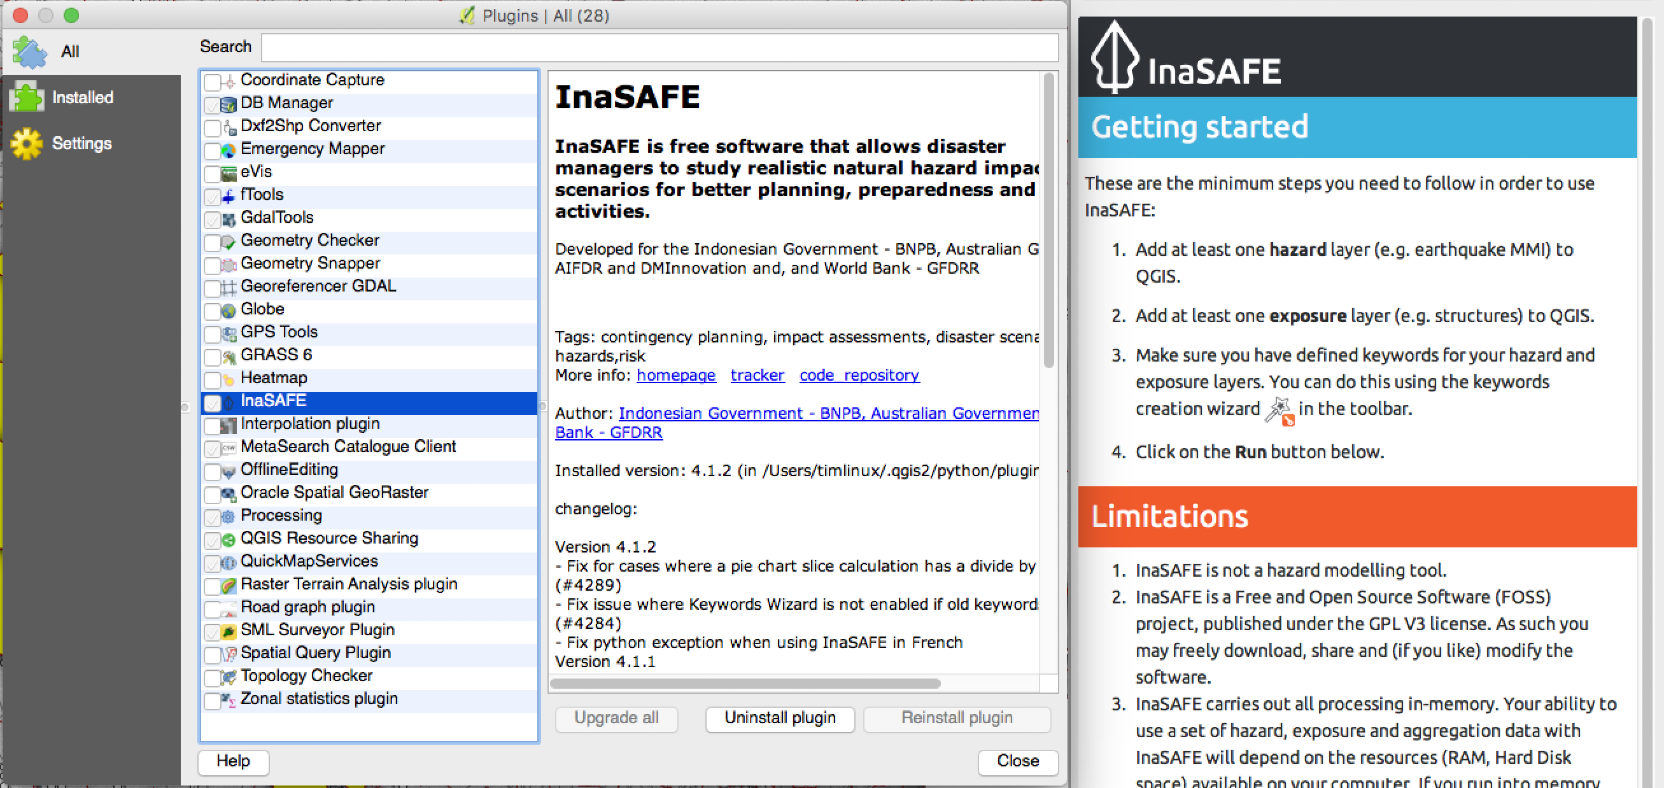
The first step to using InaSAFE is to install it using the plugin manager in QGIS. In this short worksheet you will go through the process of installing InaSAFE and we will explain how to check if a new release is available, and what the numbering of the releases means.
You try:
Goal: To be able to run an simple analysis in InaSAFE.
Open QGIS (ideally the current LTR version)
Open the plugin manager
Wait for the manager to fetch the list of available plugins
Choose the InaSAFE plugin and install it
Restart QGIS
Check your results:
Do you see InaSAFE in the plugins menu?

Do you see the InaSAFE toolbar?
Do you see the InaSAFE dock window?
Why do I need to restart QGIS?
In some cases it may not actually be necessary to restart QGIS, but because InaSAFE is a fairly complex plugin, we cannot guarantee that the plugin will unload and then reload cleanly if you are doing an upgrade. For this reason we recommend you get into the habit of restarting QGIS after update InaSAFE

More about installing InaSAFE
Installing InaSAFE is really easy right? In some cases you may experience difficulty doing the installation if you have poor internet connectivity. The plugin is about a 5mb download (at time of writing). If you are wanting to share the plugin with colleagues and your internet is poor, consider downloading the windows executable installer rather which you can then share via a USB Memory Stick or similar method. The windows installer is available on the GitHub Releases Page (see link at the bottom of this page).

We periodically make new releases – either to fix bugs or to introduce new features and improvements. We use ‘semantic versioning’ which gives you an indication of the purpose of each release. Each release number has 3 parts: major version, minor version, bug fix version. For example InaSAFE 4.1.2 has major version of 4, minor version of 1 and bug fix version of 2. Generally a change in major version introduces potentially breaking changes (e.g. requiring that you re-create your keywords). Minor version changes (e.g. 4.1 to 4.2) introduce new features and bug fix versions don’t add features but do fix bugs.

When we announce a major or minor release, we will provide a changelog that highlights the key new advances introduced with that release. You can see the changelogs at http://changelog.inasafe.org by clicking on any release in the InaSAFE project list.

One warning if you are a developer: If you check out the InaSAFE source code from Git into your QGIS plugins directory, do not also install InaSAFE from the QGIS plugin manager – it will delete your code repository!


Check your knowledge:
- True of false? : The only to install InaSAFE is using the QGIS plugin manager?
- True
- False
- Minor releases are intended to (choose all that apply):
- Introduce new bugs into InaSAFE
- Introduce new features into InaSAFE
- Introduce potentially breaking changes into InaSAFE



Further reading:
InaSAFE Releases Page: https://github.com/inasafe/inasafe/releases (including exectuable installers for Windows)
InaSAFE Changelogs: http://changelog.inasafe.org/en/inasafe/

