
Section: Introduction
Module :The Interface

The Interface in Context
“QGIS graphical user interface has many components which all contribute to how an individual access and run processes. The interface is highly customisable so that users can place icons and tabs on positions where access to processes improves.”
In this module we look at how to customise the interface and setup for first time users.
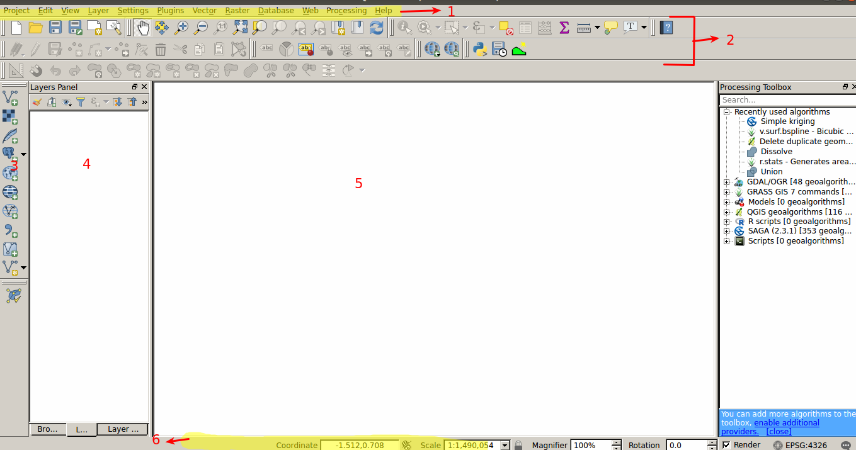
A detailed description of the GUI.
* 1 Menu Bar – Contains a list of all commands that can be run in QGIS. The menu is exhaustive of all the commands available in QGIS.
* 2 Icon toolbar – Contains shortcuts to commands available in the menu’s. Some commands will not have icons and should aways be looked at in the menu. The icons can be customisable.
* 3 Side toolbar – An extension of the icon toolbar.
* 4 Layers Panel – Contains a list of all layers that are loaded in QGIS and allows a user to interact with the properties of the layers and change their orders.
* Map Canvas – An area where rendering of layers takes place.
* Status Toolbar – This contains information that is relayed to the user. This ranges from the CRS,scale,map rotation and errors.
- Right click on an open space on the icon toolbar
- Check to see if the browser panel is active. If it is not activate it.
- The browser panel docks on top of the layers panel.
- Navigate to the newly added browser panel and move it, drag it inside the layers panel.
- When you have released it , the browser panel should dock inside the layers panel and you should see two tabs which can be clicked.

More about
The QGIS user interface is higly customisable to a user’s needs. We have just customised the browser panel by docking it as a tab. When setting up QGIS for the first time it starts up with some defaults which might not be desirable depending on how/why you want to use QGIS. Icons can be turned off and menu items can be disable in order to have a simplified interface.

Check your knowledge:
- Describe what rendering a map is:
- The actuall painting of layers so that they are visible in QGIS.
- A GIS technique that involves adding layers into QGIS.
- A type of GIS dataset.
- A GIS vector dataset where each polygon represents a building with high, medium or low occupancy rate
- Is the menu customisable:
- True
- False
Answers: 1a 2b, 3t

Further reading:
https://docs.qgis.org/2.18/en/docs/user_manual/introduction/qgis_gui.html
https://docs.qgis.org/2.18/en/docs/user_manual/introduction/general_tools.html#layers-panel
https://docs.qgis.org/2.18/en/docs/training_manual/introduction/overview.html

