

Intro to GIS Using QGIS - Laptop Guidelines

If you are attending the Introduction to GIS Using QGIS workshop, please read this handout for guidance on what kind of laptop to bring and what software to install.

This workshop is designed for absolute GIS newbies, but you must have your basic computer skills in place: you should know how to use a laptop and be able to effortlessly navigate it. There will be laptops available if participants do not have their own.

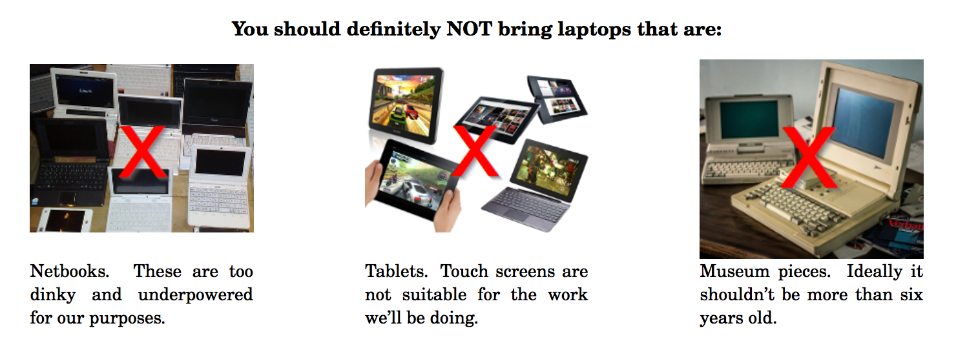

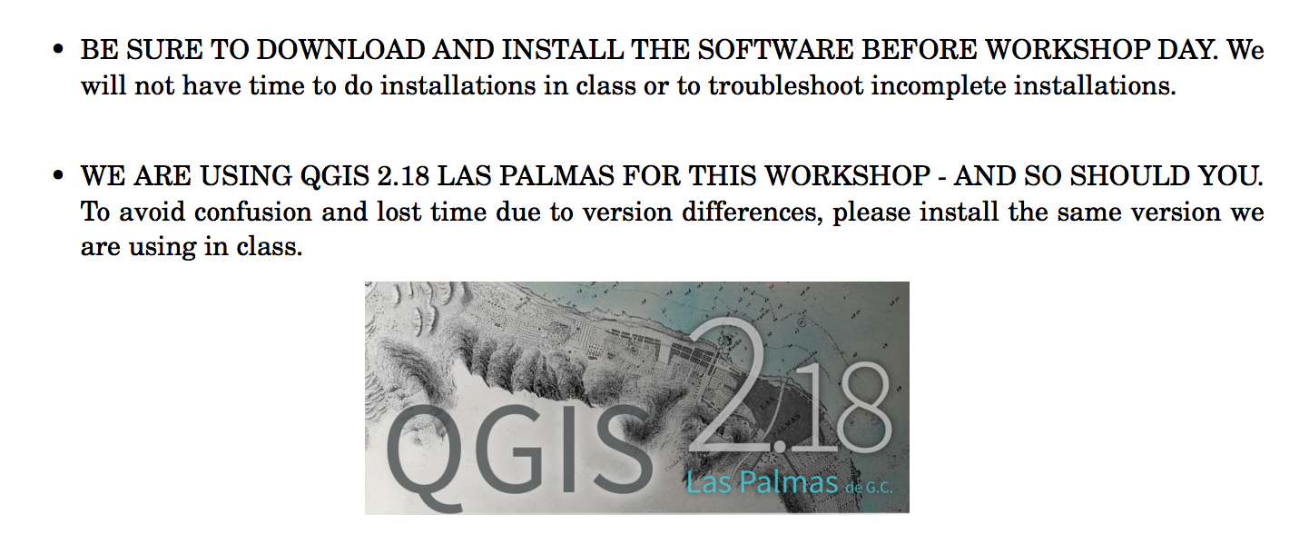

To download QGIS go to http://www.qgis.org/en/site/forusers/download.html

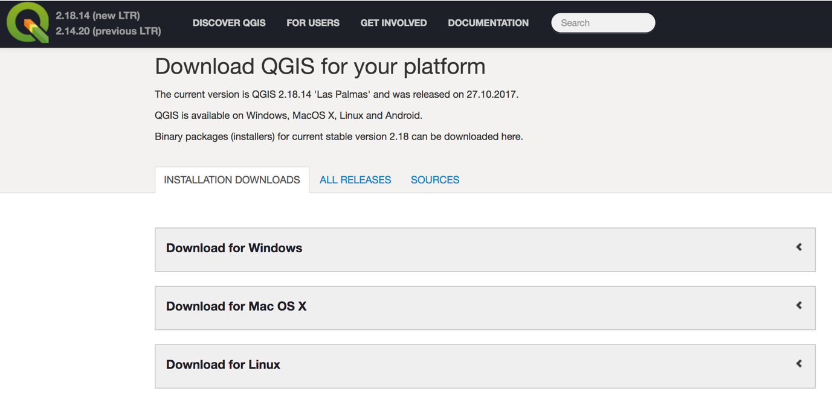

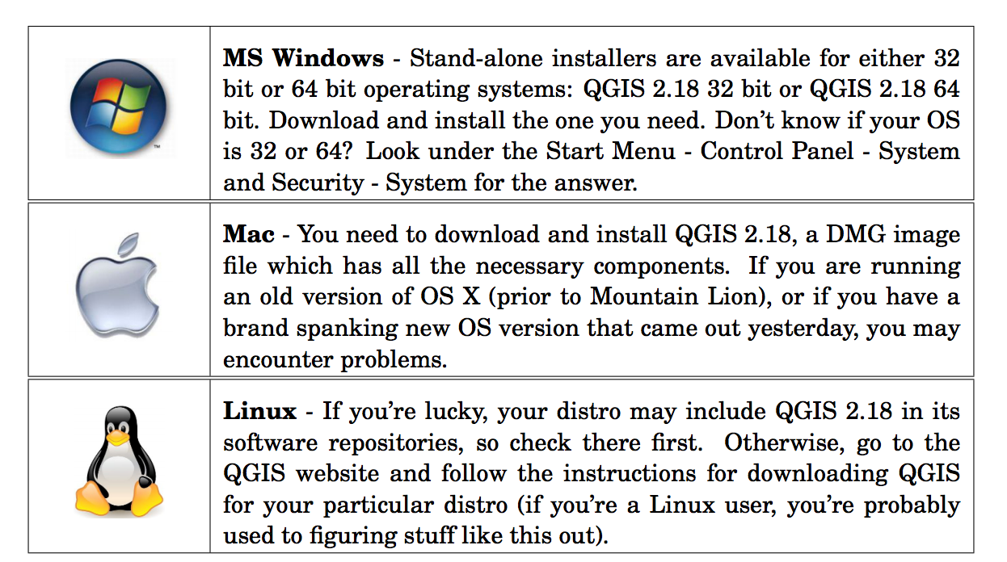

Most importantly, GIS is FUN and anyone can learn to use it!

