
Section: Overview
Module : Layers


Uploading, Viewing and Managing Layers in GeoNode
GeoNode is an Open Source Geospatial Content Management System. GeoNode is a web-based application and platform for developing geospatial information systems (GIS) and for deploying spatial data infrastructures (SDI).
In this module we will look at methods of managing data from upload to editing the layers.

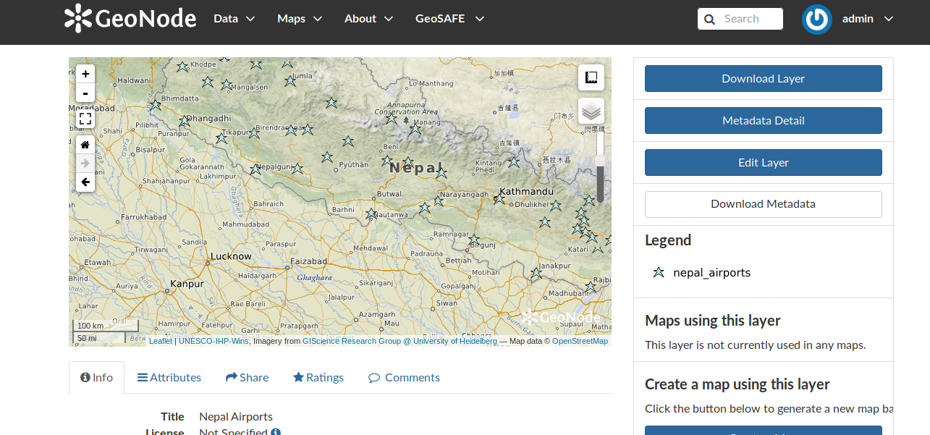
You try
Goal: To upload layers and edit their metadata.

* Prepare your layers in QGIS (Style, CRS and other metadata)
* Right click on the layer and choose export style. Save the style into a format that corresponds to the backend being used.
* Login to your GeoNode instance.
* Navigate to the upload layer page in the Data menu.
* Select the layer you need to upload. (Make sure it is the right layer type and it conforms to the allowed layer formats).
* Include the metadata file if you have one associated with the layer to be uploaded.
* Include the style file if you have one.
* Select preserve metadata option if you have selected the metadata document with the layers and you are satisfied that you have captured all details of your metadata.
* Select ‘Layer Info’ to see your layer in a live web map

Name | Value
Layer type | Raster, Vector
Layer formats for Geoserver | Gdal and Ogr compatible formats
Layer formats for QGIS server | Vector: shapefile  Raster: Geotiff or asc
Backend | Geoserver / QGIS server
Qgis style | .qml used with QGIS server backend
Geoserver style | .sld used with QGIS Geoserver backend
Desktop GIS | QGIS
Metadata file | .xml
Check your results
If you uploaded layers using the preserve metadata tag you should see that the metadata for the layer is not editable. If the preserve metadata flag was not active you should be able to edit the metadata. The loaded layer should be visible in GeoNode layer list and you can proceed to edit properties of the layer like styling etc.

More about GeoNode
GeoNode is an Open Source Geospatial Content Management System which allows us to view geospatial data in the web browser and share the data. GeoNode can ingest most open source vector or raster formats but users are encouraged to check the Gdal and Ogr sources to validate if the data types they have can be used directly in GeoNode. Layers loaded in GeoNode can be enriched by adding detailed metadata which describes the characteristics of the data and its source.


Check your knowledge
- Can a user who is not logged into GeoNode upload their layers?
- Yes, since it’s open source there are no restrictions.
- You need permissions from the owner of the GeoNode instance.
- I am not sure.
- Why is it important to capture metadata for a loaded layer?
- It is not important, because it does not change the spatial accuracy of the data.
- Because it enhances the data quality for users thinking of using your data.
- The attributes are more important than the metadata as people do not see the metadata in a GIS.
- Can I upload a proprietary raster format in GeoNode?
- Yes, as long as it is a raster layer.
- No, because the underlying software cannot read that type of data.
- Yes, if you can view it in QGIS then it is possible.


Further reading:
http://docs.geonode.org/en/master/tutorials/users/managing_layers/upload.html
http://docs.geonode.org/en/master/tutorials/admin/admin_panel/base.html

