
Section: Map Composer
Module : Multi page layouts

Map composer in Context
“Map composer allows you to add elements such as the QGIS map canvas, text labels, images, legends, scalebars, basic shapes, arrows, attribute tables and HTML frames. A user can also add multiple layouts on the same page with maps representing different scenarios”
In this module we look at how to produce a map with multiple layouts.
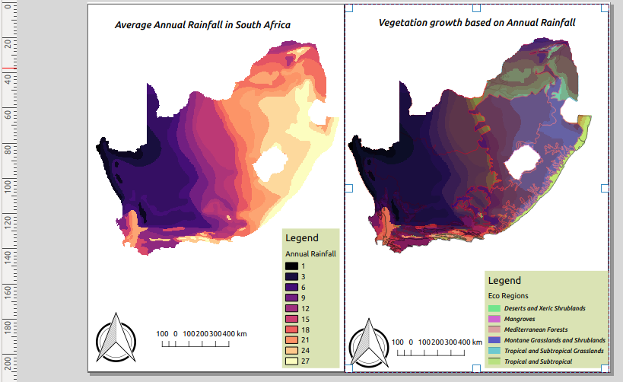
You try:
Goal: To produce maps that incoperates multiple page layouts
* Load the Layers from appendix3-local-data
* Symbolise the raster layer using Raster style
* Arrange the layer and put the vector on top
* Symbolise the vector using Vector style.
* Toggle visibility of the vector layer to off.
* In map composer add a map that covers half of the page. Add the scale bar,north arrow and map frame.
* Add the legend and put a background with color #dae3b4.
* Disable Auto Update on legend items and remove the vector from the legend. (Make the legend nice)
* Toggle lock layer, lock styles for map layers.
* Navigate to QGIS viewer and toggle visibilty on for all layers.
* Add a new map next the already added. Repeat the procedure for adding other map elements like you did for the left map.

Name | Value
Layers | South_Africa_annual_rain.tif ,sa_eco_regions.shp
Raster style | Color ramp:magma,Mode:Equal interval,class range:3
Vector style | Categorized,Column:WWF_MHTNAM,Layer transparency:30,belnding:multiply

More about
Map composer allows users to add elements to a map based on the layers that exist in QGIS map canvas. Because of the ability to lock layer styles and map layers users are able to add multiple layouts with different layers. The same layer can also be added to different map elements using different themes. Locking layer styles and maps also enables user to add overview maps .

One use of creating maps side by side is when creating maps that monitor change detection of either vegetation or urban growth.

Check your knowledge:
- What elements constitute a map:
- Layers with proprer catographic themes.
- Layers,scale bar,map titles and legends.
- Two or more map layouts and map titles.
- Why would you want to have to different map layouts using the same layer:
- To showcase the power of QGIS map composer.
- A monitor migration patterns of birds when using a bird layer.
- For the fun of it.
- What is the maximum number of map layout QGIS can handle:
- 1
- 2
- As many as you can fit on your pages
Answers: 1b, 2b, 3c

Further reading:
https://docs.qgis.org/2.18/en/docs/user_manual/print_composer/composer_items/composer_legend.html
https://docs.qgis.org/2.18/en/docs/user_manual/print_composer/composer_items/composer_legend.html

