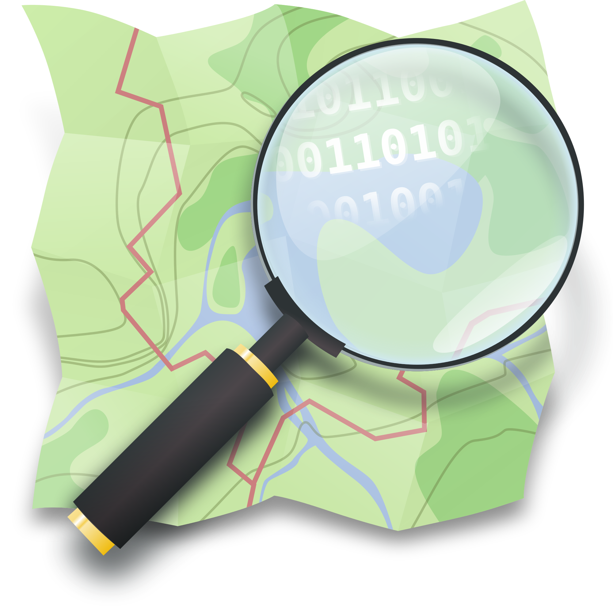
Section: OpenStreetMap
Module : Editing with the iD editor


Start contributing to OpenStreetMap with iD
“The technical overhead of getting involved in OpenStreetMap is very low. In this module we show you how to create and edit OSM data with the iD Web Editor.”
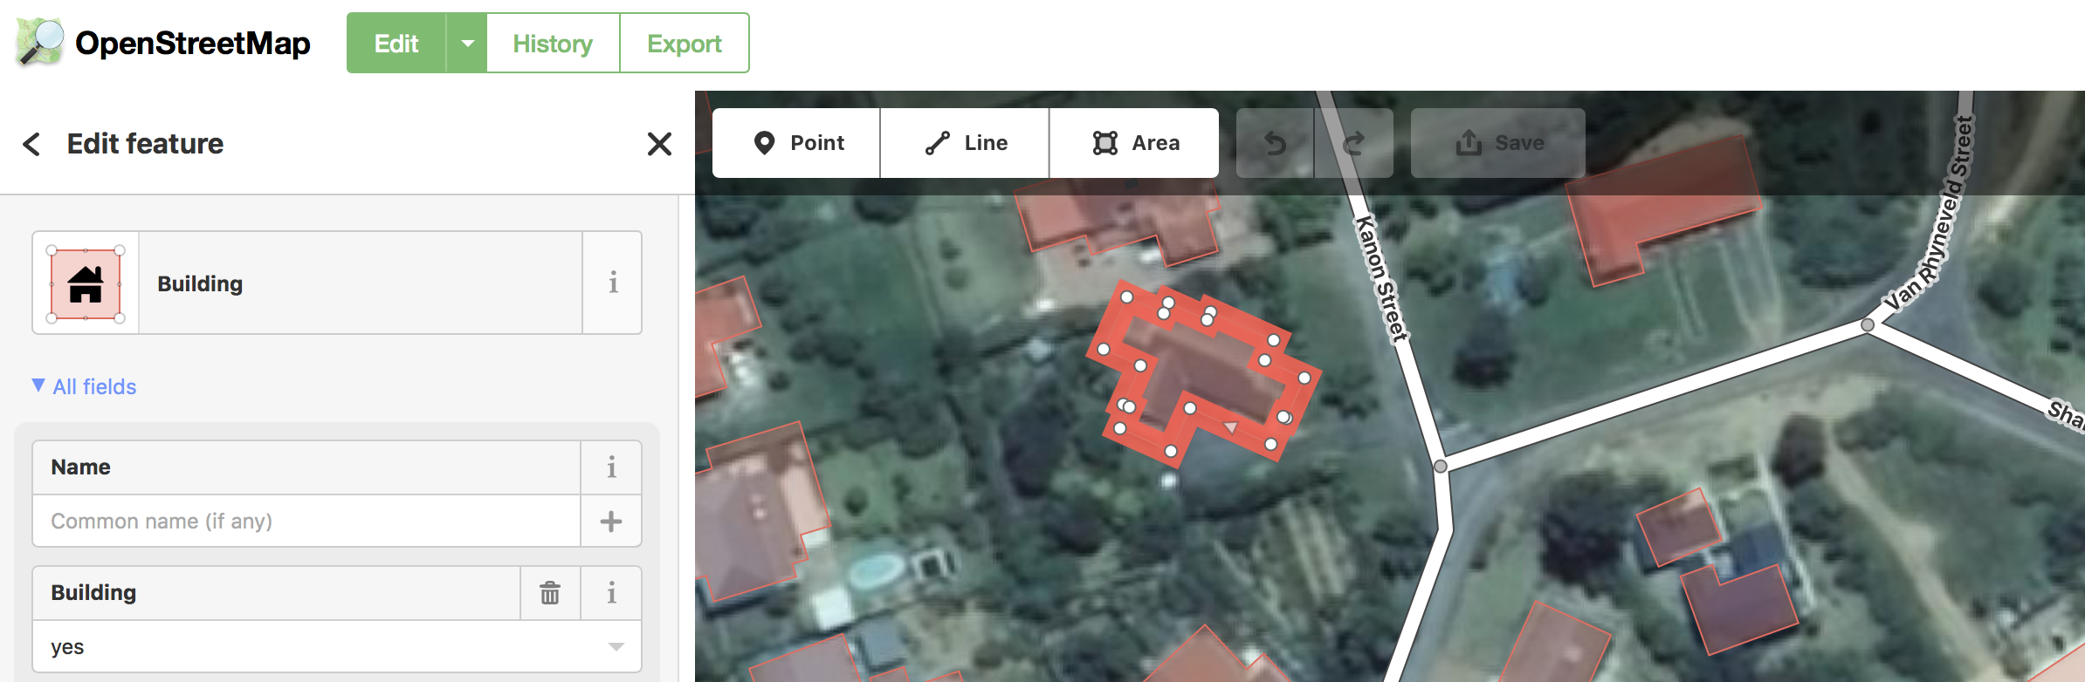
iD is an OpenStreetMap editor that usable in the web-browser with the aim to be simple and friendly. It’s a nice tool to start learning how OSM works, add a few features and to make some quick fixes in the OSM database. Whilst other GIS and OSM editing packages require installation on your desktop and have a large learning curve, iD offers the advantage that you don’t need to install anything.

You try:
Goal: Make your first contribution to OSM.

* Create your OSM account using the link “sign up” on http://www.osm.org.
* You can update some existing features by clicking on a existing object and look its tags. Try to improve these tags if you can.

* Let’s try to update the shape of an existing road by right-clicking on a road and digitize some new ones.

* Don’t forget to save your changes if you are satisfied.

Check your results:
Refresh the main map on osm.org, can you see your new buildings and roads?
Name | Value
Website | http://www.osm.org
Area of Interest | Zoom in where some buildings are missing
Capture type | 
Draw | The footprint of the building, finish your polygon by clicking again on your last point or your start point.
Search | building
Attributes | As much as you know. They all are optionals.
Orthogonalize | Right click on the building, look for the 90 degrees function.
Validate&Save |   Validate with the tick    And save


More about
iD is an online application. It’s convenient because it allows you to do some basic but useful operations, without installing anything on your computer. You can add new features to the database, but you can also update the existing ones to add new attributes or to reshape them.
In iD, there are three kinds of geometries:
- Points can be used to represent features such as shops, restaurants, and monuments. They mark a specific location, and describe what's there.
- Lines are used to represent features such as roads, railroads, and rivers.
- Areas are used to show the boundaries of features like lakes, buildings, and residential areas. They can be also be used for more detailed mapping of many features you might normally map as points.
If you want to learn more how to contribute to OpenStreetMap, you might have a look to another OSM editor called JOSM. Because iD is an online application, it’s difficult for the web-browser to handle a lot of data in memory. So for more complex contributions, we will see that JOSM is a very good to learn too.

Check your knowledge:
- iD is a good tool to?
- Make some small fixes in the database.
- Start contributing when you are in a bad internet area.
- Use when you want to edit a big area with a lot of data already in OSM.

- You would like to add a restaurant on the map:
- You don’t know its name, so you are adding “Restaurant” as the name.
- If you know the shape of the restaurant, you can draw a polygon, otherwise you make a point.

- In iD, you can change the satellite imagery if the default one is not good enough?
- Yes
- No


Further reading:
http://learnosm.org/en/beginner/id-editor/
http://wiki.openstreetmap.org/wiki/ID

