
Section: Attribute table
Module : Managing and querying data

Managing and querying attribute data in Context
“Attribute data is information appended to spatial data or in some instances there is no relation to spatial data. Interrogating the attribute table allows us to answer questions like : How,where and why ?. Understanding attribute table is the bulding blocks for having meaningful symbology.”
In this module we explore the meaning and relationships that occur between features from the attribute table.
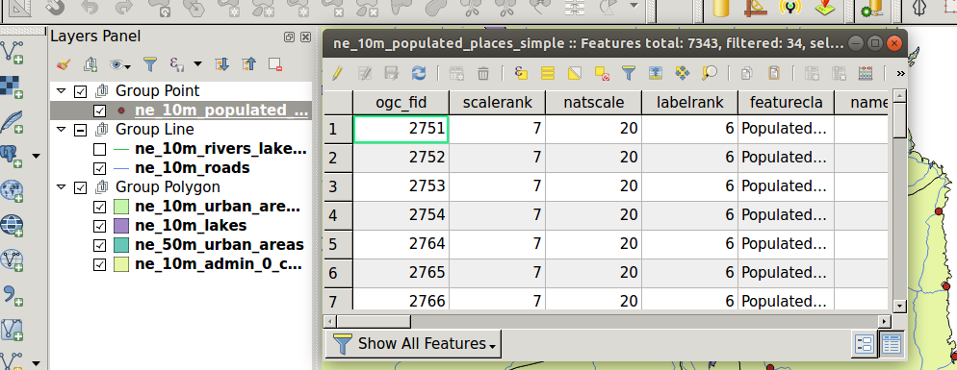
You try:
Goal: To learn attribute table basics and basic query .
Project: appendix3-local-data/attribute.qgs
* Open the project file in QGIS.
* Open the attribute table for populated place.
* Click on the bottom right side to change the view. QGIS has two views table view and form view.
* Click the lower left side to start querying your data.
* Choose show features visible on Map.
* Choose field filter and select the query field
* Filter to show all values in ‘Mozambique’
* Use the advanced filter to select all places with pop_max > 100000.
* Open the rivers lake layer and select all rivers where the river column = 'Lake Centerline'
* Select all rivers that have a name.
* Select all rivers that have a name and ranke column is greater than 5.
How is the GIS redering the features when there is no geometry column in the table ?

Name | Value
Query field | "sov0name"
River column | feature_cla
Rank column | scalerank

More about
By looking at the attribute table a user is able to understand the data and establish patterns that occurs. When querying attribute table a user uses expressions to select the features meeting a specific criteria. Expressions in QGIs are widely used and it is encouraged to master them in order to interpret the data concisely.

Check your knowledge:
- What is symbology:
- A GIS technique that is used on raster layers.
- The representation of point with graphic features.
- A vector type that is only available in the open source world.
- Which of these is following statements is true.:
- Attribute table are separate entities to the features shown in the map area.
- The geometry of features is always visible in an atribute table.
- An attribute table does not show the geometry column.
- Does raster data have attribute table ?:
- True
- False
Answers: 1c, 2b, 3f

Further reading:
https://docs.qgis.org/2.18/en/docs/user_manual/working_with_vector/attribute_table.html
https://docs.qgis.org/2.18/en/docs/user_manual/working_with_vector/expression.html

