
Section: InaSAFE Basics
Module : Understanding hazard data


Hazards in Context
“Hazard data are GIS or other datasets that represent a natural or man made phenomenon that can adversely impact on people, land and infrastructure.”
In this module we review the different types of hazard data that can be used in InaSAFE and the preparation process that needs to be carried out before hazard data can be used in an InaSAFE analysis.
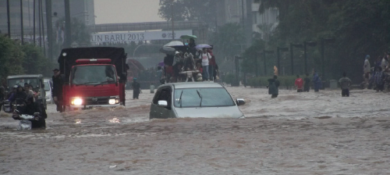

You try:
Goal: To learn to load a hazard layer in QGIS and assign its keywords
With QGIS open and the browser panel active, open the tsunami.tif dataset in the hazards folder.
Ensure the layer is visible in your map by panning / zooming / adjusting the layer order.
Use the keywords editor tool that ships with InaSAFE to defined the keywords as listed below
Check your results:
Once the keywords have been defined for a hazard layer you should notice that:
The layer details in the InaSAFE dock get displayed when you click on the layer.
The layer title is shown in the ‘in the event of’ combo in the dock question area.

Name | Value
Type | Hazard
Classified or continuous ? | Continuous
Units | m
Source | DFAT
Title | A tsunami like in 2006

More about the concept of hazards
In the context of InaSAFE a hazard is any natural or human caused event or series of events that may negatively impact the population, infrastructure or resources in an area. Some examples are:
It is important to note that InaSAFE is not a hazard modelling tool. That means that you need to source your hazard data from elsewhere and bring it along ready to use in InaSAFE.

Continuous vs. classified data?
We differentiate between data which is continuous and data which is classified. The terms can be applied equally to both hazard and exposure data. Continuous data represent a continuously varying phenomenon such as depth in meters, population counts and so on. Classified data represent named groups of values, for example, high, medium and low danger. Grouping values works well when you wish to reduce data preparation complexity or deal with local variances in the interpretation of data. For example, a flood depth of 50cm may represent a high hazard zone in an area where people commonly have basements in their houses, and a low hazard zone in areas where people commonly build their houses on raised platforms.


Check your knowledge:
- A hazard is:
- Something that will interrupt human activity like a pothole in a road
- A problem caused by human activities such as poor construction techniques in buildings
- A GIS dataset representing a natural phenomenon that will negatively impact people, land or infrastructure
- Which of these is classified hazard data:
- A GIS raster dataset where each pixel represents the depth of a flood
- A GIS vector dataset where each polygon represents an area of high, medium or low flood depth
- A GIS vector dataset where each polygon represents a building with high, medium or low occupancy rate
- InaSAFE is a tool for creating hazard data:
- True
- False
Answers: 1c, 2b, 3f


Further reading:
You can read more about hazard data at http://foo.bar

