
Section: Processing
Module :Processing Script

Python Scripts in Context
““Geoprocessing involves running a series of steps in order to achieve a specific outcome. The python framework in QGIS introduces tools which can be combined with existing geoprocessing algorithm to solve spatial problem. Because of the ease and flexibility of python features are easy to iterate and process them. The processing module introduces scripts which are written in python”

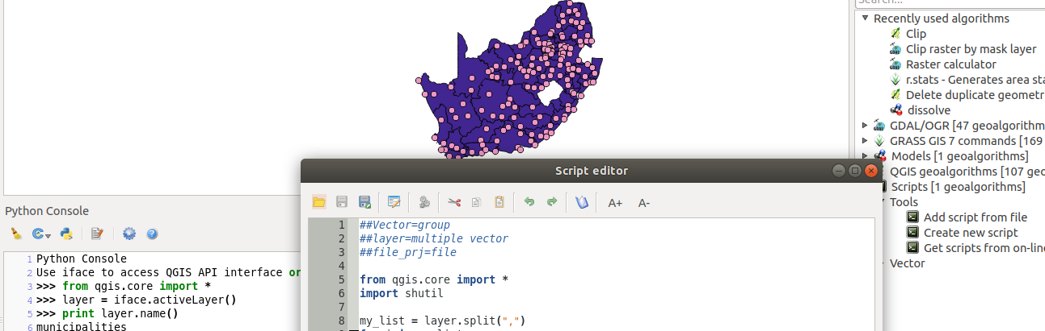
You try:
Goal: Write a python script that iterates a polygon layer and dissolve features matching an expression
NB: Load the geoprocessing project.
* Activate the python terminal.
* Select the polygon layer to make it active.
* Using the python terminal access the polygon layer and iterate over the features. Example
from qgis.core import *
poly_layer = iface.activeLayer()
Print poly_layer.name()
Do something with the layer
* In the Processing Menu activate the toolbox.
*Create a new script that selects the unique values in the “province” column and use them to select features from the polygon layer and dissolve the selected features.
Use the processing algorithms specified

Name | Value
data | Municipalities,cities_and_towns
Processing algorithm | select by expression,dissolve

More about
Python is an open source programming language which can be used in QGIS natively or in combination with the processing algorithms. Writing scripts in the processing toolbox allows a user to extent the functionalities that are offered by QGIS by adding logic in python.

The processing scripts allow a user to define dialogue which are used for inputs and outputs. The scripts are interoperable with other tools already loaded in the processing toolbox. Complex problems which are difficult to solve by using the standard GUI options in QGIS can be easily done programmatically. Processing scripts can be integrated into the QGIS Graphical Modeller for managing situations not covered by the default tools.

Processing scripts typically consist of three main sections.

Inputs – These begin with ## and provide information that is needed to turn the code into an algorithm that can be run from any GUI components.

Code – The actual code that has all the login to access the inputs and produce an output.

Outputs – For saving the final results of processing. These can be either a specific path or a temporary path where a fixed output path is not defined. i.e. output raster

Check your knowledge:
- Which of the following statements is true:
- Processing scripts only uses layers loaded in QGIS.
- Python is a type of data source available in QGIS.
- Scripting enhances processing data as it adds extra functions not available in QGIS.
- Is it possible to run a python script from outside QGIS e.g. Using an IDE:
- Scripts need to access layers which are loaded in the QGIS..
- Only after modifying the script so that it does not try to access QGIS GUI components.
- It is not possible under any circumstance.
- Processing scripts can also be written in C ++ language:
- True
- False
Answers: 1c, 2b, 3f

Further reading:
http://docs.qgis.org/2.14/en/docs/user_manual/processing/modeler.html
https://docs.qgis.org/2.14/en/docs/user_manual/processing/scripts.html

