
Section: InaSAFE
Module : Exposure


Exposure in InaSAFE

“In the context of InaSAFE, exposure refers to people, infrastructure or land areas that may be affected by a disaster.”
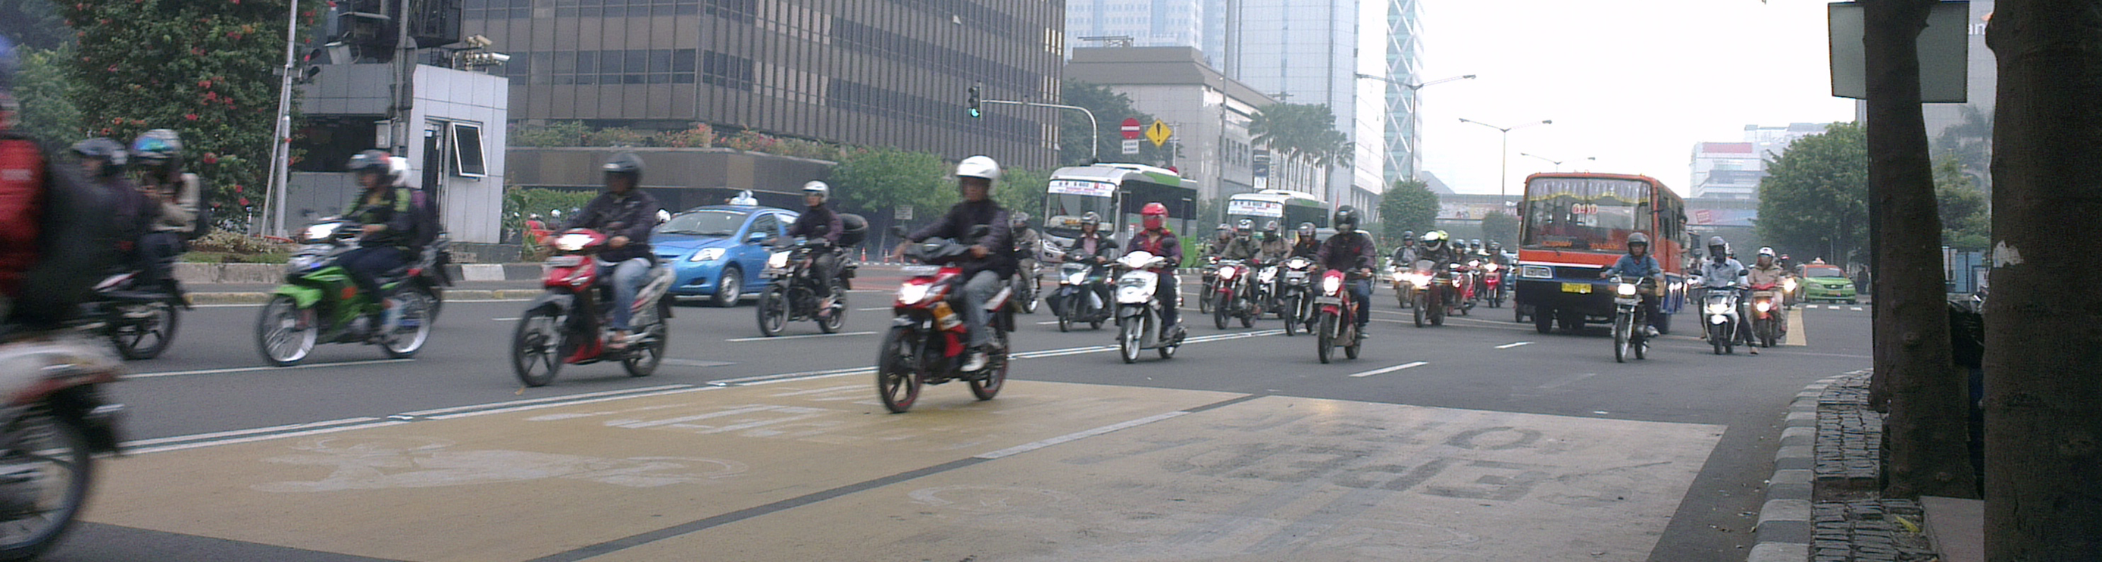
Currently InaSAFE supports these kinds of exposure data: population / people, roads, buildings, places, landcover. Exposure datasets need to comply with these modes and geometries:
Exposure Modes | Exposure Geometries
a) Continuous data | c) Vector points | e) Vector polygons
b) Classified data | d) Vector lines | f) Single band rasters

You try:
Goal: To be able to identify suitable data for use in InaSAFE.
Complete the table on the right by indicating one example exposure type for each geometry type and mode. The first entry has been completed for you as an example.

Check your results:
Swap your list with the person next to you and see if they had any different ideas about which constitute valid exposure data.
Dataset | Example
Continuous data | Population areas
Classified data
Vector points
Vector lines
Vector Polygons
Single band rasters

More about exposure
In many ways exposure data is easier to map and to obtain then hazard data. OpenStreetmap, for example, contains a massive archive of global roads and building footprints. You should be aware however that these data are often incomplete (e.g. not every building has been digitised yet in OSM) or estimages (e.g. population data). InaSAFE will always convert raster datasets (i.e. population data) to vector polygon data for the analysis. Currently the only supported raster exposure format is population data.
Categorical vector data will need to be ‘value mapped’ into standard categories in InaSAFE. For example if you have building data you will need to indicate which types of building are present in the dataset according to InaSAFE’s built in categories. Similarly for roads, you will need to indicate how the roads types in your data map to standard InaSAFE concepts such as ‘Highway’, ‘Residential Street’ etc. In InaSAFE you will need to understand the basic concepts of an exposure dataset so that you can correctly create metadata for them. InaSAFE relies on this metadata in order to determine what processing steps need to be carried out during the analysis.
Generally we use a ‘fit for purpose’ approach in InaSAFE and advise that exposure data do not need to be engineering quality (i.e. accurate to within a few mm). You should however make every effort possible to ensure that the exposure data is qualitatively, temporally and spatial accurate within the limits of what your time and budget allow.


Check your knowledge:
- Exposure data in InaSAFE can be easily downloaded from OpenStreetMap.
- true
- false
- Mark all the correct statements:
- InaSAFE requires engineering quality exposure data in order to function properly
- Exposure data is often easy to obtain from OpenStreetMap
- It helps if exposure data is up to date and as complete as possible
Answers:


Further reading:
See the detailed overview of InaSAFE exposures in the tutorials folder.
See the exposures section in the InaSAFE technical documentation at: http://manual.inasafe.org/en/index.html#exposures or in the application help.

