
Section:VectorAnalysis
Module :Population Density


Population dot density in Context
“Population distribution describes a way in which people are spread across the earth surface. Population distribution is usually shown by a dot density map where each dot represent a certain number of people. Dot density maps are useful indicators as they show the general characteristics of distribution as well as areas of high and low density”
In this module we will learn how to create a dot density map.

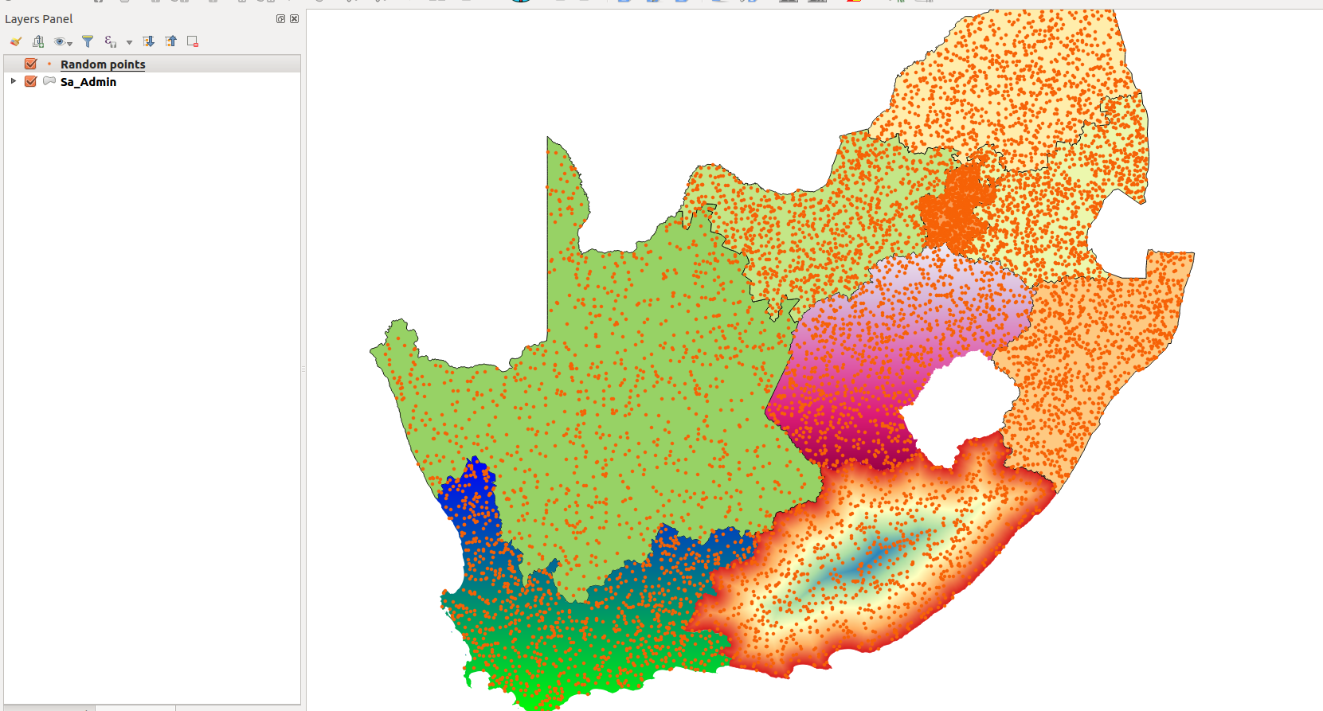
You try:.
Goal: To understand how to produce population density maps. Create a dot density map where 1 dot represents 1000 people.
Data: appendix3-local-data-district.shp,kzn_population.csv
To Do:
* Load the layers into a new project.
* Open the layer districts and create a join. Use the join field.
* Join to the specified join fields.
* Reproject the district layer to the specified CRS to make the join permanent.
* Use the spatial algorithm to create the random points.
* Symbolise the resultant point layer and create a legend that shows your results.

Name | Value
CRS | South African CRS : HBK_NO_29
Join column | District:code
Spatial algorithm | Random Points
Join fields | area_km,density,population_2016

More about dot density maps
Dot density maps are effective at showing density variations on geographic landscapes.
Dot maps are advantageous when mapping phenomena that change smoothly over a space, as the dot maps will visually match the phenomena. There are mainly two type of dot density maps namely one-to-one and one-to-many dot maps.

Dot density maps can be used in conjunction with other thematic maps to understand phenomena that occurs across the earth surface.


Check your knowledge:
- What is it useful to know population distribution:
- Because it will interrupt human activity like a farming
- For planning purpose, resources use against people
- It does not matter as long as we know the population density
- What is population distribution and how is it represented in a GIS:
- A type of gis dataset that shows how people behave
- The spread of people across the terrain
- Spread of points in a vector layer
- Is population distribution a type of dataset:
- True
- False
Answers: 1b, 2b, 3f


Further reading:
http://docs.qgis.org/2.14/en/docs/user_manual/processing_algs/qgis/vector_creation_tools.html#random-points-inside-polygons-fixed
http://smsgis.co.za/qgis-population-density-tutorial/

