
Section: Introduction
Module : Vector data formats:Basics


Vector data formats in Context
“Vector data is a representation of the world using points lines and polygons. A GIS file is a standard way for encoding geographical data into a computer file.”
In this module we will explore the various vector formats that can be utilized in a GIS.

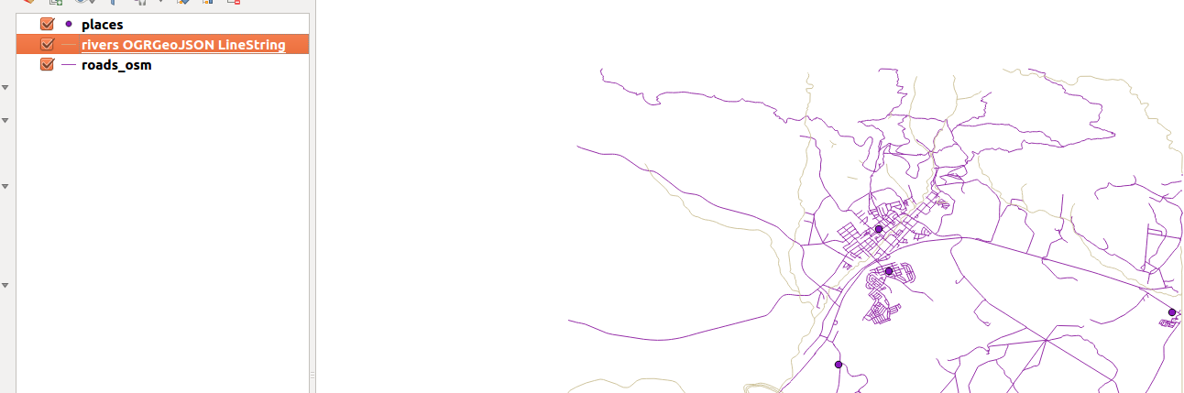
You try:
Goal: To learn how to load various vetcor data formats in QGIS
* Open a new project and load the specied layers from appendix3-local-data
* Click on add vector panel.
* Browse to path containing data and filter based on the type of data you want to load.
* Choose shapefile when loading roads_osm.
* Choose geojson when adding rivers_osm.
* Choose add delimited text layer and select places_osm.
* Select the appropriate column to use as x and y field.

Check your results:
Once you have finished you should have all the layers added in QGIS all coming from various data formats

Name | Value
Layer | places_osm.csv,rivers_osm.geojson,roads_osm.shp
Panel | Add vector,QGIS browser,Delimited text Layer

More about
QGIS uses gdal(http://www.gdal.org/) to read and write vector data. There are various data formats that gdal supports. For a full list of data formats that QGIS supports read http://www.gdal.org/ogr/ogr_formats.html . Vector data can also be loaded in read mode from zip and gzip archives into QGIS.


Check your knowledge:
- When loading a shapefile into QGIS what is the extension of the file that is generally loaded into QGIS:
- .shx
- .prj
- .shp
- What happens when a user loads a file with a .dbf extension during loading a shapefile:
- QGIS will show an error message as the data type is not supported.
- QGIS will render the layer as a non spatial layer.
- QGIS will crash.
- Can you load a spreadsheet with latitude and longitude as a spatial layer in QGIS:
- True
- False
Answers: 1c, 2b, 3t


Further reading:
https://docs.qgis.org/2.14/en/docs/user_manual/working_with_vector/supported_data.html

