
Section: Analysis
Module : Vector Analysis


Spatial analysis in Context
“Spatial analysis is the process of analyzing the relationship between locations, attributes, and the relationship of features through analytical techniques. Spatial analysis defines the relationship between features based on the topology, geometric and geographic properties of the features.”

In this module looks at a variety of spatial analysis techniques that can be used to answer geographic questions.

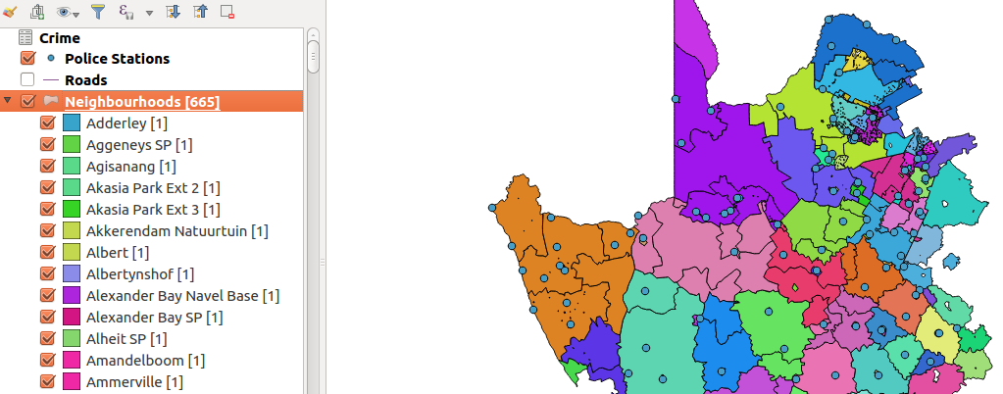

You try:
Problem: You are a resident of a neighbourhood and have been provided with crime data and police stations data. Use the datasets to answer interesting questions about your area.
Data: crime.csv,police_stations.csv,roads, districts.shp from appendix3-local-data
* Load the police_stations.csv as a spatial layer.
* Add roads from natural earth data,districts.shp
* Filter all the layers to show features that are within the districts layer.
* Update the crime layer. Use field calculator to update the name column using the expression.
Questions:
* How many police stations occur within the each district. Use the count algorithm.
* What is the length of each road. Use a suitable area expression based on CRS of layer.
* what is the total length of all roads in each district. (Sum algorithm)
* Using the crime statistics show how each crime category has varied of over the years. (join crime to police_stations and create a diagram for each crime type against year)
* Which district is the safest according to each type of crime.

Name | Value
Count Algorithm | Points In polygon
Sum Algorithm | Sum line lenghts
Area expression | $area or area($geometry)
Diagram | Bar Chart
Expression | Upper("name" )

More about
When doing spatial analysis, all layers have to be projected to the same CRS. Spatial analysis is the heart of GIS and it allows creating new derived data that can answer geographic questions. A lot of geometric processes can be done in QGIS and also spatial databases help in solving other problems better. There many tools that can be used to achieve a certain task so it is imperative to use the best tool that requires minimum steps to achieve the results.


Check your knowledge:
- What is the use of spatial analysis:
- To create new data
- To interpret problems and provide useful information
- Viewing raster data and symbolize it
- Which of these is an example of spatial operation:
- Assigning colour symbols to a vector layer
- Assigning colour symbols to a raster layer
- An administrative polygon that has been clipped to show a subset of the data
- Is a csv a type raster data:
- True
- False
Answers: 1c, 2c, 3f


Further reading:
https://docs.qgis.org/2.14/en/docs/user_manual/processing_algs/qgis/vector_analysis_tools.html#sum-line-lengths
https://docs.qgis.org/2.14/en/docs/user_manual/working_with_vector/virtual_layers.html

