
Section:Processing
Module :Graphical Modeller


Graphical Modeller in Context
“GIS work flow typically consist of running multiple steps before reaching a solution. This is cumbersome in situations where you have to do it over again. The graphical modeller is useful for defining work flows and running it multiple times with different parameters.”
In this module we will build upon the concepts we covered in module qgis_intersect.

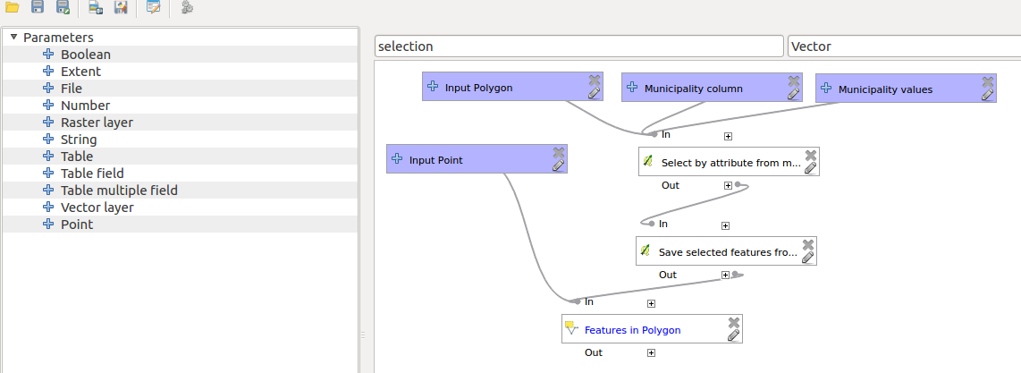
You try:
Goal: To update points (cities and towns) that lie within the each aggregate municipality layer with a column that depict the location of the town relative to the municipality. E.g. all towns within Western cape should be update ‘province=WC’
NB:Revisit the module qgis_intersect to understand the problem.
* Open the project geoprocessing from appendix3 data.
* Activate processing toolbox
* Activate the graphical modeller and choose open modeller and open update.model from appendix3-local-data
* Edit the model so that you can finish updating points in each aggregate municipality
With the name of the municipality.
* Save the model when you are done.
* A new category should now appear under models.
* Right click on the model and choose run as batch process.
* Execute for all the provinces in South Africa

Name | Value
Layers | cities_and_towns /municipalities
model | Update.model

More about
Models are very powerful as they allow GIS task to be easily automated. When creating models it is important to parametrize most things so that the algorithm can be generic and be run in multiple scenarios. Models can also be run as single algorithm or can be executed as a batch processed which allows multiple scenarios to be executed at the same time.


Check your knowledge:
- Which of the following statements is true:
- You can run algorithms from external programs in the modeller.
- Rasters cannot be used in the modeller.
- When would a user be able to use a model:
- In any situation when a task involved involve a series of steps to achieve a result.
- When digitizing vector data.
- To showcase the ability of a GIS to do complex task.
- Is a graphical model only available in QGIS:
- True
- False
Answers: 1c, 2b, 3f


Further reading:
http://docs.qgis.org/2.14/en/docs/user_manual/processing/modeler.html
http://docs.qgis.org/2.14/en/docs/user_manual/processing/index.html

