
Section:
Module :


in Context
“”
In this module we
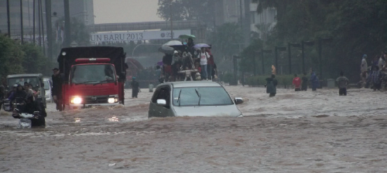

You try:
Goal: To learn
With ...
Check your results:
Once

Name | Value

More about
In


Check your knowledge:
- A hazard is:
- Something that will interrupt human activity like a pothole in a road
- A problem caused by human activities such as poor construction techniques in buildings
- A GIS dataset representing a natural phenomenon that will negatively impact people, land or infrastructure
- Which of these is classified hazard data:
- A GIS raster dataset where each pixel represents the depth of a flood
- A GIS vector dataset where each polygon represents an area of high, medium or low flood depth
- A GIS vector dataset where each polygon represents a building with high, medium or low occupancy rate
- InaSAFE is a tool for creating hazard data:
- True
- False
Answers: 1c, 2b, 3f


Further reading:
You can read more about

