Standard operating procedure
Uploading of data into CKAN and GCP

Table of Contents
Introduction 2
Data formats 2
CSV 2
Shapefile 4
Raster 4
Compressed files 4

Introduction
This guide will supply the user with instructions and standards which will be best to adhere to when uploading data using CKAN into Google cloud platform (GCP). Following this guide will allow erroneous loads in GCP (e.g. table in BigQuery from a CSV file), and will make the user’s data uploading as smooth as possible.
The first section deal with data formats.

Data formats
The amount of rules or standards a user will need to follow depends on the format. For instance a shapefile contains the field type for each field, but this is not the case with CSV files as its a text-based format.

CSV
A CSV is a delimited text file, which uses a text character (e.g. “,”, “;”, tabs, spaces, etc.) to separate columns in different columns. XYZ can also be seen as a text delimited format using a comma as the delimiter.
The example which follows (Figure 1) shows a CSV file which stores data with a comma (“,”) is the delimiter. Therefore “1950/01/01” goes with the “DTE” column, “19.300” with longitude, and so on.
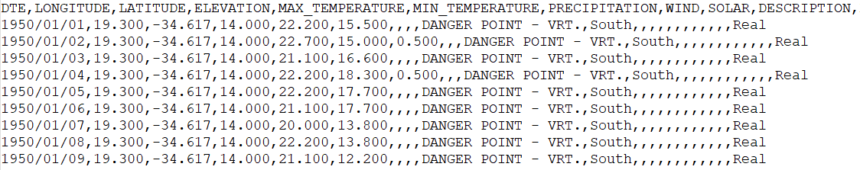Figure 1: CSV file example
When uploading a CSV file through CKAN it goes into a GCP bucket, which then automatically triggers a function which will load the table from the CSV into BigQuery. The code will also parse the CSV data, which attempts to remove any unwanted characters and automatically determines the field type (e.g. float, string, etc.). The parsing will do the following:
- Remove any spaces, tabs, and newlines from numeric columns;
- Replace spaces and other non-alphanumeric characters with “_” in field names;
- If any numeric value cannot be converted to a numeric type, that field will be set as type string;
- Spaces, and non-numeric characters will not be removed from string;
- Set a column to type date. BigQuery requires “YYYY-MM-DD”;
- Check the number of values of a row agrees with the number of field names at the first row of the CSV file;
- If a field name start with a numeric character, “_” will be added to the start of the field name;
- Empty fields will be left as-is. BigQuery sees such cases as “null”; and
- Store the parsed data in BigQuery as a table.
Table 1 shows examples of possible updates the CSV parses will perform before loading the CSV file into BigQuery.
Table 1: Examples of possible changes the CSV parser will implement
Type | Value | Updated value | Description
Field name | max temperature | max_temperature | Space removed
Field name | 123_precipitation | _123_precipitation | Starts with numeric characters
Field name | rainfall# | rainfall_ | Unwanted character removed
Numeric | 30 000 | 30000 | Space removed
Date | 2019/01/15 | 2019-01-15 | Date converted to BigQuery format
String | Danger point | Danger point | No changes, as its a string
Empty |  |  | This will be null in a BigQuery table

To be as robust as possible, it will be best for the user to make sure there are no issues in the CSV file itself. For instance, if a field should be numeric, but there is row which has a value “One”, then it will be set as a string – because BigQuery only allows numeric values (“5”, “10.6”, etc.) for numeric, there is no other option but to set this to string. Here is some best practice rules a user can follow when working with CSV files:
- Always use a comma (“,”) as the delimiter for CSV files. Not using a comma will cause issues and erroneous results in BigQuery;
- Field names:
  - Make use of short but descriptive field names. For instance, “PREC” for “precipitation” will not be good practice;
  - Avoid spaces and tabs in field names;
  - Field names should not start with numeric characters
- Field contents:
  - Be sure there are no alphabet characters or other non-numeric characters (e.g. “$”, “#”, etc.) in the field contents if it should be a numeric field;
  - Dates should always be YYYY-MM-DD (e.g. 2006-01-15);
  - Do not use YYYYMMDD (e.g. 20060115) as its difficult to automatically distinguish such values from normal numeric values;
  - Commas should not be used in field contents, because its the CSV file delimiter. This will result in a row not containing the correct number of values;
  - Empty values should be avoided if possible

Shapefile

Raster
The user can upload any rasters format (tif, PNG, etc.). Code will trigger once the raster has been stored in the bucket, which will convert the raster to a cloud optimized GeoTIFF, or COG. COGs stores the raster in tiles, where only the tiles being displayed by the user will be displays. This optimizes performance, especially for online use. For a more detailed description on COGs, see https://www.element84.com/blog/cloud-optimized-geotiff-vs-the-meta-raster-format.
Here is some rules for when uploading raster files:
- Always be sure to upload a raster which has its coordinate system correctly set;
- The raster is georeferenced;
- Avoid empty rasters;
- Avoid too large rasters (e.g. rasters can easily exceed 50GB+);

Compressed files
Currently only ZIP files are allowed for upload. When a ZIP file is stored in a bucket the code will, trigger. This code will automatically extract all the files stored in the ZIP, which will then be stored in the same bucket. When this data is stored in the bucket, it will again trigger the code. The code will then parse each file as usual – basically as if the user uploaded each file in the compressed file individually.

