GeoSAFE
with InaSAFE 4.4
Documentation
November 2018
Table of Contents
1 Overview 1
1.1 Release Changelogs 1
1.2 GeoSAFE components 2
1.3 GeoSAFE Glossary 2
2 Objectives 2
2.1 Online scenario contingency planning 2
2.2 Catalogue of disaster-related data 2
3 Preparing data 3
4 Using GeoSAFE 3
4.1 MetaSearch 4
4.2 Analysis List 5
4.3 Create Analysis 5
5 Appendix 1: Resource links 8
6 Appendix 2: YouTube videos and walkthroughs: 9
7 Appendix 3: Technical documentation 10
7.1 Translation 10
7.2 Orchestration or devops 10

Overview
This is the user manual and documentation for the web version of InaSAFE, called GeoSAFE. It runs as a Django App in a recent extension of GeoNode that uses a QGIS server back-end instead of GeoServer.
This document focuses on GeoSAFE and does not repeat documentation from the components underlying the GeoSAFE stack.

Release Changelogs
Highlights of the latest release can be viewed in the GeoNode and GeoSAFE changelogs
- http://changelog.kartoza.com/geonode
- http://changelog.kartoza.com/geosafe

GeoSAFE components
GeoNode is an open source project that provides a geospatial Content Management System (CMS) on the web. See http://geonode.org for details and documentation.
QGIS is an open source Geographical Information System (GIS) that is usually run as a desktop application but can also be a headless server application, which is how it is used in GeoSAFE. See http://qgis.org for details.
InaSAFE is free software that produces realistic natural hazard impact scenarios for better planning, preparedness and response activities. It provides a simple but rigorous way to combine data from scientists, local governments and communities to provide insights into the likely impacts of future disaster events. It is available as a QGIS Python plugin. See http://inasafe.org for details and documentation.

GeoSAFE Glossary
- Hazard layer: A spatial data set representing a natural hazard such as a flood, usually classified in some way to show the severity of the hazard, such as water depth.
- Exposure layer: A spatial data set representing something that might be exposed to a hazard, such as buildings, roads or human population.
- Aggregation layer: A spatial data set representing units of analysis, such as administrative boundaries. It both constrains the analysis area and results in reports with breakdowns per aggregation unit.
- Impact layer: A spatial data set that is generated by GeoSAFE after an analysis run. It shows the exposure data classified by the hazard classes it was exposed to.

Objectives
GeoSAFE is intended as a simple, free, accessible online platform where anyone can investigate natural disaster scenarios.

Online scenario contingency planning
In the Analysis component of GeoSAFE you can run your own disaster impact scenarios at your choice of location, or view scenarios that other people have created. GeoSAFE combines hazard and exposure data sets that you choose from those loaded on the system. It uses InaSAFE to run an impact analysis and outputs reports and an impact data set.

Catalogue of disaster-related data
The GeoNode component of GeoSAFE provides a catalogue of hazard, exposure, aggregation, impact and related vector or raster geospatial data sets that you can browse and search. You have access to full GeoNode functionality. Depending on your user role, you can upload data, download data, style layers, use web map services, edit metadata and more.
Any data set in GeoNode that has valid InaSAFE 4 keywords in its metadata will be available in the Analysis component for you to run online InaSAFE analyses.

Preparing data
To run a GeoSAFE analysis you need a hazard layer and an exposure layer and optionally, an aggregation layer. You might find the layers you want on an existing GeoSAFE instance, in which case you can choose them directly.
If you do not have either layer you will need to prepare and upload your own datasets.
GeoSAFE supports these formats:
- vector data
  - shape files
  - GeoJSON
  - QGIS layer file (.qlr) as long as it defines a valid vector data source that is accessible from the server. It was added specifically to support PostGIS layers in docker-osm (for roads and buildings in Mozambique).
- raster data
  - GeoTIFF (.tif)
  - ASCII (.asc)
  - QGIS layer file (.qlr) as long as it defines a valid raster data source that is accessible from the server.
Other requirements
- a properly defined CRS (coordinate reference system) that references a valid EPSG code
- valid data fields that InaSAFE can use (see InaSAFE documentation)
- An ISO 19115 compliant XML metadata document with the same name as the data file
  - this must contain InaSAFE keywords as XML in the Supplemental Information element
    - these must be InaSAFE version 4 keywords
How do I generate the InaSAFE keywords?
- Create your keywords in QGIS 2.18 using the latest InaSAFE 4.x plugin.
- OR view or edit the metadata from another layer on the GeoNode instance you are using and copy the contents of the Supplemental Information field (the XML snippet with the InaSAFE keywords) onto the clipboard. Then, paste them into your layer’s Supplemental Information metadata field using the QGIS Metatools plugin and then Save and export the metadata document and upload it to GeoNode to replace the old metadata document.
If your layer uploaded successfully and it has valid metadata, GeoSAFE will detect that and it will make your layer available for analysis in GeoSAFE.

Using GeoSAFE
If GeoSAFE is enabled on your GeoNode, you will see a GeoSAFE menu

Click it and you’ll see
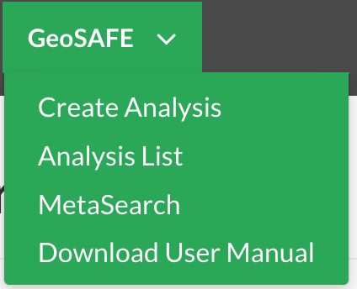
To run GeoSAFE you’ll want to choose ‘Create Analysis’.

Create Analysis
This option takes you to the GeoSAFE page, which is a single-page, self-contained application.
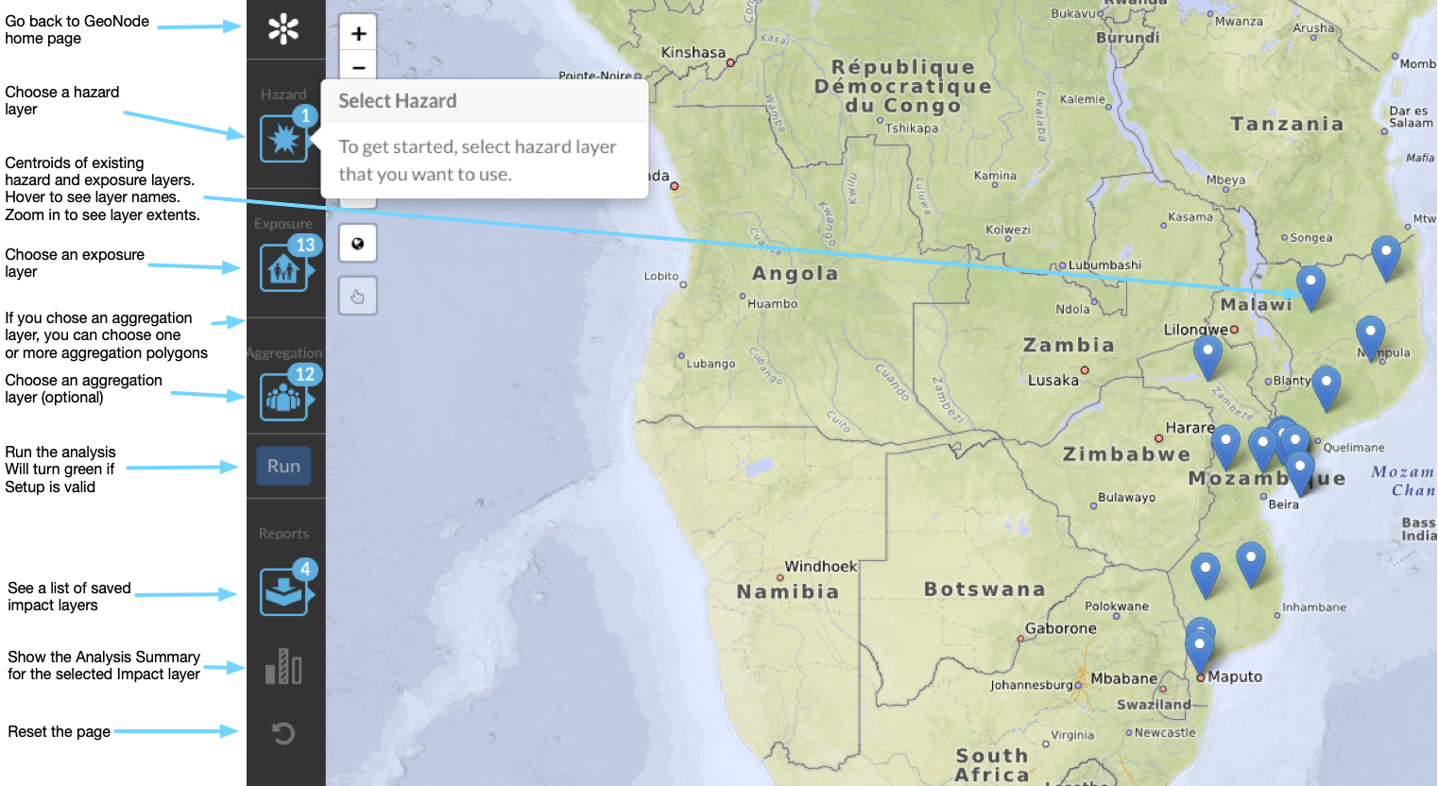
- Zoom and pan to your area of interest
  - available layers will be filtered to your view extent
- Choose a hazard layer
- Choose an exposure layer
- Choose an aggregation layer (optional)
  - If you don’t choose an aggregation layer, the analysis will run on the intersection of the view extent, the hazard layer and the exposure layer
  - If you do choose an aggregation layer the above extent will be constrained to the outer boundary of the aggregation layer and the analysis will be run separately on each aggregation polygon and then aggregated. Reports will also show results broken down by aggregation polygon.
  - Select one or more aggregation layer polygons (optional)
    - This will constrain the analysis further to run only on the selected polygons
- Run the analysis
- Wait for the analysis to complete. Large areas or high-resolution input data will result in a longer analysis time.
  - In the meantime, you can close the message window and set up other analyses, explore other analysis results or explore other layers and maps in GeoNode.
  - Go to the Analysis List occasionally to check on the progress of your analysis.
  - If you are logged in you will also receive an email notifying you of progress.
- View the results in the Impact Summary where you can follow links to download the Impact Layer or view or download the Impact or Table reports.
- The Impact Layer is just another GeoNode layer that GeoSAFE loaded into GeoNode automatically so you can interact with it and use it like any other layer.

Analysis List
This shows the list of previous analyses run on this server, that were run by logged-in users who chose to save their analysis.
The success or otherwise of each analysis is reported on and all the products of an analysis are available for view or download.
You can also go to this page after running your own analysis either to retrieve the results or to check on the progress of your analysis.
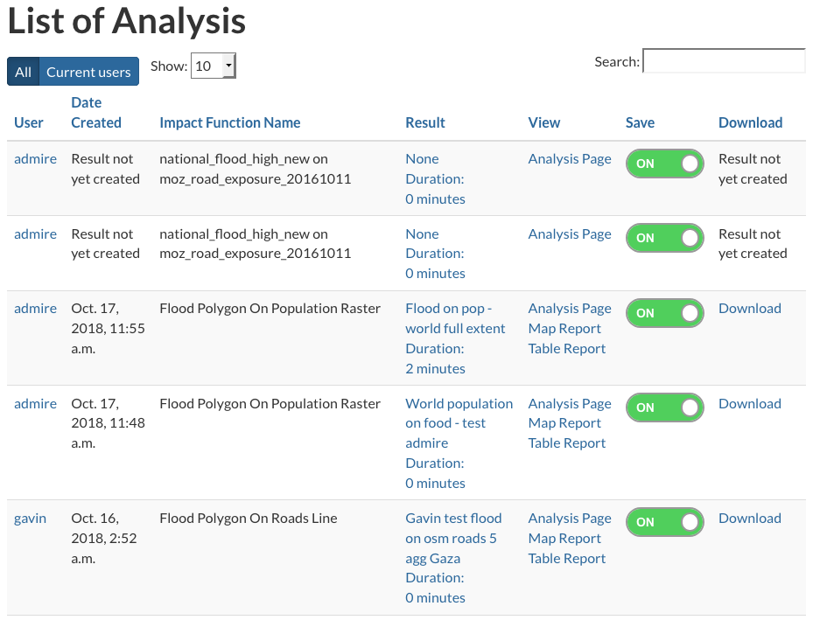

MetaSearch
If you know of a remote metadata catalogue server that supports the OGC CSW protocol and is likely to have metadata records containing WCS or WFS resource links for hazard or exposure layers, then enter the CSW service url and any search terms you want and hit ‘Submit’.
If successful it will
- return a list of remote layers
- indicate whether each layer is a valid InaSAFE layer (i.e. with keywords) or not
- allow you to further inspect a layer’s metadata or add the layer
  - adding the layer fetches it via WCS or WFS and loads it into your local GeoNode
  - if it is a valid InaSAFE layer it will then be available for GeoSAFE analyses on your server
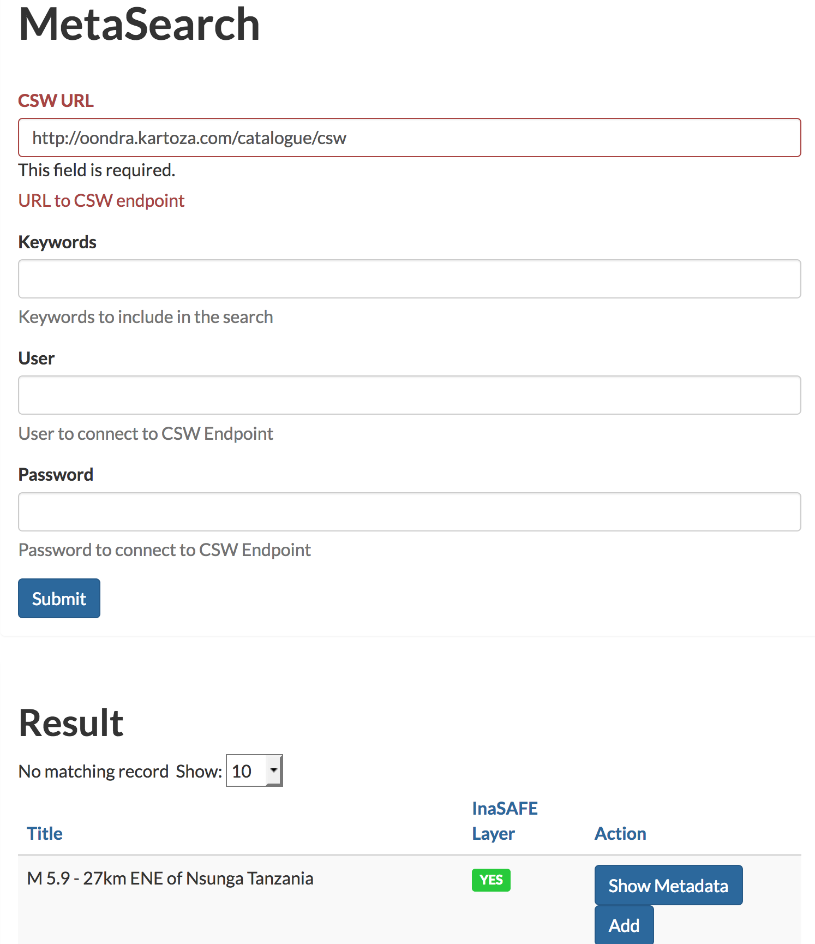

Appendix 1: Resource links
All work carried out for this project is open source and is available on GitHub. Repositories contributed to in this project are listed below.
- GeoSAFE application for GeoNode: https://github.com/kartoza/geosafe
  - Also https://waffle.io/kartoza/geosafe
- GeoNode (with QGIS-server) https://github.com/kartoza/geonode. Development here gets pushed upstream to geonode/geonode.
- QGIS https://github.com/kartoza/QGIS. Development here gets pushed upstream to qgis/qgis.
- GeoSAFE deployment https://github.com/kartoza/docker-geosafe
- Headless InaSAFE analysis https://github.com/inasafe/inasafe
- QGIS Server plugin to support on-the-fly creation of a project for a single layer (needed for GeoNode QGIS Server backend integration): https://github.com/kartoza/otf-project
- Django project to provide overrides for custom content and functionality. https://github.com/kartoza/ingc_geonode_theme. This one provides the following for the INGC instance:
  - INGC theme for GeoNode
  - Portuguese translations for GeoNode and GeoSAFE
  - Custom InaSAFE minimum needs
  - Custom InaSAFE displacement rates
  - Default zoom override to Mozambique on opening the analysis page
Testing, staging and production hosts where working code is visible
  - testing: http://testing.geonode.kartoza.com
  - staging or demo: http://staging.geonode.kartoza.com/ or http://geonode.kartoza.com/
  - production: http://geonode.ingc.gov.mz

Appendix 2: YouTube videos and walkthroughs:
- Using GeoNode With QGIS3 https://youtu.be/TL1_cYr9xZc
- Sharing Geonode Data Easily https://youtu.be/WiErQ1PIBoA
- Sharing Styles From QGIS and GeoNode https://youtu.be/nD6Cjq-tFEo
- Fetching Styles With QGIS And GeoNode https://youtu.be/TYjfpUxYQyM
- Round Tripping Metadata From QGIS To GeoNode https://youtu.be/g8mOok9ooAA
- QGIS3 Metadata Editor https://youtu.be/sY2Ffg7TAhM
- SharingReportsInGeoNode https://youtu.be/YEuzszLwZy8
- CustomisingInaSAFEReports https://youtu.be/XAvfrg0-EAY
- ReplicatingRealtimeReportsInDesktop https://youtu.be/MFqI2dbprMs
- UsingOSMData https://youtu.be/deIHXs4YEv8
- SupportingNewHazardsInInaSAFE https://youtu.be/h4Asb0F5_J8
- CustomisingMinimumNeedsInInaSAFE https://youtu.be/uDhofHnoDtk
- CustomisingInaSAFECalculations https://youtu.be/MJvdkX13FOs
- InaSAFESkillsDevelopment https://youtu.be/7yZD1K1aBF4
- GeoSAFE-InaSAFEOnTheWeb https://youtu.be/dlut7POI66k
- WhatIsGeoNode https://youtu.be/uESNZgPp37s
- WhatIsQGIS https://youtu.be/bazIpnRI9wM
- WhatIsGeoSAFE https://youtu.be/Caz_Dg27SMk
- EasyGeoNodeInstallationRancherDeployment https://youtu.be/K0ld8iA9mPg
- InaSAFE Walkthrough With José Rafael https://youtu.be/ehHxmDklAw4 (this shows using real-world data and the whole process of preparing data in QGIS, publishing in GeoNode and using it in InaSAFE)

Appendix 3: Technical documentation
This is a temporary holding place for technical documentation before it gets consolidated. Various parts exist in different git repositories and wikis

Translation
GeoNode strings are translated in the Transifex GeoNode project: https://www.transifex.com/geonode
All other strings are translated in the Transifex InaSAFE project: https://www.transifex.com/inasafe

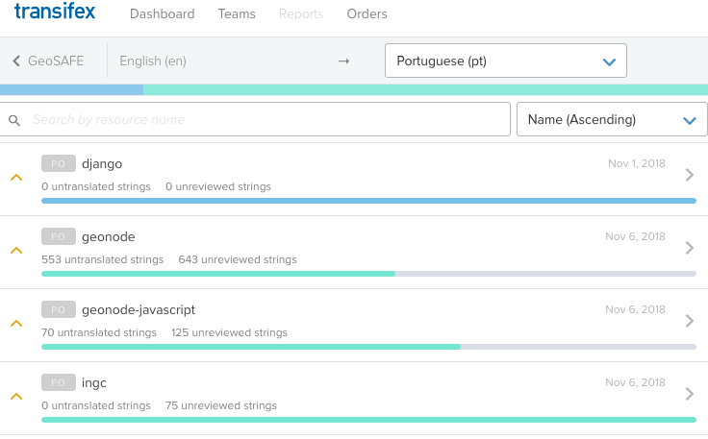
Orchestration or devops
Installation and configuration of GeoSAFE is relatively simple. All components run in Docker containers and we built public Rancher catalogues that you can use.
Set up notes for Rancher implementation are at:
https://github.com/kartoza/kartoza-rancher-catalogue/blob/master/README.md
https://github.com/kartoza/kartoza-rancher-catalogue/blob/master/templates/geosafe/README.md
https://github.com/kartoza/docker-geosafe/blob/develop/deployment/production/docs/Rancher.md

https://github.com/kartoza/geonode/wiki/QGIS-Server-Backend-Configuration

