Stream feature extractor

v2.0.0

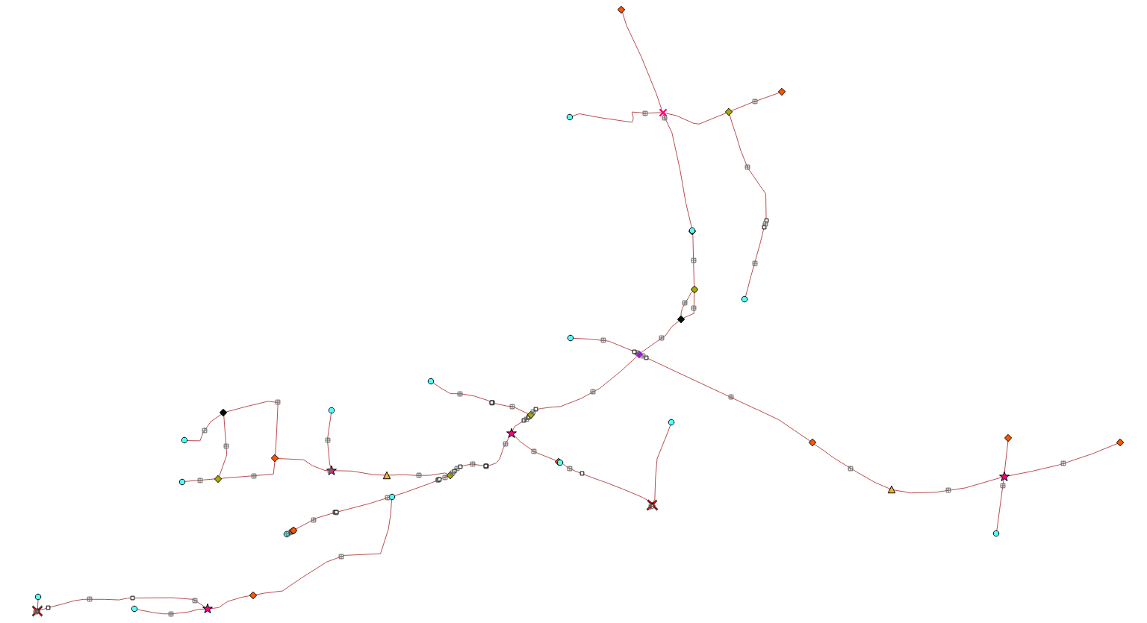

Table of Contents
Introduction 2
Development 2
Plugin conversion to Python 3 and QGIS 3 2
Improvements and issues fixed 2
Updates to documentation 3
Plugin testing 3
Manual testing 3
Testing using gitHub actions 4

Introduction
This document deals with the Stream feature extractor implementation, a plugin which is available for QGIS 3. The plugin extracts stream features, such as wells, sinks, etc. The document provides details on the conversion of the plugin from Python 2 to Python 3, and necessary changes to the plugin to work as it should in QGIS 3 for version 2.0.0 of the plugin.
The first section deals with the development changes to the plugin, followed by a section on tests performed on the plugin to ensure there are no issues.

Development
This section deals with the conversion of the plugin to QGIS 3, followed by a section on improvements and fixes applied to the plugin. The final section provides a summary on documentation changes.

Plugin conversion to Python 3 and QGIS 3
The first phase dealt with the conversion of the plugin to Python 3 and QGIS 3. This ensures that the code uses the correct syntax for Python 3 (e.g. “print ‘Hello world’” should be “print(‘Hello world’)”). For some cases (e.g. QGIS classes) still required review, and were resolved/fixed when found in the code. Initial conversion were performed using the following: https://docs.python.org/3/library/2to3.html

Improvements and issues fixed
Several issues were found during testing. This might be a result of the conversion to Python 3 and QGIS 3, or a prior issue. Here is a list of the issues:
- German translation did not work as it should when QGIS 3 makes use of the German language. A file, ‘de.gm’, were found to be missing in the repository and the cause of this. The ‘de.gm’ file is used by the Qt translator to install the translations, which were not perform. None of the translations were therefore done, and left as is (English). The file has been added to the repository again, and translations works now as it should;
- The Sentry HTML links were updated. Sentry is used to send information to a server when an error occurs. The user can disable this;
- A bug were found where Sentry logging will always be performed when an error occurs, even if it is disabled in the options. This were a result of an if-statement not working as it should, and has been resolved;
- The approach used in the plugin code to handle ‘multilinestring’ files no longer worked, and resulted in an error. A method were added to convert ‘multilinestring’ to singlepart prior to processing;
- If a line dataset contained features with ‘null’ geometry, an error occurred and processing halted. A step prior to processing were added to remove features with ‘null’ geometry. No changes are made to the original file;
- Updates to gitHub actions and actions for new push requests;
- The initial size of the help dialog has been improved;
- Fixes when loading and unloading the plugin in QGIS 3;
- The intermediate layer were not automatically added to the QGIS 3 canvas when enabled to do so in the options. This has been resolved and the layer is automatically added to the canvas;
- When opening the help dialog, the HTML documentation were not found. After further investigation, the HTML documentation were no longer present in the repository. The documentation were generated and added to the appropriate directory. The help option now correctly opens and displays the help documentation;
- GitHub Actions were created to test the plugin for any issues or errors using a test-suite. Tests are performed on all of the plugin functions using existing data in the repository;
- A section were added to the Sphinx documentation to include a section on how to do the above mentioned testing manually;
- Updates to plugin dependencies; and
- Several minor bug fixes.

Updates to documentation
The documentation of the plugin required updates:
- The ‘metadata.txt’ file were updated with the correct contact information, version number (version 2.0.0), and the changelog to include updates to version 2.0.0;
- Sphinx documentation were updated where required, and possible spelling errors corrected;
- The Sphinx documentation now includes a section on how to test the plugin or test any changes to the plugin code;
- Any contact or company information in code comments were updated; and
- Contact information has been updated for the ‘README.md’ file.

Plugin testing
Several tests were performed on the plugin using two approaches: manual testing and testing using gitHub actions. The first section deals with the former, followed by a section on the latter.

Manual testing
Manual testing were done using several datasets. Two vector types were tested, namely ‘linestring’ and ‘multilinestring’. Some of the vector files were also set up to consist of erroneous features – this was done to be sure that the plugin can handle such cases with no error. Manual tests were performed in both QGIS 3 LTS (version 3.16) and the latest current version (version 3.22). This was done in Windows 10 and Linux Ubuntu. If any errors/issues werwe found it has been resolved (see section 2). Here is a list of tests performed on both ‘linestring’ and ‘multilinestring’ vector files:
- Vector file consisting of a single feature;
- Dataset with multiple features;
- If the plugin correctly handles datasets which only consist of features with ‘null’ geometries;
- Cases where a dataset contains features with a ‘null’ geometry and features which has a valid geometry;
- Empty datasets;
- Erroneous coordinate system;
- Correctly converts multipart to singlepart;
- Intersections is detected and handled as it should be;
- If the plugin correctly produces the following:
  - Intersections;
  - Pseudo nodes;
  - Wells;
  - Segment centers;
  - Sinks;
  - Watersheds;
  - Unseparated cases;
  - Unclear bifurcation;
  - Branches;
  - Confluences; and
  - Self intersections.
- If the loaded layer correctly displays the symbology of the produced stream features when added to the QGIS canvas. This was tested for both the English and German versions of the plugin;
- Shapefiles (*.shp) and GeoPackage (*.gpkg) formats were tested; and
- Finally, a check was done on whether the plugin can be executed on raster layers or other vector layers which are not a line – the button is disabled in both the toolbar and plugin menu when a dataset is selected other than a line.
The test data used for testing are available at ‘/test/test_data’ on the plugin repository.

Testing using gitHub actions
GitHub actions were utilized to perform tests using a test-suite. The test-suite performs tests on each of the plugin methods by calling the method with an input dataset or parameter, and then compares the result to the expected value(s). If the result agrees with expected value(s) it succeeded; otherwise it failed. Test data can be found in the ‘/test’ folder on the repository.
GitHub will automatically test, if the workflow is enabled, a commit to the repository. The user can also manually set a test workflow running if needed. Tests is performed using QGIS docker images. The following QGIS versions are evaluated for issues:
- 3.10;
- 3.12;
- 3.14;
- 3.16 LTR;
- 3.18;
- 3.20; and
- latest (3.22).
Any noted errors will be shown if found by the workflow, and the user can then use the information to determine the cause of the issue.
The test-suite workflow were executed on the plugin and testing succeeded for all of the above mentioned QGIS versions.

