Result Explanations:

This document explains why there are some differences between our plugin’s results and the test data.

Overlapping lines
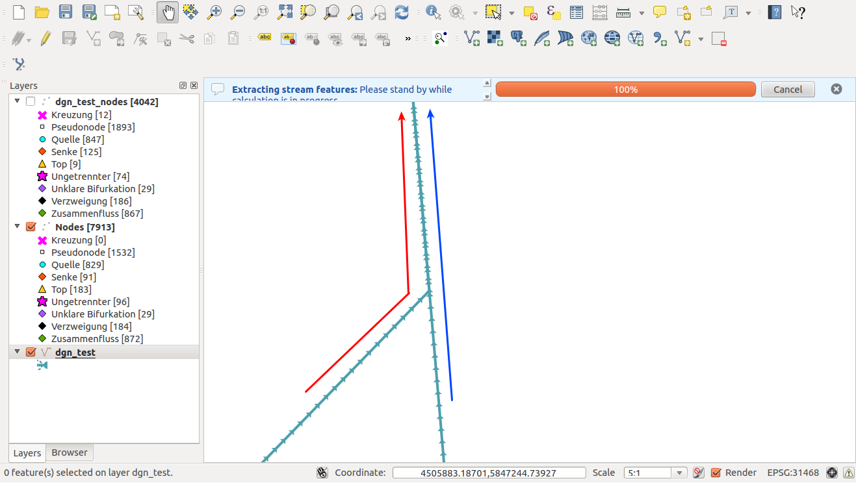
In some cases there are overlapping lines (see the red and blue line indicating overlap in the example above).

Threshold
Nodes are considered as one node if their distance is less than the threshold. There are some cases where this threshold is significant and alters the outcome of the feature extraction process. See image below with threshold = 1 (blue) and threshold = 0.01 (black).

As you can see there are some differences:
- The number of nodes extracted is different (7913 vs 7953).
- The 'nodes - blue' layer only identified the ‘unseparated’ class for those three nodes because they are within threshold = 1. But, the black one identified them successfully (compared to data test).

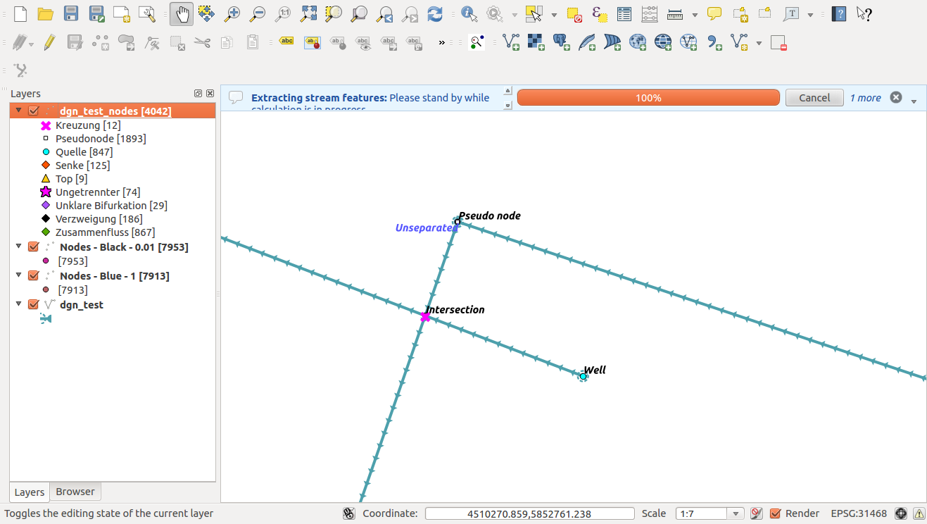

Misclassified data test
In the figure below, the node is classified as a pseudonode. But, it is not since the node has two downstream nodes while in our definition, a pseudonode is a node that has one upstream node and one downstream node.
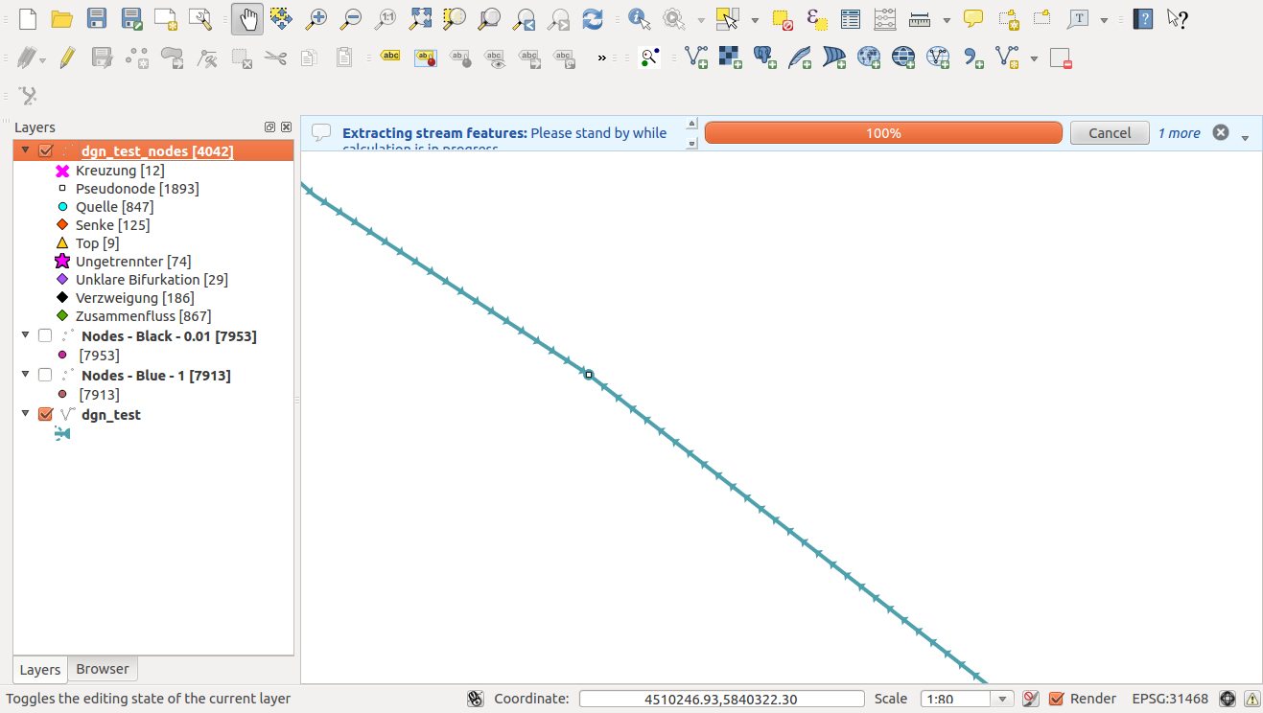

There are other examples e.g. node id 1949 in the test dataset is represented as a pseudonode but each line leaving that node runs in the opposite direction, which by our definition makes it a top / watershed.

Overlapping lines running in opposite directions

See the stream near the red line. It is actually two lines overlapping but running in opposite directions.
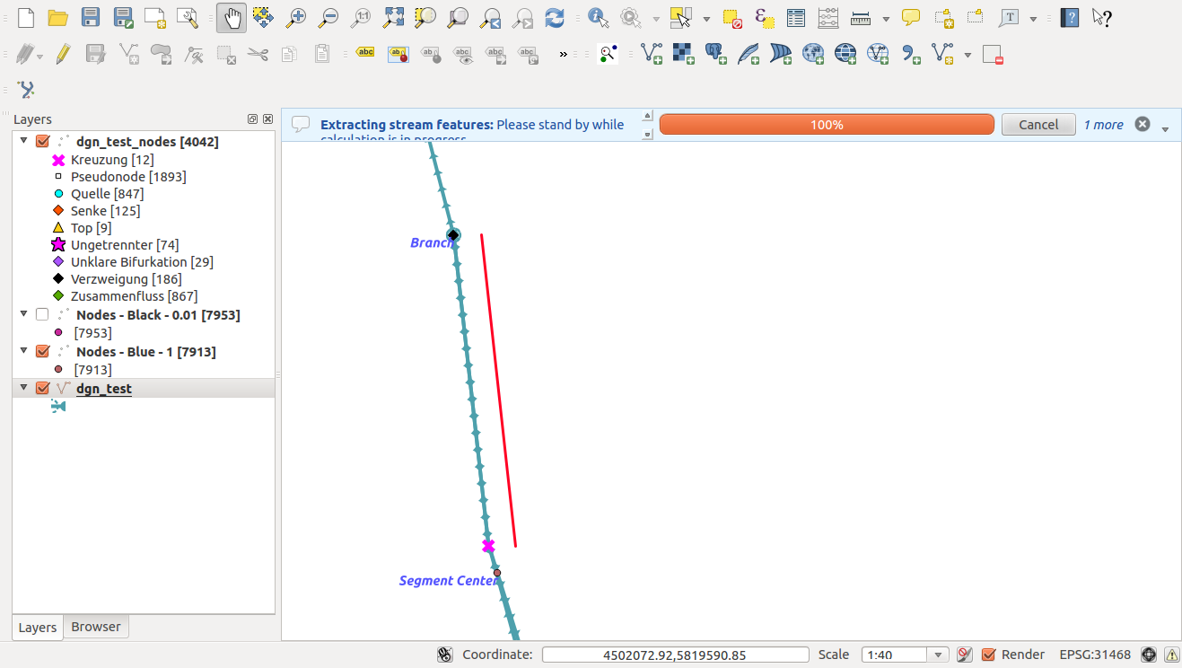

Ismail Sunni, 20 May 2014 ismail@linfiniti.com

