1: 50 000 topographical Map style of South Africa Comparison from NGI and custom style using QGIS and other open source tools

1: 50 000 topographical map From NGI: Map sheet 3118BC

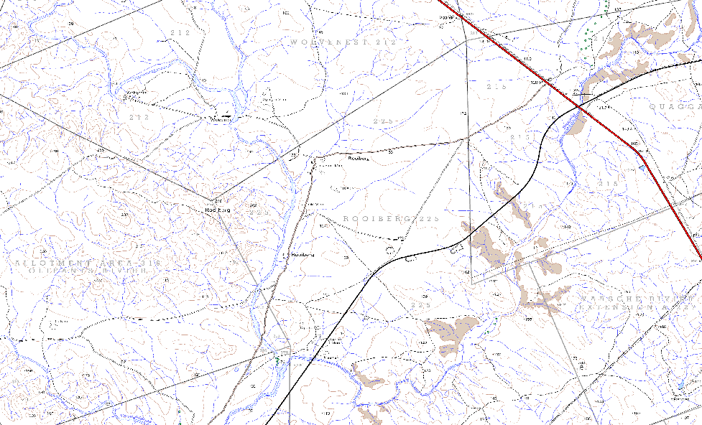

Custom Style resemblance of 1: 50 000 topographical Map Of South Africa

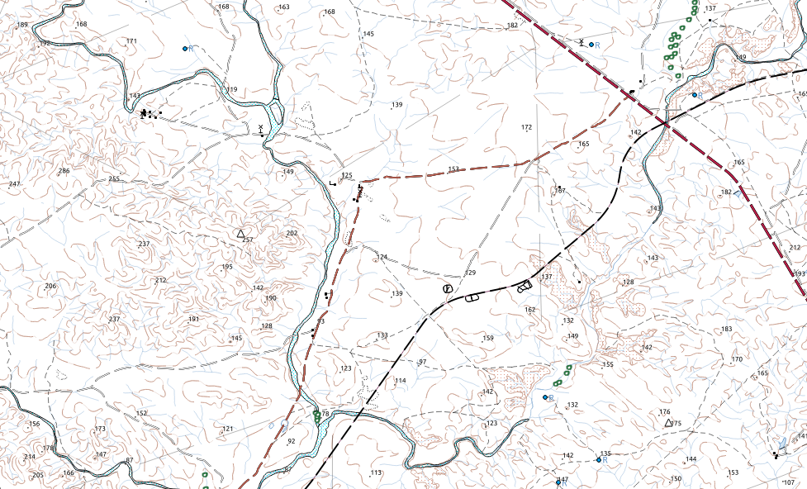

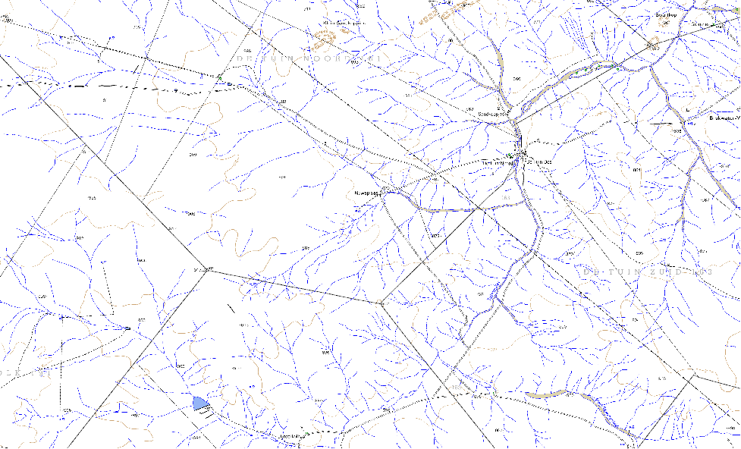
NGI vector Style: Area 2: Map sheet 3019CB
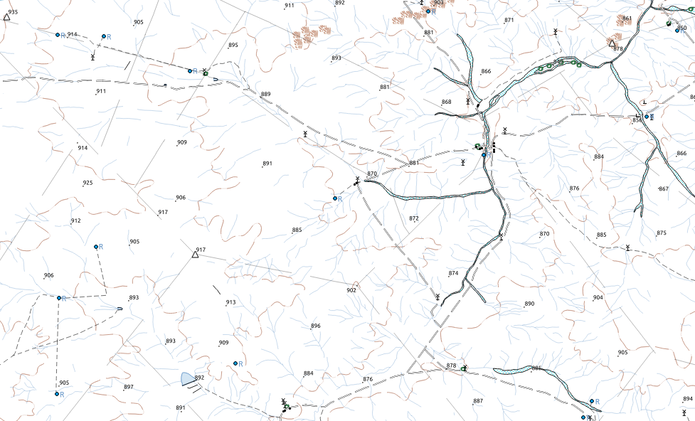
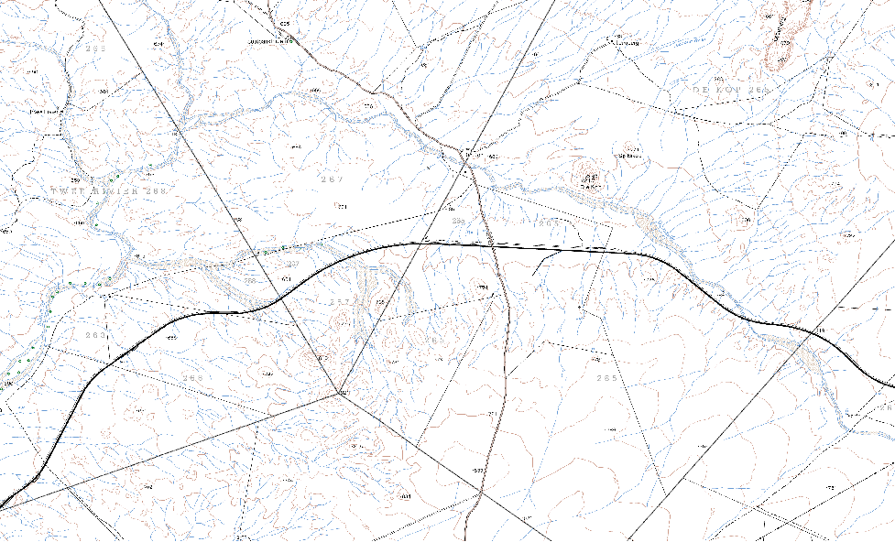
Custom style

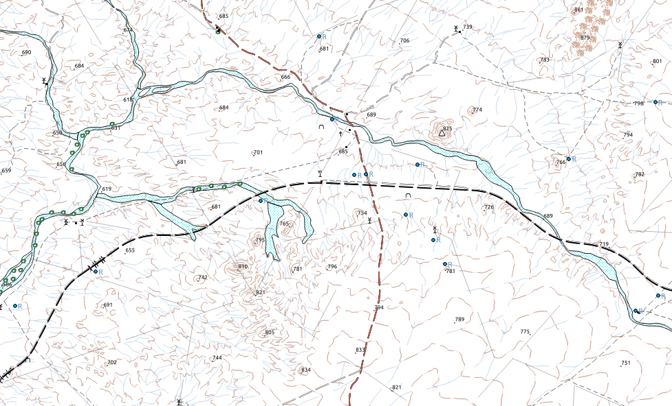
Area3
NGI style: Map sheet 3318CC
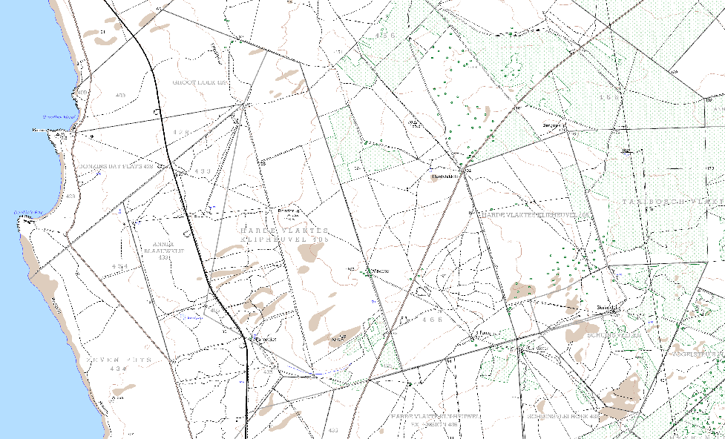
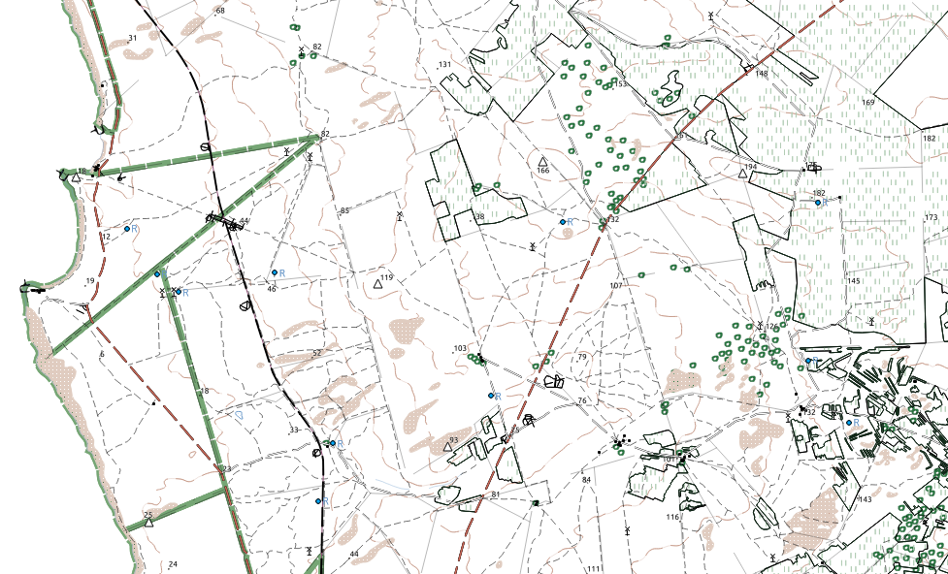

Custom Style

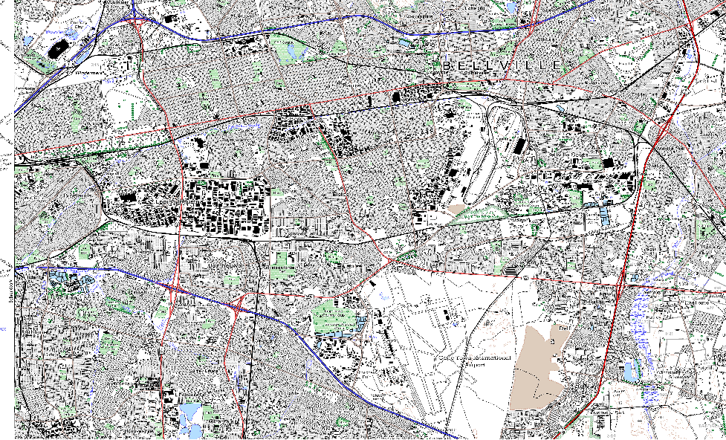
NGI: Map sheet 3318DC

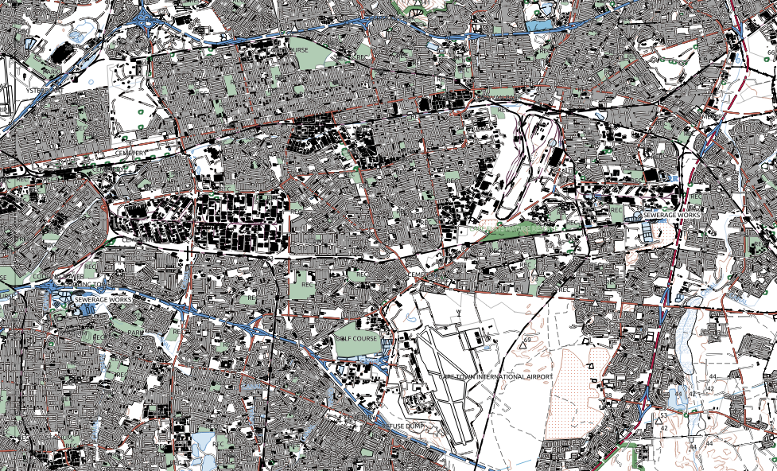
Custom Style

