Snapshot of topostyle samples compared with reference 1:50000 maps.

26 February 2013.

1: 50 000 vector styling for data provided by NGI with specifications on how to style certain features. All the styling was achieved using open source GIS tools.

This is an ongoing project so in order to show people the differences in the styles we have to keep on adding the modified style to the document. The aim of this document is to do a comparison between the user styles against the NGI styles and then add them to at the bottom to see how well they compare.

See following pages...

The first images show comparison between the NGI map sheets and the styling that was done using QGIS.

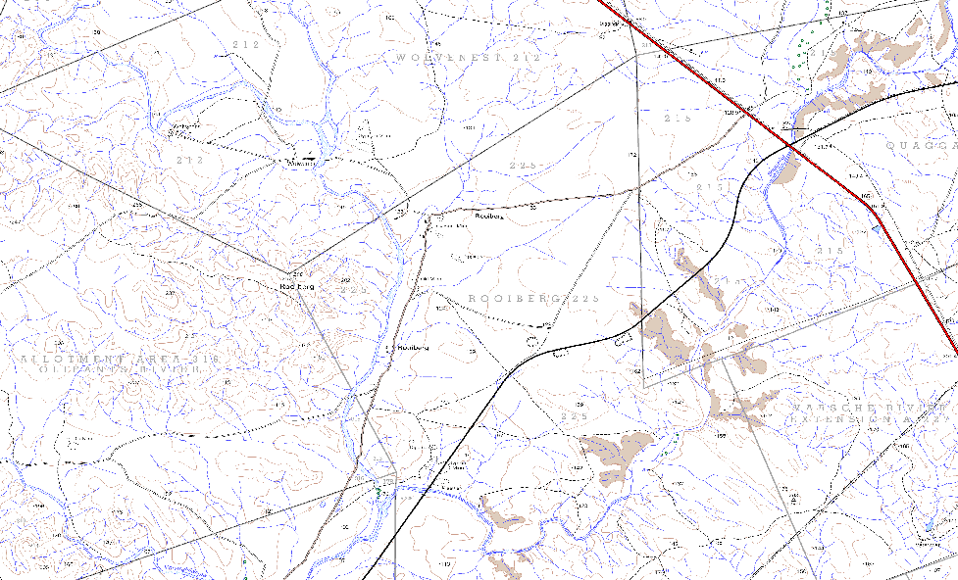
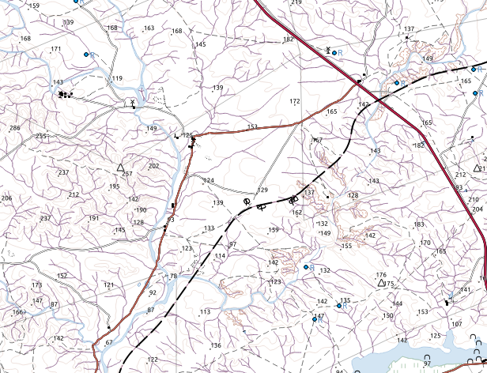
1: 50 000 topographical map From NGI: Map sheet 3118BC 1: 50 000 topographical map From QGIS: Map sheet 3118BC

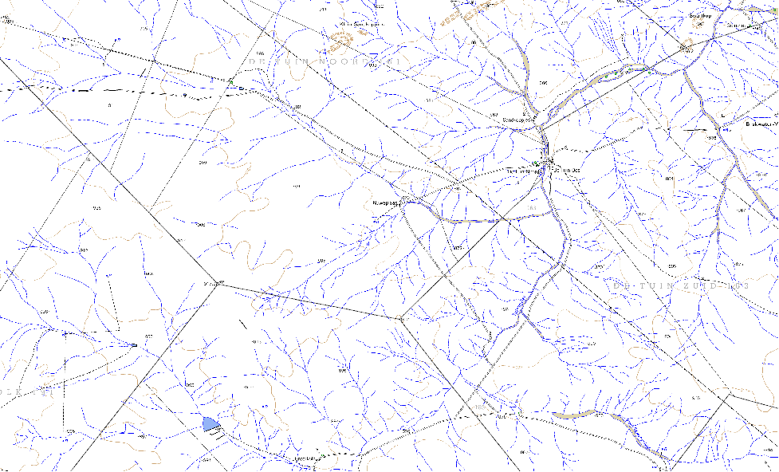
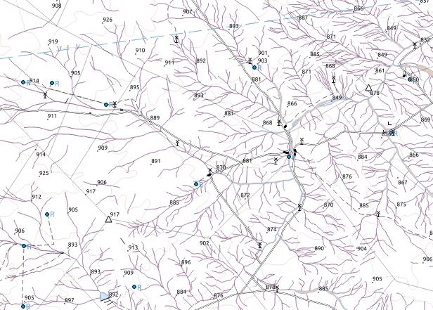
1: 50 000 topographical map From NGI: Map sheet 2920BC 1: 50 000 topographical map From QGIS: Map sheet 2920BC

1: 50 000 topographical map From NGI: Map sheet 3019CB 1: 50 000 topographical map From NGI: Map sheet 3019CB
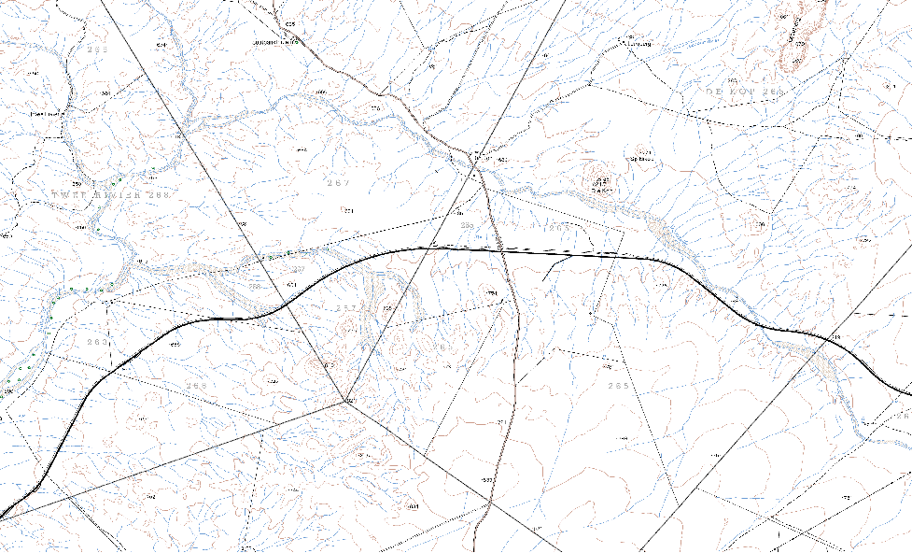
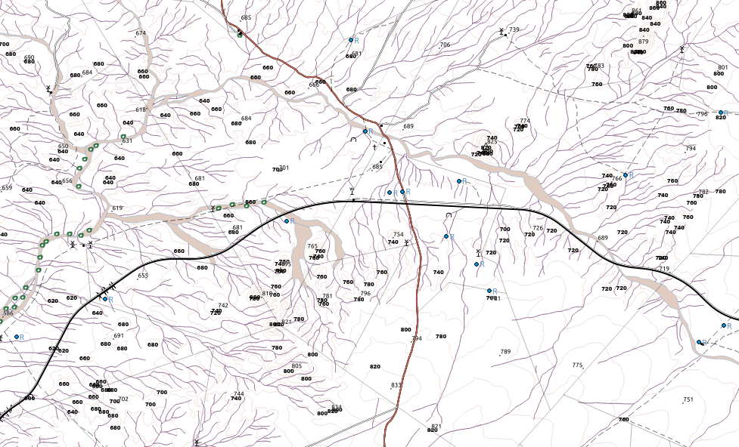

1: 50 000 topographical map From NGI: Map sheet 3318CC 1: 50 000 topographical map From NGI: Map sheet 3318CC
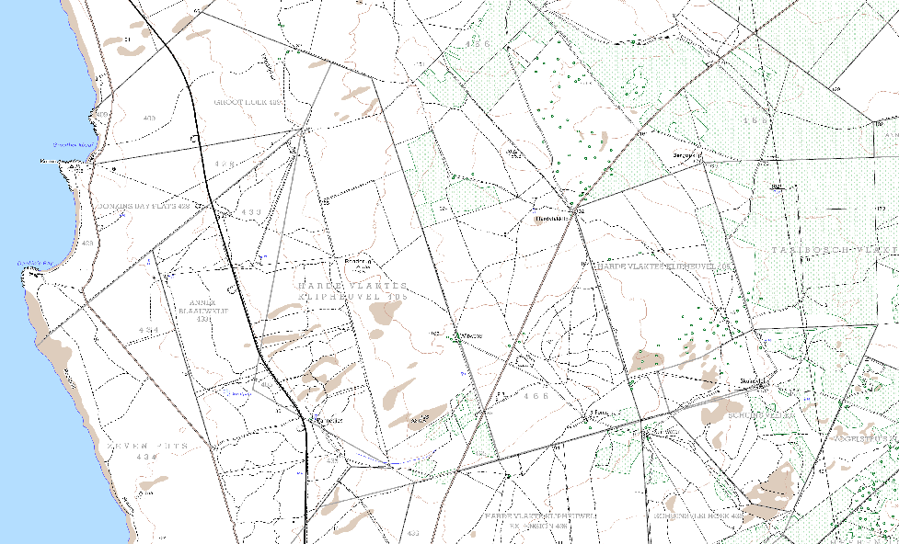
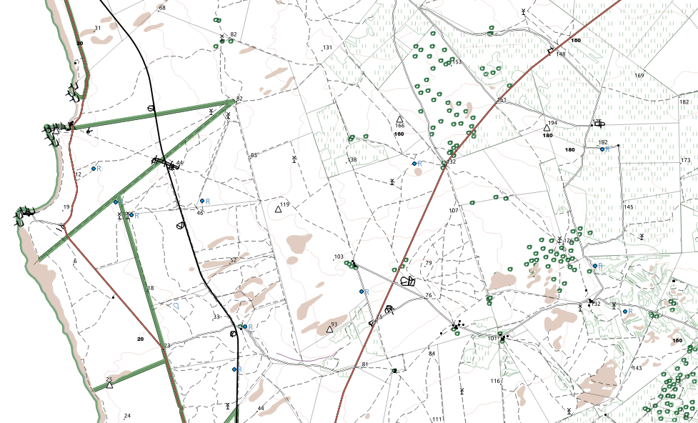

1: 50 000 topographical map From NGI: Map sheet Cape Town 1: 50 000 topographical map From NGI: Map sheet Cape Town
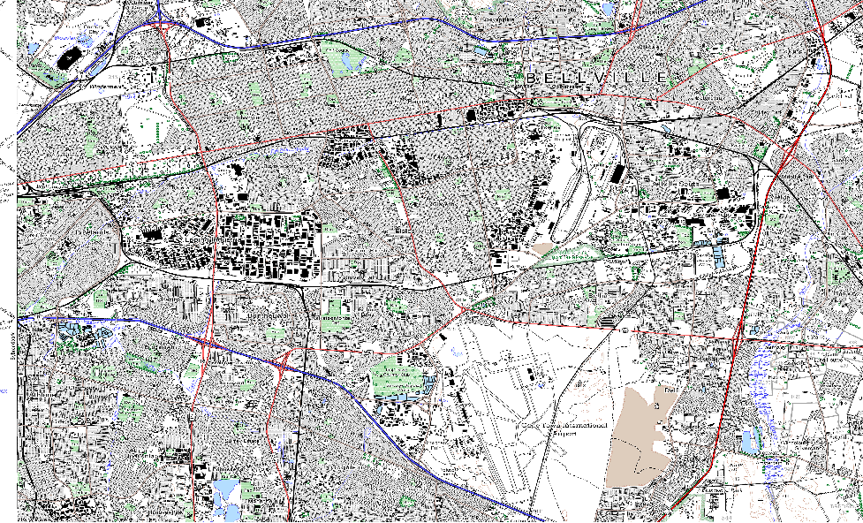
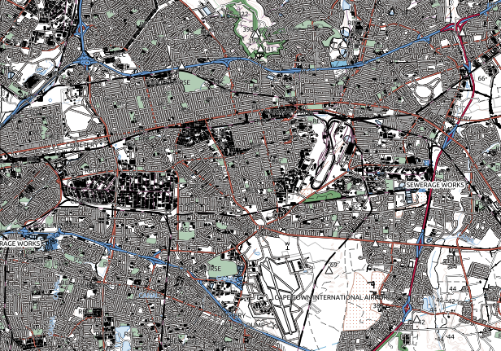

1: 50 000 topographical map From NGI: Map sheet 3118BC 1: 50 000 topographical map From Geoserver: Map sheet 3118BC
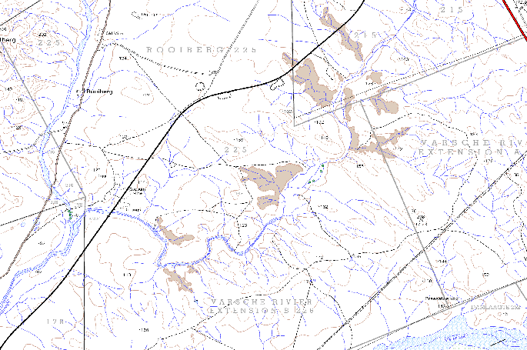
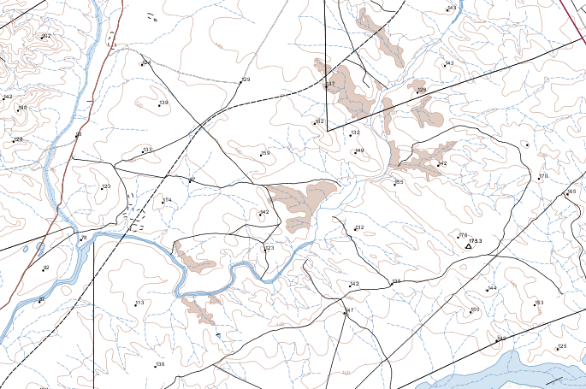

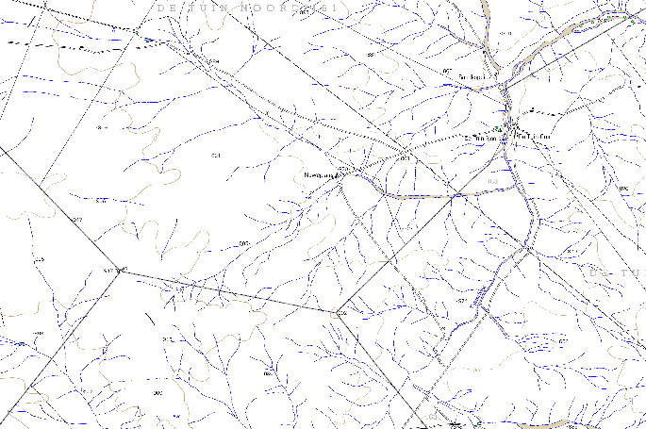
1: 50 000 topographical map From NGI: Map sheet 2920BC 1: 50 000 topographical map From Geoserver: Map sheet 2920BC
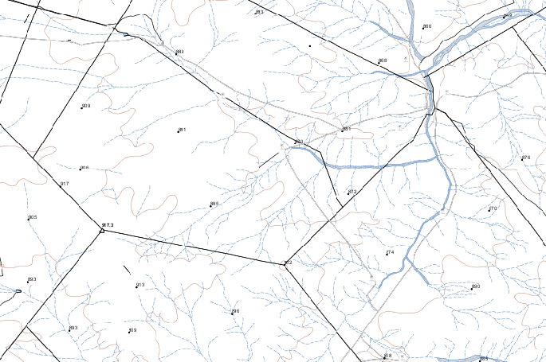

1: 50 000 topographical map From NGI: Map sheet 3318CC 1: 50 000 topographical map From Geoserver: Map sheet 3318CC
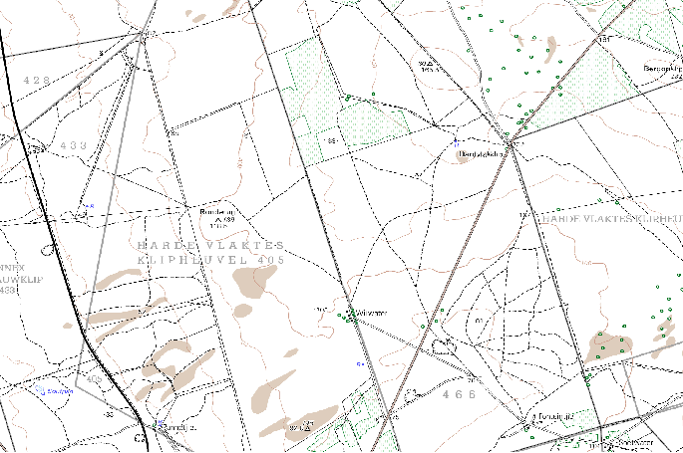
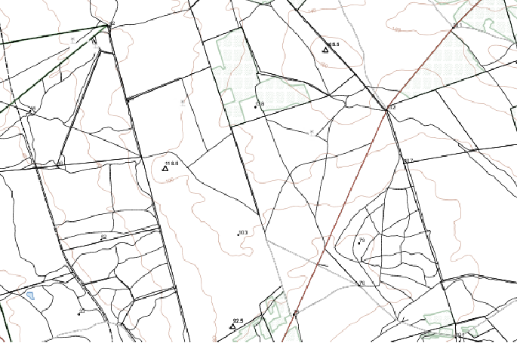

1: 50 000 topographical map From NGI: Map sheet 3019CB 1: 50 000 topographical map From Geoserver: Map sheet 3019CB
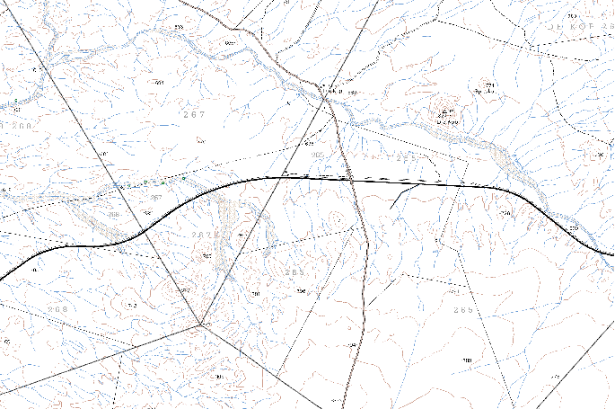
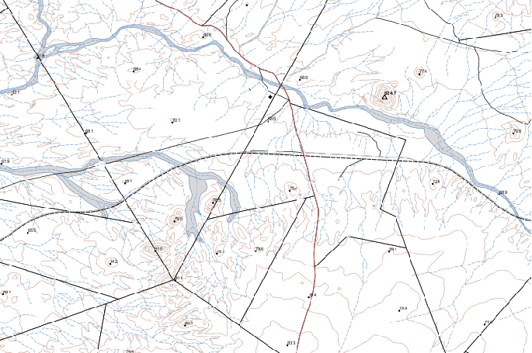

1: 50 000topographical map From NGI: Map sheet 3318DC 1: 50 000 topographical map From Geoserver: Map sheet 3318DC
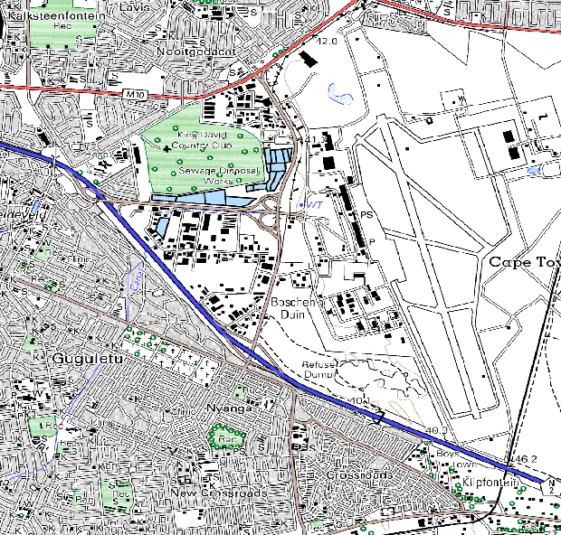
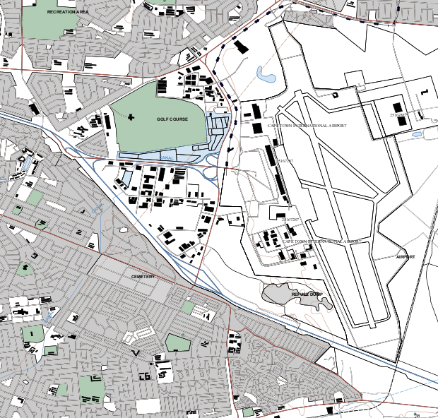
1: 50 000

