# Introduction

Analysis is the stage where prioritization is done according to the needs and requirements as per the requirements of project by specifying, identifying and adhering to the domain knowledge of the project. The main objective of analysis is to figure out the necessary steps required to enhance the goals and operation of the project. By sorting out the data and information, facilitating the information services that are imperative for analysis. In this phase, we begin to comprehend, inside and out, the necessary amendments for system to change. Here, we allocate and research to validate our resources i.e. information and identify our basic and fundamental needs like requirements and preliminary version of our software.

Analysis is an important aspect in System Development Life Cycle without which there will be unsure of final product successful release or development, which might not be fruitful. Consequently, it might lead to failure of the system and a project as a whole. So, analysis must be done in a proper manner to ensure the success and proper development of project. Therefore, to ensure the formulation of proper analysis following actions or activities are involved.

* Research on the system framework, its shortcomings and the possible new framework that can supplant the old.
* Identifying the necessary amendments that are to be made to improve the system by conducting the stakeholder analysis and taking in the consideration of client requirements.
* Documenting the requirements by validating or inspecting the necessary prerequisites identified earlier like requirement of end users

## Overview Of Recycling System

This project aims to provide services and facilities to the waste collectors and the people like us so that our environment can be kept neat and clean. Besides this, we can promote the concepts of recycling by utilizing the waste properly, either by selling or donating the wastes. Therefore, this project will adhere to Soft System Methodology. Since, there will be continuous interaction with clients and the system will be solely more focused on the human interaction rather than the technical things, comparatively. So, an overview of how the system will work is shown with the help of rich picture. Rich picture enables us to understand and give the excellent visual communication about the system. The graphical representation of this project will provide and overview i.e. general idea about how this project will work as shown in the form of rich picture as shown below.

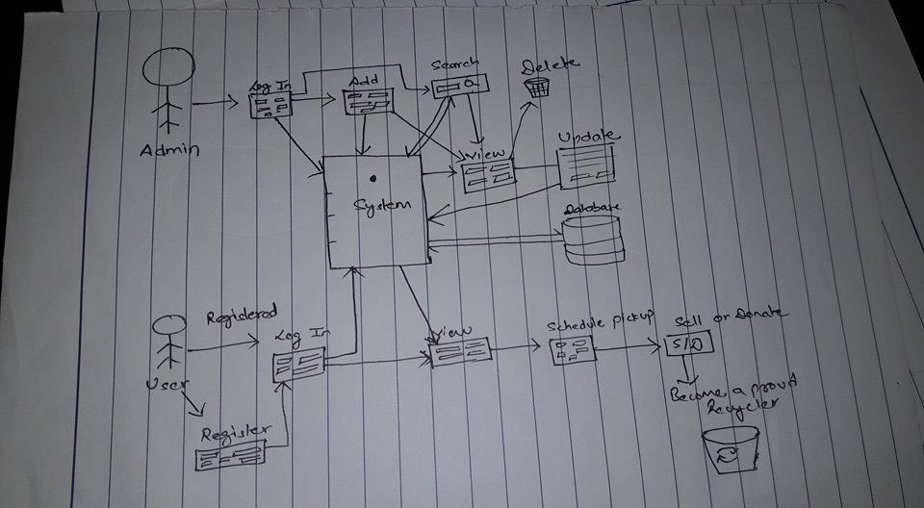

Figure Rich Picture

## Feasibility Study

The evaluation and study of project viability is must before developing or continuing the project. So, Feasibility study is must when analyzing the system or a project. It enables us to know the project limitation and its potential. Whether the project will have a fruitful result or is it a waste of time. So, in order to successfully develop a project without any possible hindrance and to provide solution for the future problem by identifying the project restriction feasibility study is must. So, the feasibility study of five areas of project is must.

1. Technical Feasibility – It enables to formulate the ideas into action to be embedded in the working system. And our recycling system resources are easily available. There will be no problem for assembling the hardware and software for the recycling system.
2. Economic Feasibility – Our proposed system is economically feasible and it is within affordable price. With the completion of this project it can be assured that there will be steady economic growth to the company since it helps to quantify the economic growth.
3. Legal Feasibility – Wile doing research on this project. There were no any legal issues regarding the proposed system. And the project is being developed as per the law and order maintain by government.
4. Operational Feasibility – The proposed system will be able to solve the problems of trash collector by saving their time. Instead of visiting people door to door. Trash collector can make good use of the proposed system to collect the trash efficiently and effectively. Since the recycling system ensures that the system is reliable, maintainable and easy to use.
5. Scheduling Feasibility – It is the most important aspect to be considered. And before analysis phase, proper scheduling is done in the planning phase while providing the proposal. So the project were broken down into smaller modules to manage the scheduling feasibility and the best possible time estimation were proposed to ensure the scheduling feasibility to ensure the success of project

Here, in this document. Section 2 consists of system requirement specification where all, the necessary requirement like functional, non-functional requirement and the prioritization are specified. Likewise, in section 3.

# System Requirement Specification

Requirement specification were carried out by collecting information i.e. facts about project and identifying necessary feature or function that the client or and end user needs for the system. With requirement specification necessary preparations can be done for documentation, which will definitely be helpful. When formulating design and developing the system. It is carried out through 1.Research

2.Observation.

Requirement Specification includes fact-finding to study the current system for the development and identification of new systems. Here, it consists of two requirement i.e. functional and non-functional requirements. It helps to understand the system and its overall requirement.

## Functional Requirements

Functional Requirements are those features that the system must have like basic CRUD operation. It consists of operation like login, sign-up (interface requirements) related with the functionality of the system or which includes outlines of workflows specifying a behavior or something that must be done by the system. Functional requirement facilitates what the system should do.

Therefore, given below functional requirements are the requirements that will be included in the system that is being developed. Here, the functional requirement with its description and dependencies are illustrated in the table below.

|  |  |  |  |  |
| --- | --- | --- | --- | --- |
| ID | Title | Description | Rational | Dependencies |
| FR1 | Sign UP | The users of the system should be able to sign up through sign up form. The user must provide the necessary information correctly | For login credentials necessary information are required | R2 |
| FR2 | Login | Admin and users should be able to access the system by login in with the help of registered username and password | To authorize access in the system to registered users | R1 |
| FR3 | Add Property | Admin must be able to add additional property for trash management category when a new property is feasible or it can be included according to necessity. Since only few types of trash are included. He should make necessary arrangement to provide required details about the property. | Addition of new available property for users. | N/A |
| FR4 | Search Property for admin | The admin should be able to search and view property like sold and donated trash to manage trash record. | To give access authority to update, delete and manage records of client accordingly. | R3 |
| FR5 | View Property Details | Admin and Users should be able to view the value and the types of trash in view property | To view the details of the trash where it is categorized and to know the value of that waste material | R3,R4,R5 |
| FR6 | Update Property Detail | The information or value of the trash might be change or may be prioritized according to needs for recycling or other purposes. So if any changes are needed then admin must be able to update the property details | To facilitate the new updated category to be enabled so that it could be recycled when added as a new property type of trash | R3,R4 |
| FR7 | Delete Property | Admin must be able to remove the unnecessary property. If it cease to exist or, if it is no longer in use | If some property type or trash are no longer used or are not available then it must be removed. | R3 |
| FR8 | Scheduling | To facilitate the collection of trash on time | Users trash must be collected in-order to utilize the recycling process. So to retrieve trash scheduling is done and the client and trash collector will conclude the selling or donating process. | R9,R10 |
| FR9 | Sell | Client should be able to sell the trash with its respective value | To provide the respective valued price of trash to the client | N/A |
| FR10 | Donate | Client might be interested in donating trash rather than selling. | To facilitate the charity process as per the clients desire. | N/A |

## Non-Functional Requirements

All other requirements, which were not specified by functional requirements are non-functional requirement. Non-functional requirements are system attribute that defines how the system operates rather than what the system should do. Non-functional requirements are the system qualities which are equally important and critical and plays a vital role while developing a system. Some of the Non-Functional requirements are as illustrated in the given table below.

|  |  |  |  |  |
| --- | --- | --- | --- | --- |
| ID | Title | Description | Rational | Dependencies |
| NFR1 | Performance | Multiple users should be able to make good use of the system from different locations. Around 50,000 people should be able to use the system and the system should give a proper response to its user. So the maximum response time is dependent on the number of concurrent users, number of request per second and the average think time in seconds. So the maximum response time will be around 30-45 seconds. | To facilitate the quick response and faster performance while accessing the system by the user from different region. | NFR4,NFR9 |
| NFR2 | Availability | The system must be accessible 24X7 by utilizing more servers. | User must be able to access when necessary | NFR6 |
| NFR3 | Reliability | System should give a reliable outcomes and must be dependable 99% without any flaws. It should be able to keep on with the ongoing time. | Even after making use of system for a long period. It must give accurate result without any flaws. | NFR4 |
| NFR4 | Security | System must be secured so, there won’t be any manipulation and misuse of any data or information of system admin and user. Thus, the password must be assured safe with encryption technique or with other alternative ways.` | To assure the safety of the system to its user. | N/A |
| NFR5 | Usability | End users should easily access and make use of the system without any problem. | To facilitate ease of use for the non-technical user as well | NFR1,NFR3 |
| NFR6 | Interoperability | Facilitate the communication between different systems without any issues which needs to interact for the smooth functioning of the system | To provide the convenient interaction of the various systems. | NFR1 |
| NFR7 | Maintainability | To facilitate the correction and fixing of bugs and some flaws easily when identified for better performance | To ensure the smooth processing of the system and to assure the system in well maintained without any major flaws | NFR4 |
| NFR8 | Testability | System should be manageable if error or bugs are identified without any complexities. | To examine the proper functioning and smooth operation of the system | NFR3,NFR4,NFR5,NFR6 |
| NFR9 | Scalability | System should be able to handle multiple users without any hindrance by providing accurate outcomes. | To maintain scalability of the system | NFR1,NFR3,NFR6 |

## Prioritization

Prioritization aids to organize resources and budgets properly. It also assists in managing the vague requirements that are unknown. In addition to that, it makes people to be confident of their requirements. And also it helps to make our vision clear about what to be included and excluded when major problems related to budge and scheduling occur. It plays vital role in the software deployment part too.

Here, this project will adhere to MoSCoW prioritization. Prioritization will be done, by utilizing MoSCoW technique. This techniques is utilized by analysts and stakeholders to prioritize the requirement collaboratively. With this technique requirement can be categorized into four groups

1. M-Must have: Those requirements which are guaranteed to be delivered. Without this, project will cease to succeed or be delivered. This requirement are non-negotiable.
2. S-Should have : Considerably important requirement but are not vital. Feature in should have are highly prioritized.
3. C-Could have: Those requirement which are not needed but can be added. This feature will have less impact on the project
4. W-Won’t have: In won’t have, requirements will be kept for future use and are not focused currently in the project. So it won’t have any effect on the success of current project.

MoSCoW prioritization is carried out because:

1. It ensures effectiveness of prioritization
2. To balance the requirements and to manage the resources
3. Provides and expert opinion.
4. Quick and easy to complete

The table illustrated below shows the MoSCoW prioritization being carried out:

|  |  |  |
| --- | --- | --- |
| ID | Requirements | MoSCoW |
| FR1 | Sign Up | Must have |
| FR2 | Login | Must have |
| FR3 | Add Property | Must have |
| FR4 | Search Property for admin | Must have |
| FR5 | View Property Details | Must have |
| FR6 | Update Property Details | Must have |
| FR7 | Delete Property | Should have |
| FR8 | Scheduling | Must have |
| FR9 | Sell | Must have |
| FR10 | Donate | Should have |
| NFR1 | Performance | Should have |
| NFR2 | Availability | Must have |
| NFR3 | Reliability | Should have |
| NFR4 | Security | Must have |
| NFR5 | Usability | Must have |
| NFR6 | Interoperability | Must have |
| NFR7 | Maintainability | Could have |
| NFR8 | Testability | Could have |
| NFR9 | Scalability | Should have |

# Use Case Diagram

The pictorial illustration to describe a business process or systems function steps, that are necessary for the process off accumulating the requirement information influencing both the internal and external factor are use cases.

In analysis, use case aids to analyze the system by analyzing the interaction of system components or elements. So that the external view of system can be understood properly and also to capture the functional requirements in use cases to get a dynamic exposure of the system. It illustrates the general overview of the system scenario, which gives an idea about how the system is communicating with the actor and use cases. Here, it also depicts the summary of various use cases within a system and also helps to provide information about their interaction and relationship among the use case and actors. Actors are represented by stick figures in use case diagram and an oval shape illustrates processes.

# Architecture

## System Architecture Initial Class Diagram

# Conclusion