# Abstract

In today’s world, Information Technology has been an integral part of one’s life. It has been a basic need in our day-to-day lives. Without information technology we humans will cease to operate our most of the important activities. The modern world that exists today has been completely dependent on the information Technology. Everyone wants to show the true potential, creativity and passion. So, Information Technology has become a stepping-stone in every progressive work.

Therefore, with the help of Information Technology all the problems faced by an individuals can be identified and the appropriate remedy can be proposed. Keeping this fact in mind, in the present context. There has been huge need for promoting the concept of green environment. For this purpose, this project about Recycling was created to boost the motivation of common people. To boost the motivation, a simple trick is being utilized. It’s about earning some money with exchange of waste that can be recycled. Since, most of the resources are limited. There should be an awareness with which every one can realize the value of the resources that are present within our surroundings. So, the concept about the project called recycling came for this computing project.

# Acknowledgement

I would like to thank our project facilitator for giving us this opportunity to complete an open project. This project has been a great help to learn new things and to boost our creativity and passion towards information technology. I am very grateful to stackoverflow and my seniors for assisting me with this project. And I am truly grateful to our Dhruba sir for facilitating the workshop for Code Igniter. It was possible to complete this project because of the workshop that I had attended

# Introduction

This project is about the system for recycling product, which facilitates the management of waste product like papers, plastics and glasses. It only concentrates on the waste materials that could be recycled except organic or non-recyclable items. We all know that one ton of recycled paper can save approximately about 20 trees, 4100 Kilowatt hours of electricity; enough energy to power a house for few months. Therefore, it can be said that, this system is an initiative for user or client to contribute some unnecessary things to be of good use by selling and donating things like trash such as papers, glasses, bottles and others for better environment and livelihood. Here, client or supplier can register for an account and they can help by donating or selling their waste product. Which will ultimately help to keep our environment clean and also helps to save tree. With the help of this system user or client can make a good use of their unwanted materials to earn some money. They can also donate glasses, plastics and papers instead of selling it. However, it all depends on the client. In this system all the records of papers, glasses and plastics are kept. So that the recycling company can have a good knowledge about remaining materials which are recycled and the materials which are to be recycled. By doing so both the supplier and recycling company are contributing for the welfare of our environment. It solves the problem of dumping unnecessary waste materials in an unorganized way. Instead of dumping such thing and burning such things one can make a good use of papers, glasses, plastics and others. So, with the help of this system people can sell or donate their recyclable waste materials that are of no use by selecting the suitable dates to book to supply. After selecting suitable dates to sell or donate such items, such items will be collected on particular date and the collector will pay for the recyclable product are which are to be sold by calculating its weight and depending on the weight and type of recyclable items. And the records of such item will be managed accordingly by specifying the category in which they belong to like papers. In papers there will be sub types like magazines, cardboard, notes, book etc. and so on.

This system particularly focuses to close the gap between waste seller and waste collector. So, that waste collector would also be able to utilize the modern technology wisely to make their life easier instead of traveling doors to doors of every individual’s. With the help of this system it will also encourage the business entrepreneur doing business related to recycling.

The client, customer or user of this product will benefit highly. Since this project helps to encourage the business related to recyclable trash and also helps to motivate the common people like us to value the trash or any waste materials that could be re-used or recycled. Which ultimately helps to keep our environment clean and keeps us healthy.

## Aims

* To develop a web based application that facilitates and encourages the waste business by managing the recyclable items that could be re-used.
* To ease the work of recyclable waste collector’s like bottle collector, paper collector.
* To automate the recycled reports

## Objectives

* Developing user friendly web based system using programming language such as PHP and database such as MySQL
* To complete a project in a given time frame to step in a real world project
* To have experience and to learn to solve the problems and errors by identifying bugs and errors.
* Analyze and solves the issue of proper dumping of waste materials.
* To learn to design and develop a dynamic website for a real world project.
* Testing the application to be sure, whether it gives the outcome as expected or not.
* To provide a detailed documentation which could specify every phase of this project

## Main Features

The main features of Recycling System are as follows:

* Registration of client or suppliers.
* Scheduling pickup
* Show list of recyclable trash
* Login and Logout features
* Signup features

## Development Methods

### Waterfall Model

For this project I prefer to choose Water Fall Model. This model is traditional and straightforward to utilize. It is also known as Liner Sequential Life Cycle Model. This model is difficult to oversee because of the unbending nature of the model – each stage has particular expectations and a survey procedure. In this model stages are handled and finished each one in turn. Stages don't cover. Waterfall shows function admirably for littler activities where prerequisites are very clear. Waterfall consists of six different phases, which are as follows:

* Requirement Analysis:- Requirement Analysis are carried out by different information gathering techniques. For instance, survey, questionnaire, interviews and also through secondary source of data. And then the acquired information is documented in specification document.
* Design:- After the completion of Requirement Analysis. Design is carried out with reference to Requirement Analysis. It consists of two different model i.e. structural and behavioral models. Which helps in implementation phase. After completing the design phase next phase is carried out i.e. Implementation phase is carried out in a chronological order in a waterfall model.
* Implementation:- With the completion of Design phase. Implementation will be carried out with the reference to the design phase and coding will be done likewise following the design phase. Here, system is developed by integrating and coding the system with the help of structural and behavioral model
* Testing:- Testing is and important aspect for developing well and furnished software or system integrating all the features of system. So that the various errors and bugs could be fixed with the help of texting like unit testing and black box testing.
* Deployment:- After following all the development method that are mentioned above. Deployment is done to present the developed system for the real user so that they could utilize its main features.
* Maintenance:-If any errors or breakdowns occur after the completion of all the steps. Maintenance is done to fixed the issues. Not only that system is also upgraded in this phase as per the necessity and demands.

In the Implementation part of waterfall model Design pattern like MVC will be used. By adapting to the MVC framework the coding part is carried out. Here, model handles business logic, view will be responsible for the presentation of state of the mode to the user and finally controller permits user to communicate with the model

# Chapter 2 Analysis

# Introduction

Analysis is the stage where prioritization is done according to the needs and requirements as per the requirements of project by specifying, identifying and adhering to the domain knowledge of the project. The main objective of analysis is to figure out the necessary steps required to enhance the goals and operation of the project. By sorting out the data and information, facilitating the information services that are imperative for analysis. In this phase, we begin to comprehend, inside and out, the necessary amendments for system to change. Here, we allocate and research to validate our resources i.e. information and identify our basic and fundamental needs like requirements and preliminary version of our software.

Analysis is an important aspect in System Development Life Cycle without which there will be unsure of final product successful release or development, which might not be fruitful. Consequently, it might lead to failure of the system and a project as a whole. So, analysis must be done in a proper manner to ensure the success and proper development of project. Therefore, to ensure the formulation of proper analysis following actions or activities are involved.

* Research on the system framework, its shortcomings and the possible new framework that can supplant the old.
* Identifying the necessary amendments that are to be made to improve the system by conducting the stakeholder analysis and taking in the consideration of client requirements.
* Documenting the requirements by validating or inspecting the necessary prerequisites identified earlier like requirement of end users

## Overview Of Recycling System

This project aims to provide services and facilities to the waste collectors and the people like us so that our environment can be kept neat and clean. Besides this, we can promote the concepts of recycling by utilizing the waste properly, either by selling or donating the wastes. Therefore, this project will adhere to Soft System Methodology. Since, there will be continuous interaction with clients and the system will be solely more focused on the human interaction rather than the technical things, comparatively. So, an overview of how the system will work is shown with the help of rich picture. Rich picture enables us to understand and give the excellent visual communication about the system. The graphical representation of this project will provide and overview i.e. general idea about how this project will work as shown in the form of rich picture as shown below.

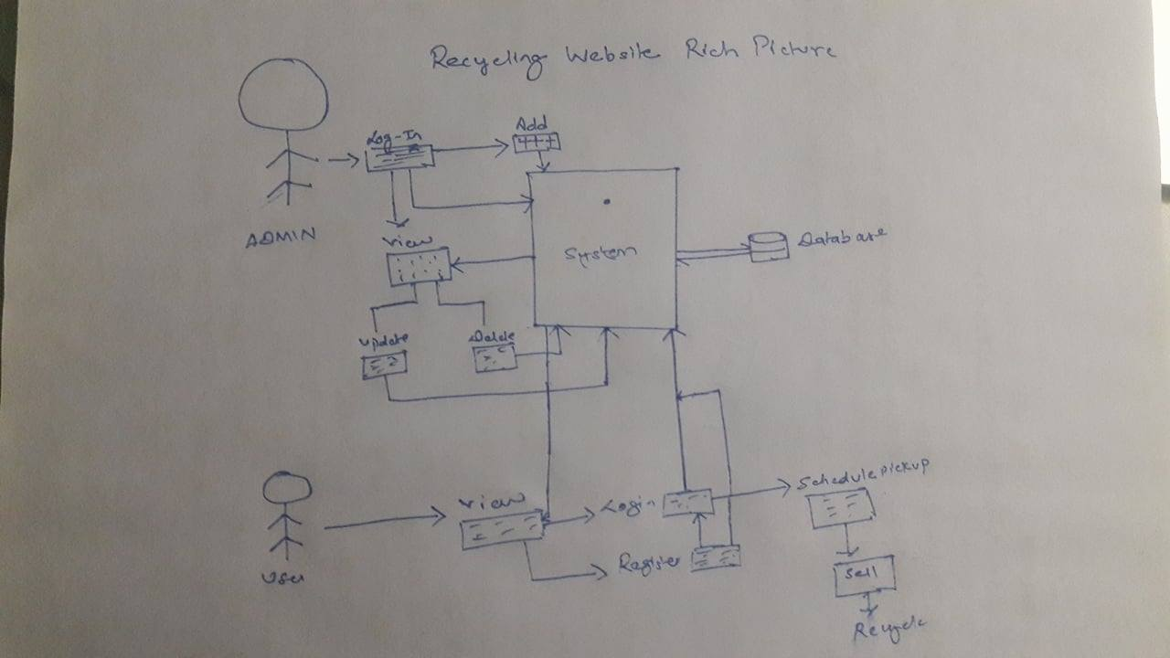

Figure Rich Picture

## Feasibility Study

The evaluation and study of project viability is must before developing or continuing the project. So, Feasibility study is must when analyzing the system or a project. It enables us to know the project limitation and its potential. Whether the project will have a fruitful result or is it a waste of time. So, in order to successfully develop a project without any possible hindrance and to provide solution for the future problem by identifying the project restriction feasibility study is must. So, the feasibility study of five areas of project is must.

1. Technical Feasibility – It enables to formulate the ideas into action to be embedded in the working system. And our recycling system resources are easily available. There will be no problem for assembling the hardware and software for the recycling system.
2. Economic Feasibility – Our proposed system is economically feasible and it is within affordable price. With the completion of this project it can be assured that there will be steady economic growth to the company since it helps to quantify the economic growth.
3. Legal Feasibility – Wile doing research on this project. There were no any legal issues regarding the proposed system. And the project is being developed as per the law and order maintain by government.
4. Operational Feasibility – The proposed system will be able to solve the problems of trash collector by saving their time. Instead of visiting people door to door. Trash collector can make good use of the proposed system to collect the trash efficiently and effectively. Since the recycling system ensures that the system is reliable, maintainable and easy to use.
5. Scheduling Feasibility – It is the most important aspect to be considered. And before analysis phase, proper scheduling is done in the planning phase while providing the proposal. So the project were broken down into smaller modules to manage the scheduling feasibility and the best possible time estimation were proposed to ensure the scheduling feasibility to ensure the success of project

Here, in this document. Section 2 consists of system requirement specification where all, the necessary requirement like functional, non-functional requirement and the prioritization are specified. Likewise, in section 3.

# System Requirement Specification

Requirement specification were carried out by collecting information i.e. facts about project and identifying necessary feature or function that the client or and end user needs for the system. With requirement specification necessary preparations can be done for documentation, which will definitely be helpful. When formulating design and developing the system. It is carried out through 1.Research

2.Observation.

Requirement Specification includes fact-finding to study the current system for the development and identification of new systems. Here, it consists of two requirement i.e. functional and non-functional requirements. It helps to understand the system and its overall requirement.

## Functional Requirements

Functional Requirements are those features that the system must have like basic CRUD operation. It consists of operation like login, sign-up (interface requirements) related with the functionality of the system or which includes outlines of workflows specifying a behavior or something that must be done by the system. Functional requirement facilitates what the system should do.

Therefore, given below functional requirements are the requirements that will be included in the system that is being developed. Here, the functional requirement with its description and dependencies are illustrated in the table below.

|  |  |  |  |  |
| --- | --- | --- | --- | --- |
| ID | Title | Description | Rational | Dependencies |
| FR1 | Sign UP | The users of the system should be able to sign up through sign up form. The user must provide the necessary information correctly | For login credentials necessary information are required | FR2 |
| FR2 | Login | Admin and users should be able to access the system by login in with the help of registered username and password | To authorize access in the system to registered users | FR1 |
| FR3 | Add Property | Admin must be able to add additional property for trash management category when a new property is feasible or it can be included according to necessity. Since only few types of trash are included. He should make necessary arrangement to provide required details about the property. | Addition of new available property for users. | N/A |
| FR4 | View Property for admin | The admin should be able to view details of trash with its value | To give access authority to update, delete and manage records of client accordingly. | FR3 |
| FR5 | Record details | Admin and Users should be able to record the Details of different categories of waste | To view the details of the trash where it is categorized and to know the value of that waste material | F2,FR6,FR3,FR7,FR8 |
| FR6 | Update | The information or value of the trash might be change or may be prioritized according to needs for recycling or other purposes. So if any changes are needed then admin must be able to update the property details and the records | To facilitate the new updated category to be enabled so that it could be recycled when added as a new property type of trash | FR3,FR4 |
| FR7 | Delete | Admin must be able to remove the unnecessary property and records. If it cease to exist or, if it is no longer in use | If some property type or trash are no longer used or are not available then it must be removed. | FR3 |
| FR8 | Scheduling | To facilitate the collection of trash on time | Users trash must be collected in-order to utilize the recycling process. So to retrieve trash scheduling is done and the client and trash collector will conclude the selling process. | FR9 |
| FR9 | Sell | Client should be able to sell the trash with its respective value | To provide the respective valued price of trash to the client | N/A |
| FR10 | Necessary Validations | Necessary validation needs to be implemented to get the valid input. |  | FR1,FR2 |

## Non-Functional Requirements

All other requirements, which were not specified by functional-requirements are non-functional requirements. Non-functional requirements are system attribute that defines how the system operates rather than what the system should do. Non-functional requirements are the system qualities that are equally important and critical and plays a vital role while developing a system. Some of the Non-Functional requirements are as illustrated in the given table below.

|  |  |  |  |  |
| --- | --- | --- | --- | --- |
| ID | Title | Description | Rational | Dependencies |
| NFR1 | Performance | Multiple users should be able to make good use of the system from. It must handle the multiple access from user. | To facilitate the quick response and faster performance while accessing the system by the user from different region. | NFR4,NFR9 |
| NFR2 | Availability | The system must be accessible 24X7 by utilizing more servers. | User must be able to access when necessary | NFR6 |
| NFR3 | Reliability | System should give a reliable outcomes and must be dependable 99% without any flaws. It should be able to keep on with the ongoing time. | Even after making use of system for a long period. It must give accurate result without any flaws. | NFR4 |
| NFR4 | Security | System must be secured so, there won’t be any manipulation and misuse of any data or information of system admin and user. Thus, the password must be assured safe with encryption technique or with other alternative ways.` | To assure the safety of the system to its user. | N/A |
| NFR5 | Usability | End users should easily access and make use of the system without any problem. | To facilitate ease of use for the non-technical user as well | NFR1,NFR3 |
| NFR6 | Interoperability | Facilitate the communication between different systems without any issues which needs to interact for the smooth functioning of the system | To provide the convenient interaction of the various systems. | NFR1 |
| NFR7 | Maintainability | To facilitate the correction and fixing of bugs and some flaws easily when identified for better performance | To ensure the smooth processing of the system and to assure the system in well maintained without any major flaws | NFR4 |
| NFR8 | Testability | System should be manageable if error or bugs are identified without any complexities. | To examine the proper functioning and smooth operation of the system | NFR3,NFR4,NFR5,NFR6 |
| NFR9 | Scalability | System should be able to handle multiple users without any hindrance by providing accurate outcomes. | To maintain scalability of the system | NFR1,NFR3,NFR6 |

## Prioritization

Prioritization aids to organize resources and budgets properly. It also assists in managing the vague requirements that are unknown. In addition to that, it makes people to be confident of their requirements. And also it helps to make our vision clear about what to be included and excluded when major problems related to budge and scheduling occur. It plays vital role in the software deployment part too.

Here, this project will adhere to MoSCoW prioritization. Prioritization will be done, by utilizing MoSCoW technique. This technique is utilized by analysts and stakeholders to prioritize the requirement collaboratively. With this technique requirement can be categorized into four groups

1. M-Must have: Those requirements which are guaranteed to be delivered. Without this, project will cease to succeed or be delivered. This requirement are non-negotiable.
2. S-Should have : Considerably important requirement but are not vital. Feature in should have are highly prioritized.
3. C-Could have: Those requirement which are not needed but can be added. This feature will have less impact on the project
4. W-Won’t have: In won’t have, requirements will be kept for future use and are not focused currently in the project. So it won’t have any effect on the success of current project.

MoSCoW prioritization is carried out because:

1. It ensures effectiveness of prioritization
2. To balance the requirements and to manage the resources
3. Provides and expert opinion.
4. Quick and easy to complete

The table illustrated below shows the MoSCoW prioritization being carried out:

|  |  |  |
| --- | --- | --- |
| ID | Requirements | MoSCoW |
| FR1 | Sign Up | Must have |
| FR2 | Login | Must have |
| FR3 | Add Property | Must have |
| FR4 | View Property for admin | Must have |
| FR5 | Record Property Details | Must have |
| FR6 | Update Property Details | Must have |
| FR7 | Delete Property | Should have |
| FR8 | Scheduling | Must have |
| FR9 | Sell | Must have |
| FR10 | Necessary validations | Must have |
| NFR1 | Performance | Should have |
| NFR2 | Availability | Must have |
| NFR3 | Reliability | Should have |
| NFR4 | Security | Must have |
| NFR5 | Usability | Must have |
| NFR6 | Interoperability | Must have |
| NFR7 | Maintainability | Could have |
| NFR8 | Testability | Could have |
| NFR9 | Scalability | Should have |

# Use Case Diagram

The pictorial illustration to describe a business process or systems function steps, that are necessary for the process off accumulating the requirement information influencing both the internal and external factor are use cases.

In analysis, use case aids to analyze the system by analyzing the interaction of system components or elements. So that the external view of system can be understood properly and also to capture the functional requirements in use cases to get a dynamic exposure of the system. It illustrates the general overview of the system scenario, which gives an idea about how the system is communicating with the actor and use cases. Here, it also depicts the summary of various use cases within a system and also helps to provide information about their interaction and relationship among the use case and actors. Actors are represented by stick figures in use case diagram and an oval shape illustrates processes. 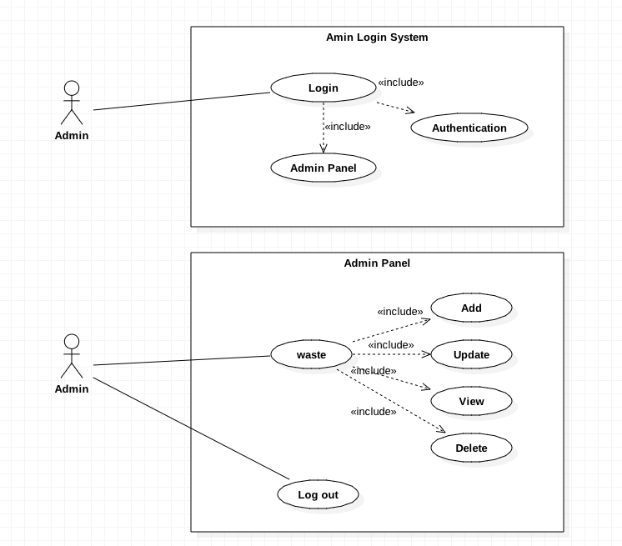

Figure Use case Diagram

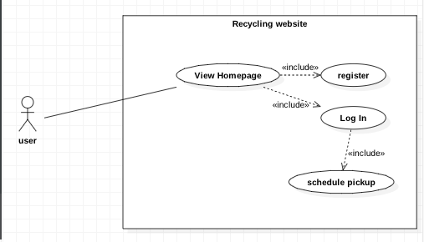

Figure Use case Diagram

# Architecture

As per the definition provided by IEEE. “Architecture is the fundamental organization of a system embodied in its components, their relationships to each other, and to the environment, and the principles guiding its design and evolution”. [IEEE 1471]

Architecture is imperative because of the following reasons:

1. It empowers the usage and further advancement of a framework.
2. It portrays a framework in a design keeping in mind the end goal to empower its use
3. It uncovers the structure of the framework yet conceal the execution subtle elements
4. It attempts to address the necessities of different partners.
5. It helps us to understand the greater part of the use cases and scenarios.

## System Architecture

In this project, MVC design pattern will be adapted to maintain easy change and maintainability. With the help of MVC model, we can enhance the faster development process, support for asynchronous technique. In addition to that, to ensure maintainability of web application of this project without affecting the entire model and to utilize the data without formatting MVC model will be of great use.

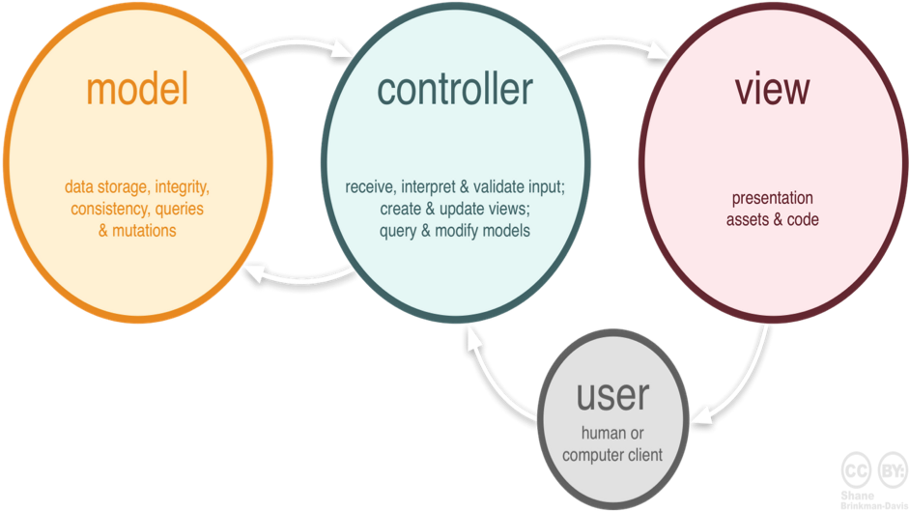

Figure System Architecture

Here, different aspects of web application for this project are separated in MVC framework. Where Model is responsible for controlling data of the application. Likewise, View is in charge of presentation of the data to clients like user interface. And controller acts as the intermediary between model and view for communication.

## Initial Class Diagram

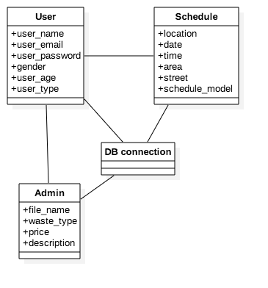

# Conclusion

In conclusion, we have successfully accomplished the objective of analysis phase. By carrying out the thorough detail research and analysis of the project. The end of this project is about promoting the concept of recycling. Therefore, all the necessary core requirements were successfully identified and understood. Furthermore, feasibility study, system requirement specification, prioritization and the architectural design of the system was performed in order to move towards design phase. With this all we were able to foresee how the structure of our system will be and how this project will be formulated by fulfilling all the vital requirements of the system.

# Chapter 3 Design Specification

# Introduction

The way toward characterizing the parts, modules, interfaces and information after approving the requirement specification from the analysis phase to more precise technical process is design. It gives a reasonable proclamation of what the system is supposed to do, with which a high-level design for the system can be produced.

In this, design phase structural model, database model and behavioral model are produced. This model greatly helps to understand the system as per the requirement of user and also helps to communicate and get a generic overview of how the system actually works. This design phase deals with the physical design that satisfies the criteria given in the system requirement specification.

# Structural Model

Here, in this recycling system. Structural model is represented through class diagram that is a part of structural modeling. It only illustrates the static features, which is consistent and does not change over a time as shown below via class diagram. It only describes the architecture of the system

## Class Diagram

Class Diagram provides a generic architectural static overview of the system. It shows the relationship between classes and its functionality. It also provides information for the collaboration amidst the elements or components to establish a structural connection. It

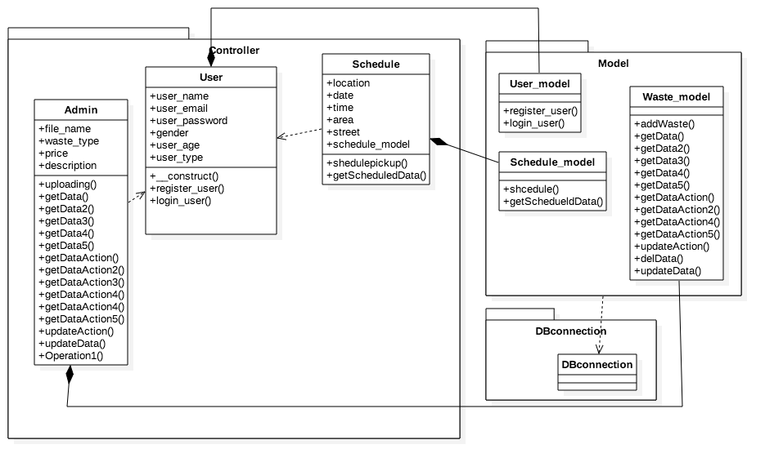

Figure Final Class Diagram

# Database Model

## Entity Relationship Diagram:

An entity relationship diagram is a modeling technique for modeling and representing the database table in a tabular format where an entity modeling done by displaying an interrelationship between the entities. An ER diagram is not only a database modeling method. It is also a way or medium for the communication between various relation in relational database and its attribute. Here, ER diagram is illustrated for the current system as represented below in the diagram.

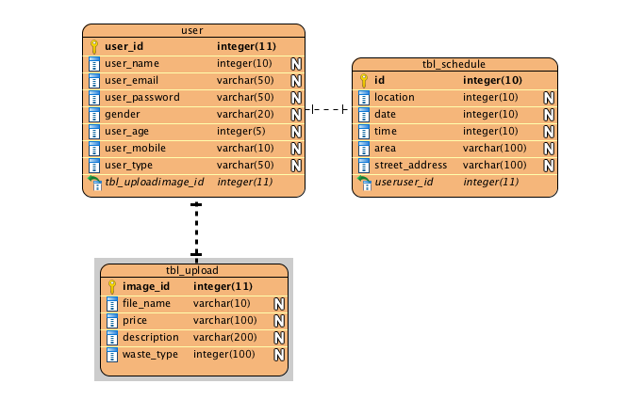

## Data Dictionary:

Data Dictionary is a document or an arrangement of records that contains a database's metadata. Data dictionary is normally hidden from the sight of normal user’s. However, the system admin make an appropriate use of data dictionary. Here, data dictionary aids in providing with the detailed core information of how the data is represented and what data types are being used.

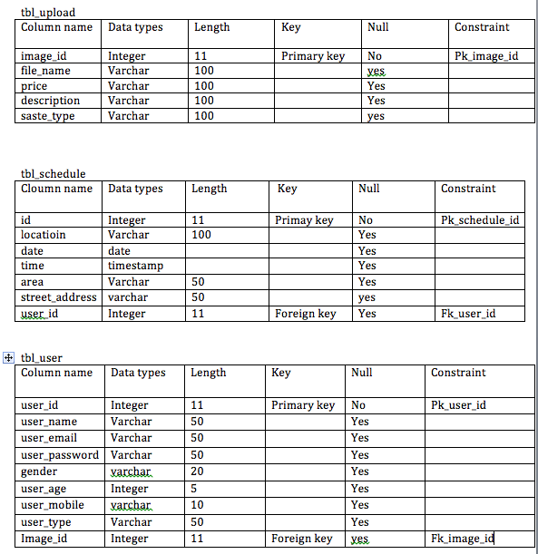

# Behavior Model

Behavioral model characterizes the dynamic parts of framework plan. It portrays how a framework should react to clients and change after some time. It is utilized to depict framework usefulness. The outlines we will use for behavioral model of framework configuration are:

1. Sequence Diagram and
2. Activity Diagram

## Sequence Diagram

The sequential representation diagram demonstrates the arrangement in which the procedures work in the framework for some specific occasion or client connection. This outline displays the interaction between the admin, recycling system and the database. All the process adheres to a sequential flow as illustrated in the represented sequential diagram.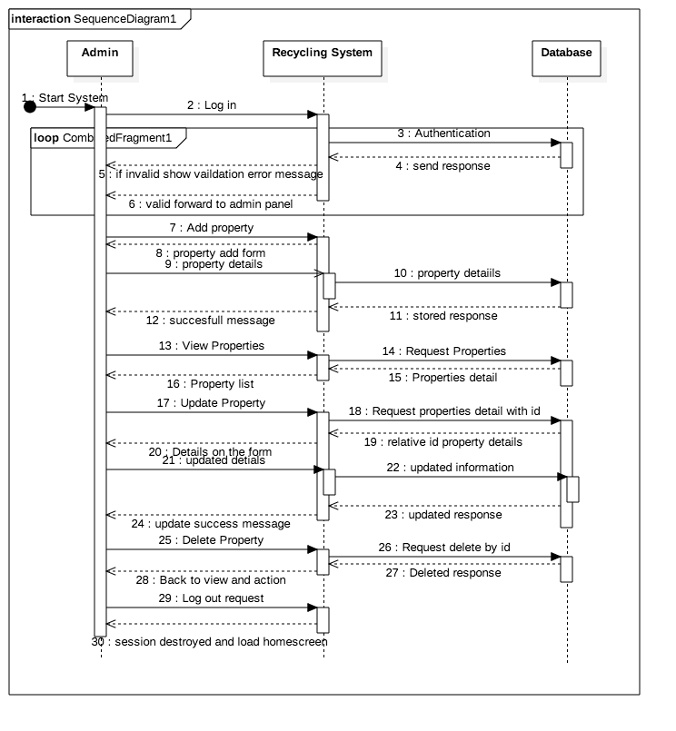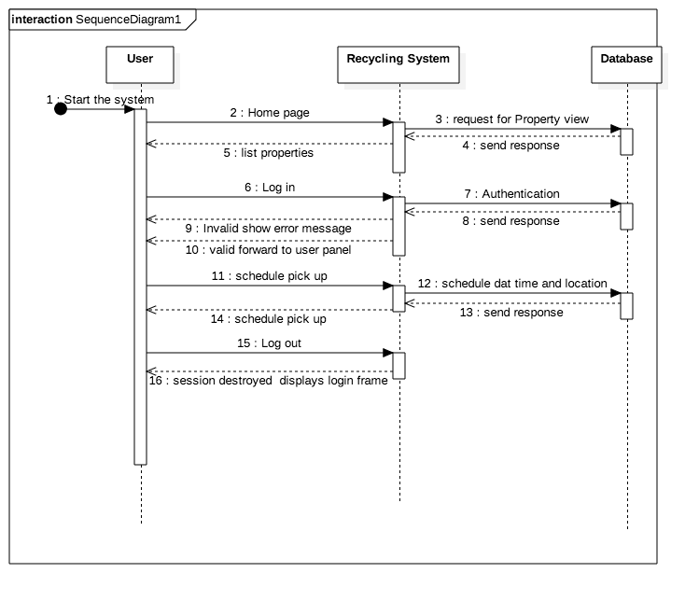

## Activity Diagram

An activity diagram is an action chart that displays the progression of activities in an action graph. Activity diagram gives a generic understanding of how the activities of the system are currently working. With this we can know the flow and understand the nature of system. An activity diagram for this proposed project is as displayed below.

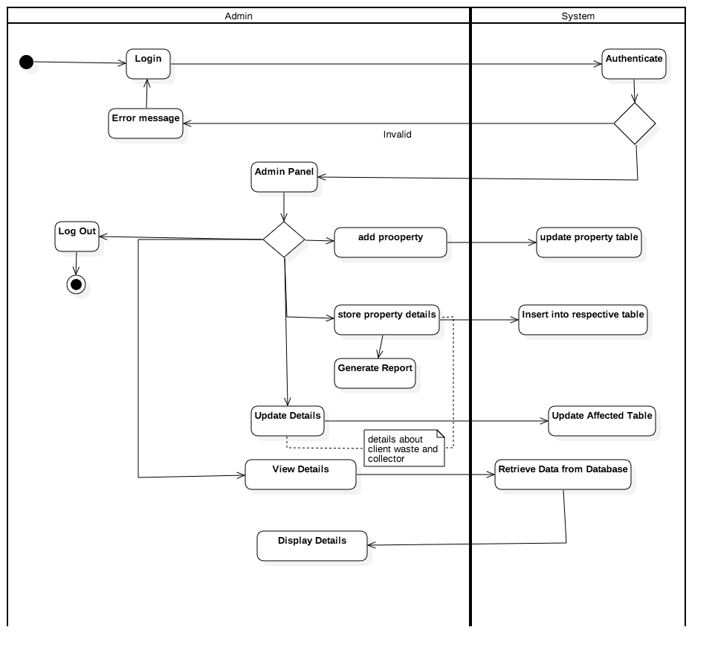

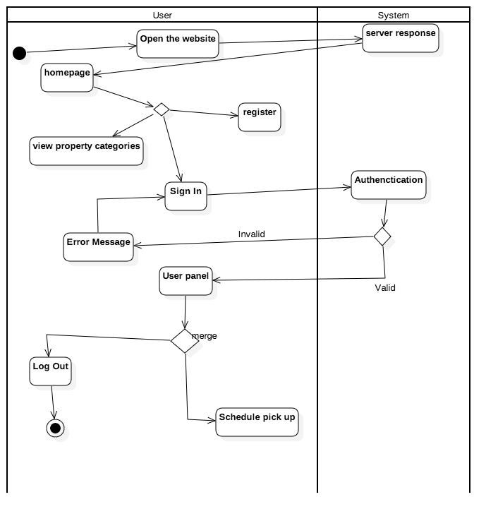

# CHAPTER 4 Implementation

# Introduction

Implementation is the next phase after the design in software development lifecycle. Every steps in software development life follows a certain rule to be in a chronological order of steps. In SDLC, only after the completion of one phase it can proceeds to next and after the design implementation phase is carried out. Here, basically after going through the documents provided from the design phase coding is generally started. Here, coding is done in php language for this recycling website which adapts to the code igniter framework. By adapting to this framework, it automatically organizes the data in module view controller. Hence the implementation phase will be carried out after the completion of design phase and the implementation phase will be in the code igniter framework.

# Programming Language

A programming language is a communication language in computers. It helps computer to understand and interpret the instruction provided via programming language. So, for the building an online website for the recommended system. I preferred to use PHP and MySQL.

# PHP

Here, PHP is utilized in order to bring the designated designed documents into live action. When developing a website via PHP. It is important to ensure that the website that is being developed is in object oriented and the website should be dynamic. So in order to implement the concept of object oriented programming and building the dynamic website. We can make use of certain framework. Here, I chose to build this project in code igniter framework which automatically sets the website or project in the object oriented concept and also the data will be organized in MVC design pattern.

# MySQL:

MySQL is the best available option for every students related in the field of programming. With this we can easily store our records in database. It is a best available option as open source relational database management system. Here, it is utilized in this project for the purpose of developing and web based platform which can perform some basic CRUD operation such as create, retrieve, update and delete. In addition to that we can store manipulate and organize the necessary data’s in the relational database.

# Development Environment

To fulfill the objectives of the project by developing the web based application various tools and software were utilized as part of the development environment. For the development of this project different tools and softwares such as phpstorm v2017.2.4, php version 7, MySQL relational database management system, star UML were utilized. Further than that one of the important open source software XAMPP is used for the development of the project. It is supported in every project and it can be utilized for the development and learning purposes.

# Development Platform

For the successful development of the web based application required for this project. I utilized the most common popular platform that everyone utilizes because of its numerous benefits. So, in this project php is used as the development platform since it is one of the highly favorable and preferred scripting side language used all over the world for the smooth development of web based application

# Chapter 5. Deployment Strategy

# Introduction

This phase incorporates the management of necessary preparation needed to bring the product or software in front of the clients. So that, the client or user can make use of the product without any complexities. In this phase, deployment can be done via data migration or system migration. With data migration , the data zipped file of database query can be unzipped to make use of the database fields and the necessary data storage will be imported in the client side. And with the, system migration all the important codes that were build by the programmers will be loaded in the web servers of the client.

Here, the deployment phase can be carried out by installing the system either parallel or with whole replace of system by full installation.

* + 1. Parallel installation: Parallel installation ensures the safety of current system and it can help to continue the work which was being done and at the same time the new system can be installed too. It is very helpful way of installing in the system that need to be work on without affecting its function.
    2. Full Installation: In this type of installation. The client or user cannot work on their present system, instead they need make their free time available by resuming their current work. Since, when installation is being performed no other work can be done until the system is completely installed.  
         
       User Training

User Training is very important phase of software deployment. Whenever the new software are being deployed. It is not possible to know whether the users can utilize the system or without any instructions. So, in-order to utilize the features of the software to its fullest. User training is an important aspect.

# Conclusion

Here, deployment strategy is carried by considering the need an requirement of the client. It is equally important to provide the handful set of instructions after the development of the software or the product. Since the user may be unaware of the features and services of the software. While deploying the software, it should be installed on client system as pert the client necessity and satisfaction. When installing the system, it should not affect the clients work at most unless and until the client desire for the full installation. Because when full installation is being done, it is important to keep backup of the important data otherwise data might be lost. So this point should be taken into considerations.

# Chapter 6. Other Project issues

# Project Management

## Work Breakdown Structure (WBS and Time Estimate)

A work breakdown structures (WBS) is a graph or a chart that outlines the relationship between the fundamental components, which are decomposed into the smaller activities that are to be performed. The main purpose of WBS is to predict the outcome precisely by organizing and defining the scope of overall project. This is done via hierarchical tree structure where the whole projects are breaks down to more specific and manageable chunks. Which helps to monitor the project by entrusting the responsibilities and managing the project in a controlled manner. Ultimately, it helps to ensure that everything is double-checked and nothing is overlapped. WBS helps us to ensure proper time management for the completion of each and every phase of development methods. Here, the working components are modularized so that the project could be developed in more effective and efficient way.

Given below is the complete Work Breakdown Structure

Figure Work Breakdown Structure

# Risk Management

While working in a project we may encounter different sorts of risk. It might have a greater negative influence on our project resulting in the delaying in completion of different phases of system development. So, we need to be prepared to face such unlikelihood by managing and identifying the likelihood occurrence of such threats with their negative impacts in our system.

There are four steps for managing and controlling risks on the project

* Identifying Risks
* Assessing the impact of risks
* Alleviating critical risk
* Controlling risks

To predict the likelihood of each impact of identified risks we can use the relation

*Impact=Likelihood x Consequences*

Based on the scale illustrated in the Table 3.1 and Table 3.2 the likelihood and consequences of the risk are determined

|  |  |
| --- | --- |
| **Likelihood** | **Values** |
| Low | 1 |
| Medium | 2 |
| High | 3 |

*Table 3.1: Risk Likelihood Values (Dawson 2005)*

|  |  |
| --- | --- |
| **Consequence** | **Value** |
| Very Low | 1 |
| Low | 2 |
| Medium | 3 |
| High | 4 |
| Very High | 5 |

*Table 3.2: Risk Consequence Value (Dawson 2005)*

The tabular representation illustrated below represents the risk and their possible consequence value with regards to the vale assigned from the above table. The appropriate measures to mitigate the risk are present on the end column.

|  |  |  |  |  |
| --- | --- | --- | --- | --- |
| **Risk** | **Likelihood** | **Consequence** | **Impact** | **Action** |
| Scarce of required resources | 1 | 4 | 4 | Research the resource required and be well prepared to begin with. |
| Flaw in estimation and scheduling | 2 | 5 | 10 | Should concentrates more on planning of the project analysis should be done well |
| System Failure | 1 | 5 | 5 | Timely maintenance and backup should be done on regular basis |
| Illness | 3 | 2 | 6 | Time lost by the sick leave should be cover by working extra hours. |
| Power Cut | 1 | 4 | 4 | Extra back up power should used |
| Disaster | 1 | 4 | 4 | External backup and cloud-based backup should be done so that the system will not be affected. |
| Human Error | 4 | 3 | 12 | Double check and correction in the development phase should be done carefully |

# Configuration Management

Configuration Management is the process that tends to maintain integrity over time by preserving the systematic changes so that it could be accessed when necessary. It ensures that amendment in any segment will not have any effect on the other stages of project. It facilitates easy backup of the project artifacts. It maintains the consistency and discipline form implementing any amendments in the artifacts.

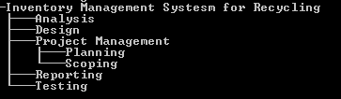

## Milestones

Milestones are the particular point in time, which determines whether or not the project is making any positive development. It ‘s a reference signal post to check the advancement of project that symbolizes the major turning point or decision point within a project. It helps project manager to successfully predict the direction of project, whether it is on schedule or not. It sums up an important value in a project management. Milestone has no duration but it has a fixed dates. It is a unique event that needs more focus. It helps to assure to further advance of project and also to verify on time scheduling of a project for overall development within a fixed date to accurately predict the on time completion of the project.

The table below illustrates the major milestones and their indicated planned deliver dates.

|  |  |
| --- | --- |
| **Milestones** | **Dates** |
| Scoping | Aug 4, 2017 |
| Project Proposal | July 14, 2017 |
| Use Cases | July 25, 2017 |
| Analysis Specification | Aug 1, 2017 |
| Design Specification | Aug 23, 2017 |
| Build Database | Sept 1, 2017 |
| Coding | Sept 15, 2017 |
| Implementation | Sept 15, 2017 |
| Integration Testing | October 9, 2017 |
| Testing | October 9, 2017 |
| User Manual | October 12, 2017 |
| Reporting | October 20, 2017 |

Table: Anticipated Milestones

The above shown tabular representation determines the estimated completion of important phases of system development as milestone of the project. The above mention time period is determined by focusing on the complexity level and maximum period of time that is essential for the completion of such phases of system development

## Schedule

The proper planning for the time estimation of the different activities in this project is done via ProjectLibre. The diagram below illustrates the time management that should be given for the different phases of development. It is done via specifying the main objectives in systematic order to complete the project in sequential order and considering the milestones and the time management of respective development phases that are to be completed on time. With the help of Gantt Chart the time management for the project will be estimated and it will helps us to concentrate and manage our time accordingly. Scheduling also helps to keep a regular track of progress report. It helps project manager to determine the pace of development of different phases. It also helps us to allocate our time with respective to the time needed for the completion of modularized working components.

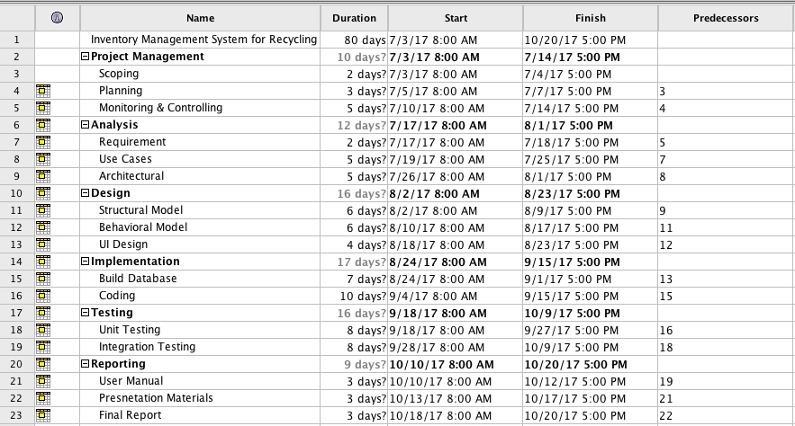

Figure Gantt Chart 1

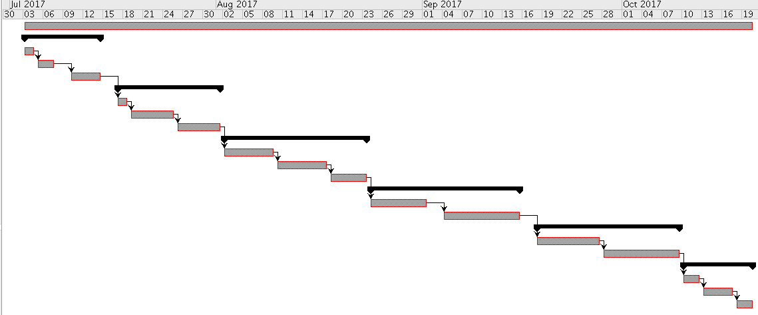

Figure Gantt Chart 2

# Testing

Testing is a standout amongst the most vital stage that the SDLC comprises. It should be performed before hand the organization so the right framework or programming is conveyed that satisfies the customer's necessities and not prompt customer's mistake and disappointment. The way toward testing is utilized to decide whether there are any sort imperfections or missing necessities on the created programming application thus that it could be redressed before the conveyance of the last item guaranteeing the quality and client's fulfillment.

There are various sorts of testing structure which each testing spends significant time in the trial of certain part of the completed application.

Black-box Testing: In this test, just the yield of a specific usefulness is tried encouraging the contribution to it without knowing the inside working rationale of the application.

White Box Testing: rather than discovery testing, this testing is a definite trial of the product, the structure of code and the rationale that backings its capacities.

# Chapter 7. Future Work and Enhancement

To improve this project it needs to have additional functionality and services. This project was developed as per the feasibility study and interoperability study and various factors. With this research I was able to develop the project that was feasible only for the ring road are side of Kathmandu. However, in near future it will be developed in such a way that this project will be feasible all around the country and additional services besides the recycling will be also added in order to have a productive end results and user satisfaction. In near future the website will incorporate payment gateway facility and messaging facility too. Furthermore there will additional addition of services for organic decomposer and utilizing all types of waste.

# Appendix

## Appendix 1

### Black Box Testing

Table : Test Cases and Test Results

|  |  |
| --- | --- |
| **Test Case** | 1 |
| **Purpose** | To check whether registration works or not |
| **Test Data** | Name, email and password were inserted as input |
| **Expected Result** | The user should be registered and taken to the dashboard |
| **Actual Result** | The user was registered and taken to the dashboard |
| **Conclusion** | Test was successful |

|  |  |
| --- | --- |
| **Test Case** | 2 |
| **Purpose** | To check whether login works or not |
| **Test Data** | Username and password were the inputs |
| **Expected Result** | The dashboard needs to appear |
| **Actual Result** | The user was logged in and taken to the dashboard |
| **Conclusion** | Test was successful |

|  |  |
| --- | --- |
| **Test Case** | 3 |
| **Purpose** | To check whether the admin is able to add new property |
| **Test Data** | The necessary property details were inserted |
| **Expected Result** | The success message need to be alerted with new property addition |
| **Actual Result** | The property was added and the message was alerted and the admin was redirected to the dashboard |
| **Conclusion** | Test was successful |

|  |  |
| --- | --- |
| **Test Case** | 4 |
| **Purpose** | To check whether the property is displayed on the dashboard |
| **Test Data** | The property inserted |
| **Expected Result** | The properties will appear on both the admin and user dashboard |
| **Actual Result** | After the property was added the properties were displayed on both the admin and user dashboard |
| **Conclusion** | Test was successful |

|  |  |
| --- | --- |
| **Test Case** | 5 |
| **Purpose** | To check the property of details is recorded or not |
| **Test Data** | Property info |
| **Expected Result** | The properties will be listed and will be displayed i |
| **Actual Result** | The properties were listed as expected |
| **Conclusion** | Test was successful |

|  |  |
| --- | --- |
| **Test Case** | 6 |
| **Purpose** | To check whether properties can be updated by admin |
| **Test Data** | New info on some fields |
| **Expected Result** | The success message will displayed with the appropriate update |
| **Actual Result** | Property was successfully updated and relative message was displayed |
| **Conclusion** | Test was successful |

|  |  |
| --- | --- |
| **Test Case** | 7 |
| **Purpose** | To check if the delete function works |
| **Test Data** | Property details view |
| **Expected Result** | The data will be deleted and a successful message will be displayed |
| **Actual Result** | The property was deleted and appropriate message was displayed |
| **Conclusion** | Test was successful |

|  |  |
| --- | --- |
| **Test Case** | 8 |
| **Purpose** | To check the scheduling function works for the user |
| **Test Data** | The user details along with some required property details |
| **Expected Result** | The reservation details will be added to the database and the appropriate message will be displayed |
| **Actual Result** | The reservation was successful as expected |
| **Conclusion** | Test was successful |

|  |  |
| --- | --- |
| **Test Case** | 9 |
| **Purpose** | To check the validation works on register, login and all the forms |
| **Test Data** | Necessary form related inputs |
| **Expected Result** | The system could validate the data inserted on the form fields at submit event and notify the admin or user for any invalid input or empty input fields |
| **Actual Result** | The validation worked as expected and the necessary message was displayed for any empty field or invalid input |
| **Conclusion** | Test was successful |

|  |  |
| --- | --- |
| **Test Case** | 10 |
| **Purpose** | To check whether the logout function works |
| **Test Data** | Logout button |
| **Expected Result** | The admin and users will logged out and redirected to home page |
| **Actual Result** | Both were logged out form the website and taken to the home page |
| **Conclusion** | Test was successful |

#### Test Scripts

1. Register  
   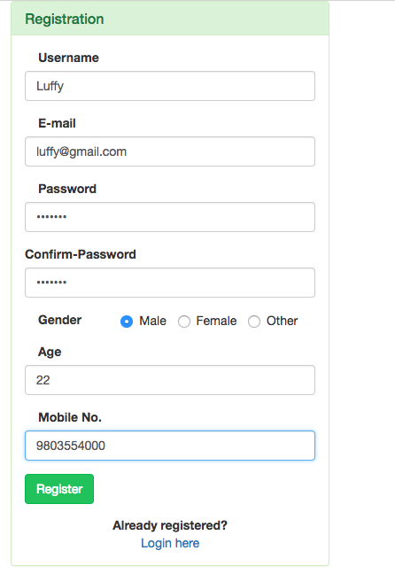

Figure Registering

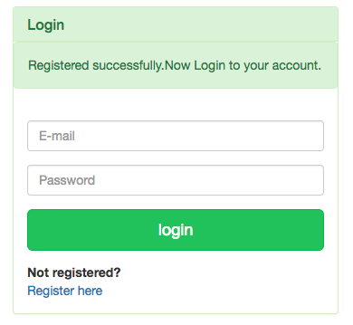

Figure Successfully Registered

1. Login  
   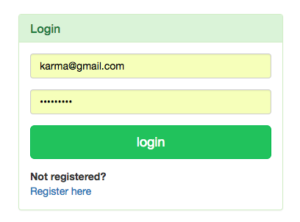

Figure Login Form

1. Add Property  
   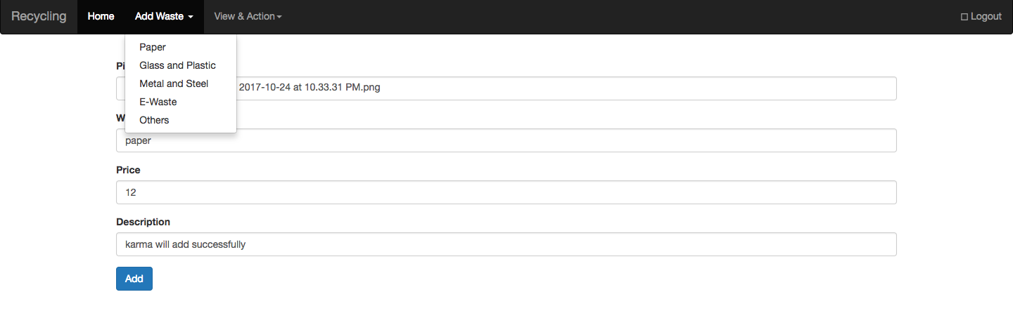

Figure Add property

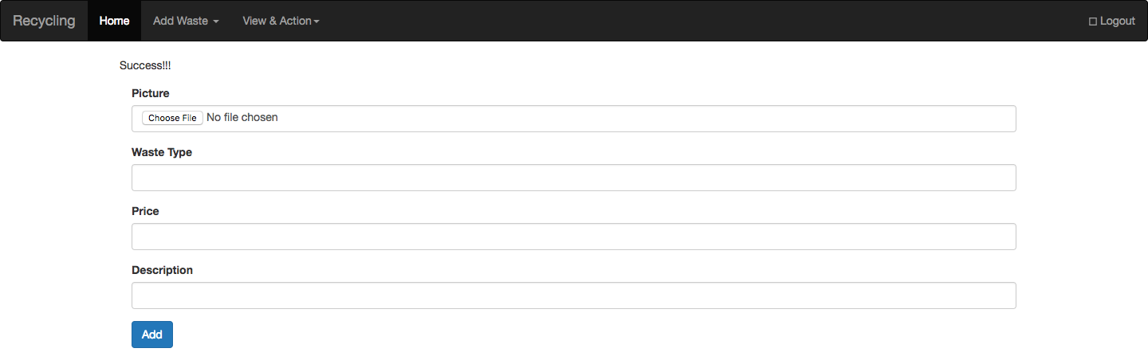

1. View Property  
   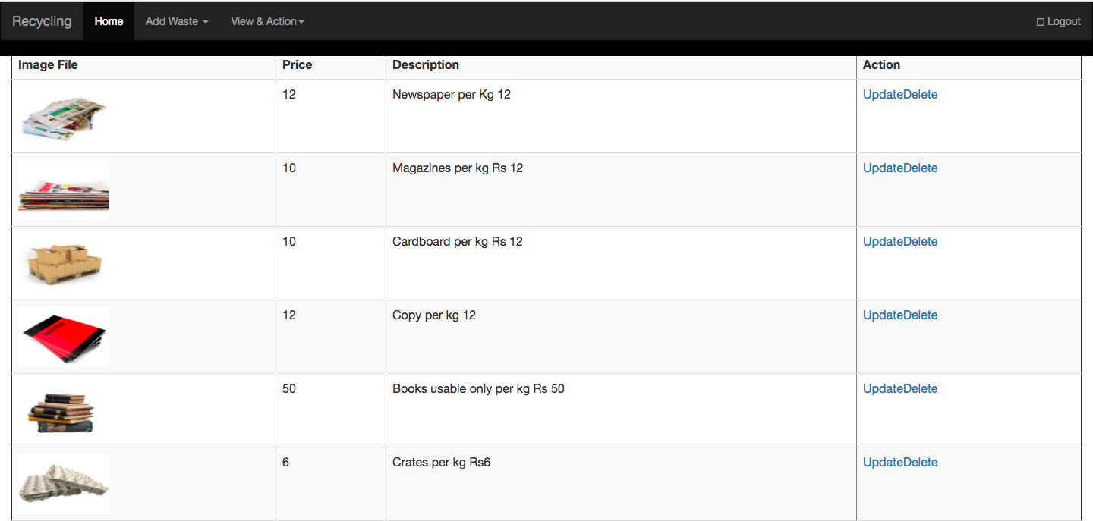

Figure Admin distinct view property  
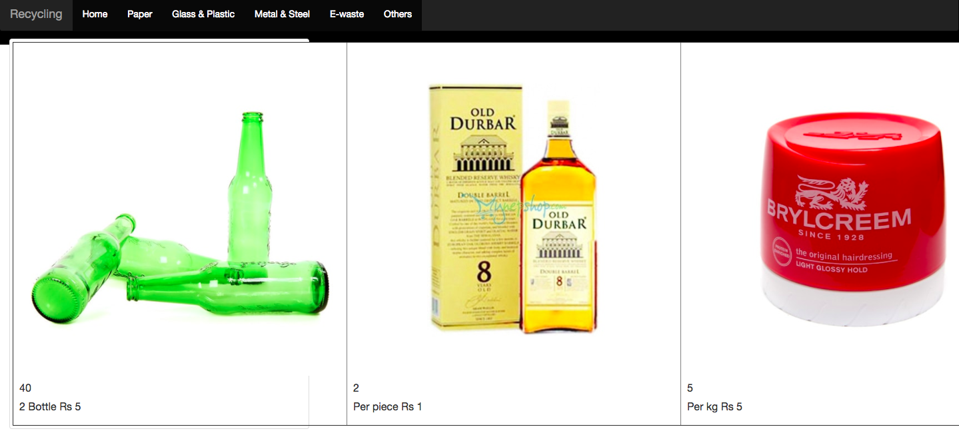

Figure User view according to property type

1. Recorded Details  
   

Figure Record of Distinct property  
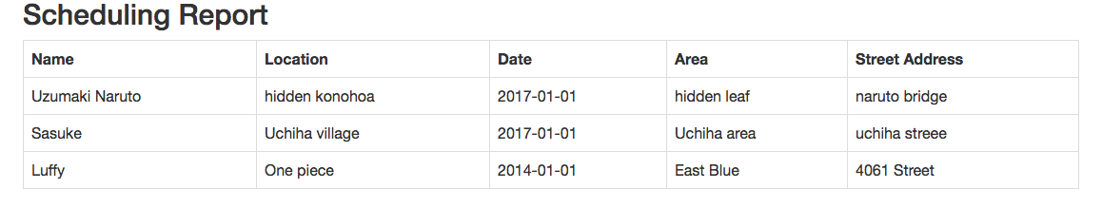

Figure Record of Scheduled time by users

1. Update Property  
   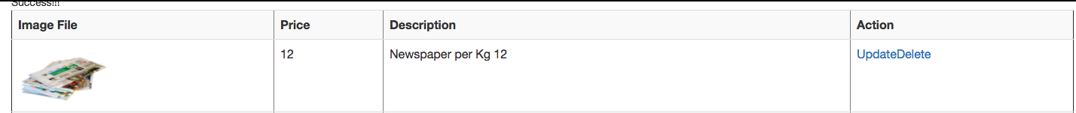
2. Delete Property
3. Scheduling  
   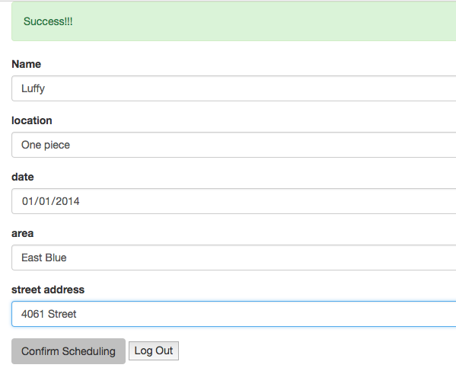

Figure scheduling

1. Necessary Validations  
   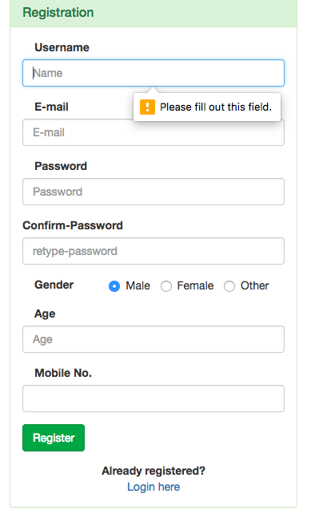

Figure Registration form validation  
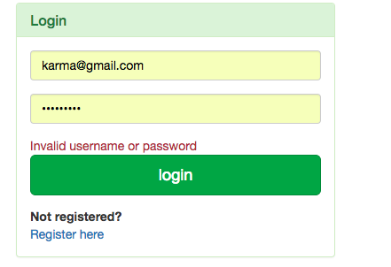

Figure Login validation

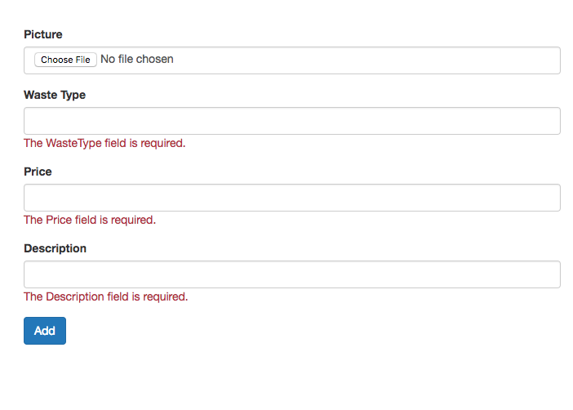

Figure Validation for Add property

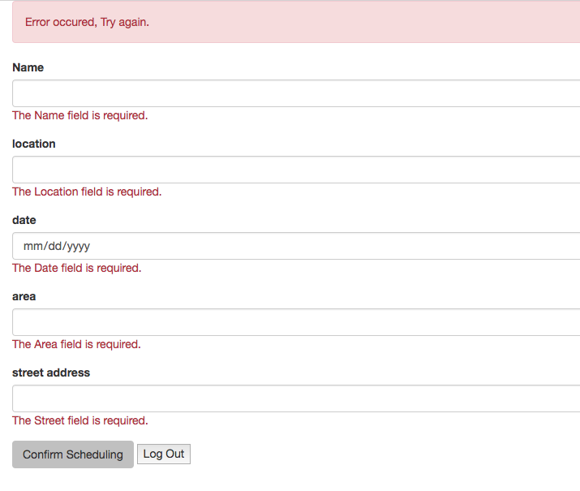

Figure Scheduling validation

1. Log Out



Figure Log out

# Appendix 2

## White Box Testing

### Test Scripts

1. Register  
   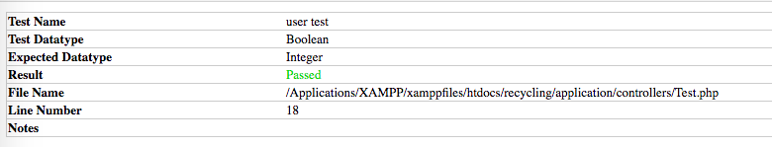

Figure Registered Test

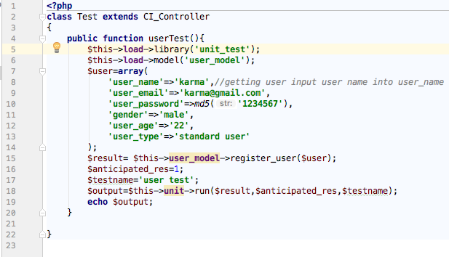

Figure For Register Testing

1. Login
2. Add Test  
   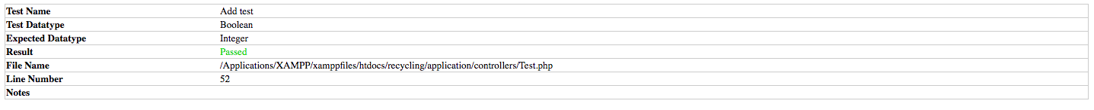

Figure AddTest Result

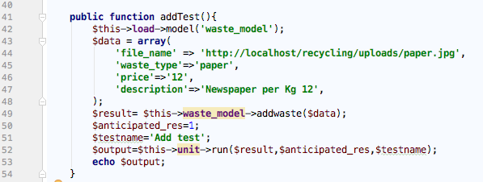

1. View Property Admin  
   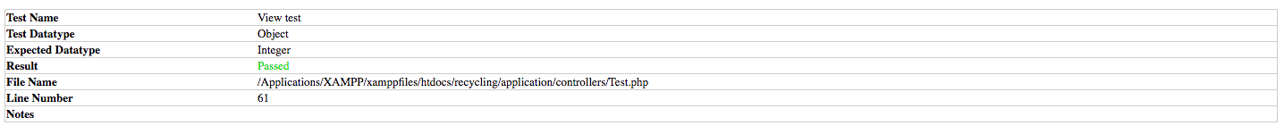

Figure Result View  
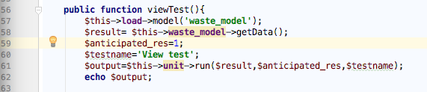

Figure View Test Script

1. Record Details  
   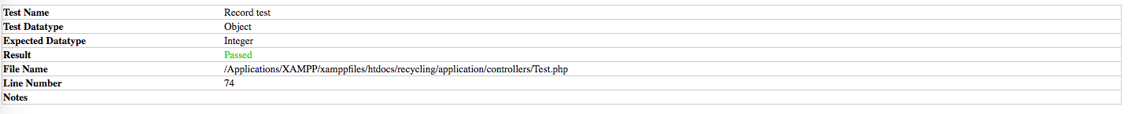

Figure Record Test Result

1. 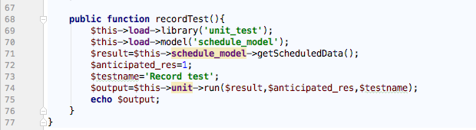

Figure Record Test Script

1. Update  
   

Figure Update Result

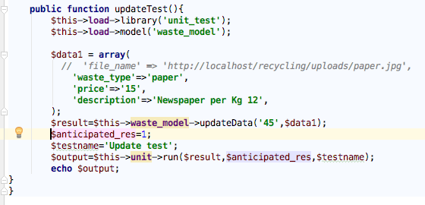

Figure Update Test Script

1. Delete  
   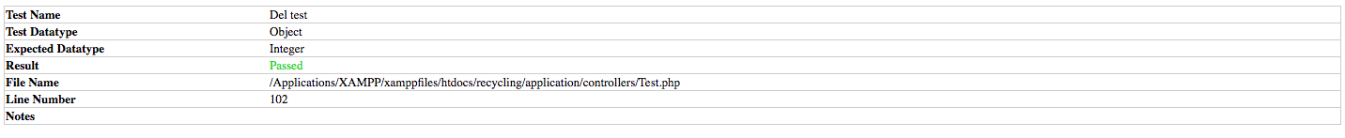

Figure Del Test Result  
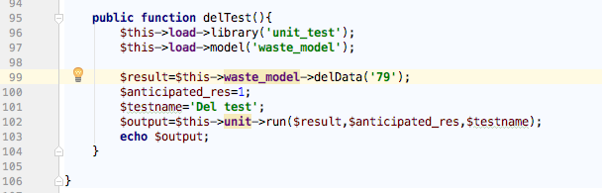

Figure Del Test Script

1. Scheduling  
   

Figure Schedule Test

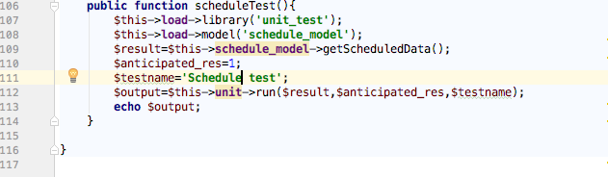

Figure Schedule Test Script

# Conclusion:

Here, project was successfully developed adhering to the soft system approach. While developing this website waterfall methodology was adapted. Since it ensures the completion of each phase. Without the completion of each phase in this methodology It is not possible to move forward to next phase. In order to successfully develop this project various plans were made by creating the schedules and breaking down the work into sub tasks. And after successful completion of analysis, design and implementation stage. Testing was done to make sure everything was fine.