Binary Scintillation Exchange Format (BiScEF) - Version 1.1
The format is intended to be used for archiving and exchange of scintillation data. It is intended to be flexible and extensible. Although it defines many parameteres and datasets, only a minimum set of information is mandatory. This allows the file contents to be adjusted for different setups, while guaranteeing the minimum amount of information required to understand and use the data.

File format: NetCDF4 / HDF5
(File is both a valid NetCDF4 file and a valid HDF5 file)

See e.g.: https://docs.unidata.ucar.edu/netcdf-c/current/interoperability_hdf5.html
"Assuming a HDF5 file is written in accordance with the netCDF-4 rules (i.e. no strange types, no looping groups), and assuming that every dataset has a dimension scale attached to each dimension, the netCDF-4 API can be used to read and edit the file, quite easily."

https://docs.unidata.ucar.edu/nug/current/netcdf_data_set_components.html

File naming convention:
It is recommended to use one of these naming schemes:
[CountryCode][ReceiverCode][yyyy][mm][dd].nc (daily files)
[CountryCode][ReceiverCode][yyyy][mm][dd]_[hh].nc (hourly files)
[CountryCode][ReceiverCode][yyyy][mm][dd]_n[serialnumber].nc (alternative numbering scheme)
[CountryCode][ReceiverCode]_n[serialnumber].nc (alternative numbering scheme)

[ReceiverCode] = 4-character identifier
[CountryCode] = Country code for receiver site. ISO 3166-1 alpha-3 (e.g. "NOR")
[yyyy] = year, 4 digits
[mm] = month, 2 digits
[dd] = day, 2 digits
[hh] = hour, 2 digits
[serialnumber] = An integer. To be used if a different numbering scheme is wanted, e.g. numbering events.

File contents:
Each file contains data from 1 receiver.
The time period contained within is recommended to be 1 day or less, but the format allows for more.

Metadata:
Attributes at root level in the file:

Name | Type | Description | Mandatory?
BiScEFVersion | String | The version of the format used in this file.  Consists of a string of the form "1.0", where the first number is the major version and the second number is the minor version.  Files of the same major version are backwards compatible. | Yes
Hardware information
ReceiverType | String | Model name of receiver | Yes
ReceiverFWVersion | String | Receiver firmware version | No
ReceiverCode | String | Receiver identifier (typically, a 4-letter code) | Yes
ReceiverIdNum | integer | Receiver id number  (Not internationally/interagency coordinated. Numbering should be valid within the Agency that collected the data) | No
ReceiverLongitude | float | Approximate geographical Longitude, in degrees East, of the receiver.  Should be accurate to 0.01 degrees or better. | Yes
ReceiverLatitude | float | Approximate geographical Latitude, in degrees North, of the receiver.  Should be accurate to 0.01 degrees or better. | Yes
ReceiverHeight | float | Approximate geographical Height, in meters, of the receiver.  Height is the height above the WGS-84 ellipsoid. | No
ReceiverCoord | float[3] | Approximate geocentric coordinate (x, y, z) of the receiver, in meters. | No
ReceiverSamplingRate | float | Sampling rate of the receiver, in Hz. | Yes
AntennaType | String | Model name of antenna.  Not mandatory, but recommended. | No
AntennaSerialNo | String | Serial number of antenna | No
File contents information
Constellations | String | A string specifying which constellations are allowed in this file. (i.e. other constellation are excluded)  Each constellation is specified with a single character:  'G' = GPS  'E' = Galileo  'R' = GLONASS  'C' = BeiDou  'S' = SBAS  'J' = QZSS  'I' = IRNSS | No
SignalStatement | String | A textual description defining what is used as "signal 1", "signal 2" and "signal 3" in this file.  Not mandatory, but recommended.  Currently we recommend using this definition:  "Sig1" means L1CA for GPS/GLONASS/SBAS/QZSS, L1BC for Galileo, B1 for BeiDou.  "Sig2" means L2C for GPS/GLONASS/QZSS, E5a for Galileo, L5 for SBAS, B2 for BeiDou.  "Sig3" means L5 for GPS/QZSS or E5b for Galileo. | No
Processing information
PhaseHighPassFilterFreqCutoff | float | Cutoff frequency of the high-pass filter used for the phase index computation | Yes
PhaseHighPassFilterType | String | Short description of the type of filter used for the high-pass filtering of phase. (e.g. "6th order Butterworth") | Yes
ElevationCutoff | float | Elevation mask [degrees]. All data below this elevation has been excluded from the file. | Yes
SLMHeight | float | Height of the ionospheric Single Layer, used when computing the Longitude/Latitude of the Ionospheric Pierce Point (IPP). In meters.  Mandatory if the datasets "Longitude" and "Latitude" are provided. | Sometimes
Administrative information
Agency | String | Agency/Organization/Other that collected the data. | No
Country | String | Country code for the country in which the receiver is located, using the standard ISO 3166-1 alpha-3 | No
Contact | String | Contact email address | No
DOI | String | Digital Object Identifier (DOI) for data citation | No
License | String | Licensing terms for the data in the file | No
Comment | String | Any additional information that does not fit into the other fields. | No

Data:
Data are organized as separate datasets containing 1D arrays in time.
All arrays are of the same length, such that all data at the same index are associated.
The file does not need to contain all types of data.
In fact, none of the scintillation data types are mandatory, but it is recommended to provide at least the main scintillation index parameters ("S4s1" and "Phi60s1").

All datasets in the file share the same dimension "UNIXTime". A dataset/variable named "UNIXTime" also exists, containing the values of that dimension axis. This has been chosen to provide all data on a common time axis which is not dependent on the GNSS constellation, and is supported by all computer systems.
There are datasets defined for the commonly used GPS time parameters (week number and time-of-week), but since these are not used as the dimension variable they are not mandatory.

Name | Type | Description | Mandatory?
Time parameters
GPSWeek | integer[] | GPS week | No
TOW | integer[] | GPS second-of-week | No
UNIXTime | integer64[] | Seconds since Jan 01 1970. (UTC) | Yes
Satellite parameters
SVID | integer[] | Satellite identifier. See separate section for full description. | Yes
Azimuth | float[] | Azimuth of satellite [degrees] | Yes
Elevation | float[] | Elevation of satellite [degrees] | Yes
Longitude | float[] | Longitude of the Ionospheric Pierce Point (IPP), in degrees East | No
Latitude | float[] | Latitude of the Ionospheric Pierce Point (IPP), in degrees North | No
Septentrio-specific parameters
Sept_Rxstate | integer[] | Value of the RxState field of the ReceiverStatus SBF block | No
Sept_sbf2ismrversion | integer[] | sbf2ismr version number | No
Data, per signal (# = 1, 2 or 3)
AvgCN0s# | float[] | Average signal # C/N0 over the last minute [dB-Hz] | No
S4s# | float[] | Corrected S4 on signal # | No
S4uncors# | float[] | Uncorrected S4 on signal # | No
S4cors# | float[] | Correction to S4 on signal # | No
Phi01s# | float[] | 1-second phase sigma on signal # [radians] | No
Phi03s# | float[] | 3-second phase sigma on signal # [radians] | No
Phi10s# | float[] | 10-second phase sigma on signal # [radians] | No
Phi30s# | float[] | 30-second phase sigma on signal # [radians] | No
Phi60s# | float[] | 60-second phase sigma on signal # [radians] | No
AvgCCDs# | float[] | Average code-carrier divergence for signal # [meters] | No
SigmaCCDs# | float[] | Standard deviation of code-carrier divergence for signal # [meters] | No
lockts# | integer[] | Signal lock time for signal # [seconds] | No
SIs# | float[] | SI index on signal # | No
SInums# | float[] | Numerator of SI index on signal # | No
ps# | float[] | Spectral slope for detrended phase in the 0.1 to 25 Hz range for signal # | No
Ts# | float[] | Phase power spectral density at 1 Hz on signal # [rad^2/Hz] | No
plows# | float[] | Spectral slope for detrended phase in the 0.1 to 8 Hz range for signal # | No
pmids# | float[] | Spectral slope for detrended phase in the 8 to 16 Hz range for signal # | No
phighs# | float[] | Spectral slope for detrended phase in the 16 to 25 Hz range for signal # | No
Data, from signal combinations
TEC45 | float[] | TEC at TOW-45 sec, with calibration [TECU] | No
dTEC6045 | float[] | dTEC from TOW-60 to TOW-45 [TECU] | No
TEC30 | float[] | TEC at TOW-30 sec, with calibration [TECU] | No
dTEC4530 | float[] | dTEC from TOW-45 to TOW-30 [TECU] | No
TEC15 | float[] | TEC at TOW-15 sec, with calibration [TECU] | No
dTEC3015 | float[] | dTEC from TOW-30 to TOW-15 [TECU] | No
TECtow | float[] | TEC at TOW, with calibration [TECU] | No
TECtow_uncal | float[] | TEC at TOW, without calibration [TECU] | No
dTEC15tow | float[] | dTEC from TOW-15 to TOW [TECU] | No
locktTEC | integer[] | Lock time on second frequency used for TEC computation [seconds] | No
CN0TEC | float[] | Average C/N0 of second frequency used for TEC computation [dB-Hz] | No
ROTIFullHz | float[] | Rate-of-TEC index, based on full time resolution signal 1 and signal 2. | No
ROTI1Hz | float[] | Rate-of-TEC index, based on signal 1 and signal 2 decimated to 1 Hz resolution. | No

Attributes associated with each dataset:

Name | Type | Description | Mandatory?
Description | String | A short textual description of the variable contained in the dataset. E.g.:  "60-second phase sigma on signal 1" | Yes
Unit | String | The physical unit of the dataset.  Can be omitted for datasets that do not have a physical unit.  E.g: "radians" | Sometimes

File Structure:
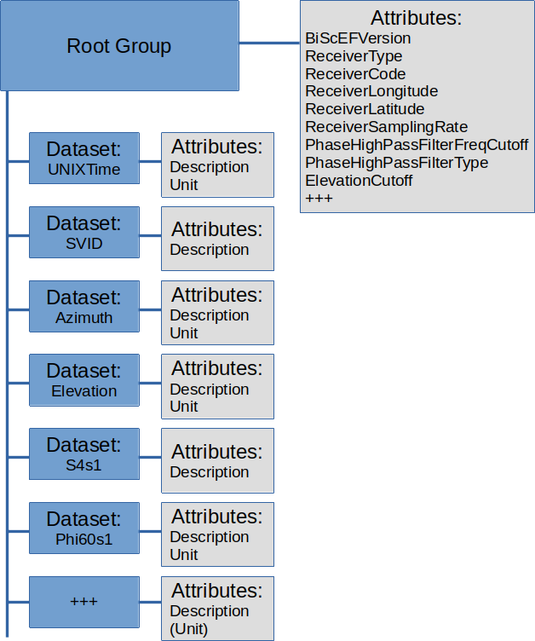

SVID:
Value | Description | RINEX code
0 | Do-not-use value | N/A
1-37 | PRN number of a GPS satellite | Gnn (nn = SVID)
38-61 | Slot number of a GLONASS satellite with an offset of 37 (R01 to R24) | Rnn (nn = SVID-37)
62 | GLONASS satellite of which the slot number is not known | N/A
63-68 | Slot number of a GLONASS satellite with an offset of 38 (R25 to R30) | Rnn (nn = SVID-38)
71-106 | PRN number of a GALILEO satellite with an offset of 70 | Enn (nn = SVID-70)
107-119 | L-Band (MSS) satellite. Corresponding satellite name can be found in the LBandBeams block. | N/A
120-140 | PRN number of an SBAS satellite (S120 to S140) | Snn (nn = SVID-100)
141-180 | PRN number of a BeiDou satellite with an offset of 140 | Cnn (nn = SVID-140)
181-187 | PRN number of a QZSS satellite with an offset of 180 | Jnn (nn = SVID-180)
191-197 | PRN number of a NavIC/IRNSS satellite with an offset of 190 (I01 to I07) | Inn (nn = SVID-190)
198-215 | PRN number of an SBAS satellite with an offset of 57 (S141 to S158) | Snn (nn = SVID-157)
216-222 | PRN number of a NavIC/IRNSS satellite with an offset of 208 (I08 to I14) | Inn (nn = SVID-208)
223-245 | PRN number of a BeiDou satellite with an offset of 182 (C41 to C63) | Cnn (nn = SVID-182)

Phixx indices
Phi01 is the average of the 60 standard deviations computed over 1-s intervals during the last minute.
Phi03 is the average of the 20 standard deviations computed over 3-s intervals during the last minute.
Phi10 is the average of the 6 standard deviations computed over 10-s intervals during the last minute.
Phi30 is the average of the 2 standard deviations computed over 30-s intervals during the last minute.
Phi60 is the standard deviation computed over the whole last minute.

S4 correction
The S4 correction accounts for the thermal noise contribution to the S4. The corrected S4 index (S4s#) is related to the uncorrected S4 (S4uncors#) and its correction (S4cors#) in this way:

If the S4 correction is greater than its uncorrected value, the corrected S4 value is set to zero.

Note on compression
If compression is desired, it is recommended to use the internal compression routines of the HDF5/NetCDF4 format. See e.g.:
https://www.hdfgroup.org/2015/04/hdf5-data-compression-demystified-1/
https://www.hdfgroup.org/2017/05/hdf5-data-compression-demystified-2-performance-tuning/

Plotting script - Time series and skyplots
This format description is distributed with a python script that can be used to generate a selection of plots from this kind of file.
If run with the option "-h", it prints instructions for usage:
$ python3 MakeDataPlots.py -h
usage: MakeDataPlots.py [-h] [-G] [-R] [-E] [-C] [-S] [--plot_ts_simple]
[--plot_ts_box] [--plot_sky] [--plot_heat_sigPhi]
[--elevationCutoff ELEVATIONCUTOFF]
filename

BiScEF data plotter

positional arguments:
filename Filename of input data file

optional arguments:
-h, --help show this help message and exit
-G, --GPS Make plots for GPS (default: False)
-R, --GLONASS Make plots for GLONASS (default: False)
-E, --Galileo Make plots for Galileo (default: False)
-C, --BeiDou Make plots for BeiDou (default: False)
-S, --SBAS Make plots for SBAS (default: False)
--plot_ts_simple Plot simple time series (default: False)
--plot_ts_box Plot box-and-whiskers time series (default: False)
--plot_sky Plot skyplots (default: False)
--plot_heat_sigPhi Plot 2d histogram of sigma phi over time with mean
sigma phi (default: False)
--elevationCutoff ELEVATIONCUTOFF
Set elevation angle cutoff (default: 5)

NB: This script assumes that the file contains data from one day (or less)

The following figures show examples of plots generated by the script.
The box-and-whiskers plots use the default settings in matplotlib: The box extends from the lower to upper quartile values of the data, with a line at the median. The whiskers extend from the box to show the range of the data. Outlier points are those past the end of the whiskers.

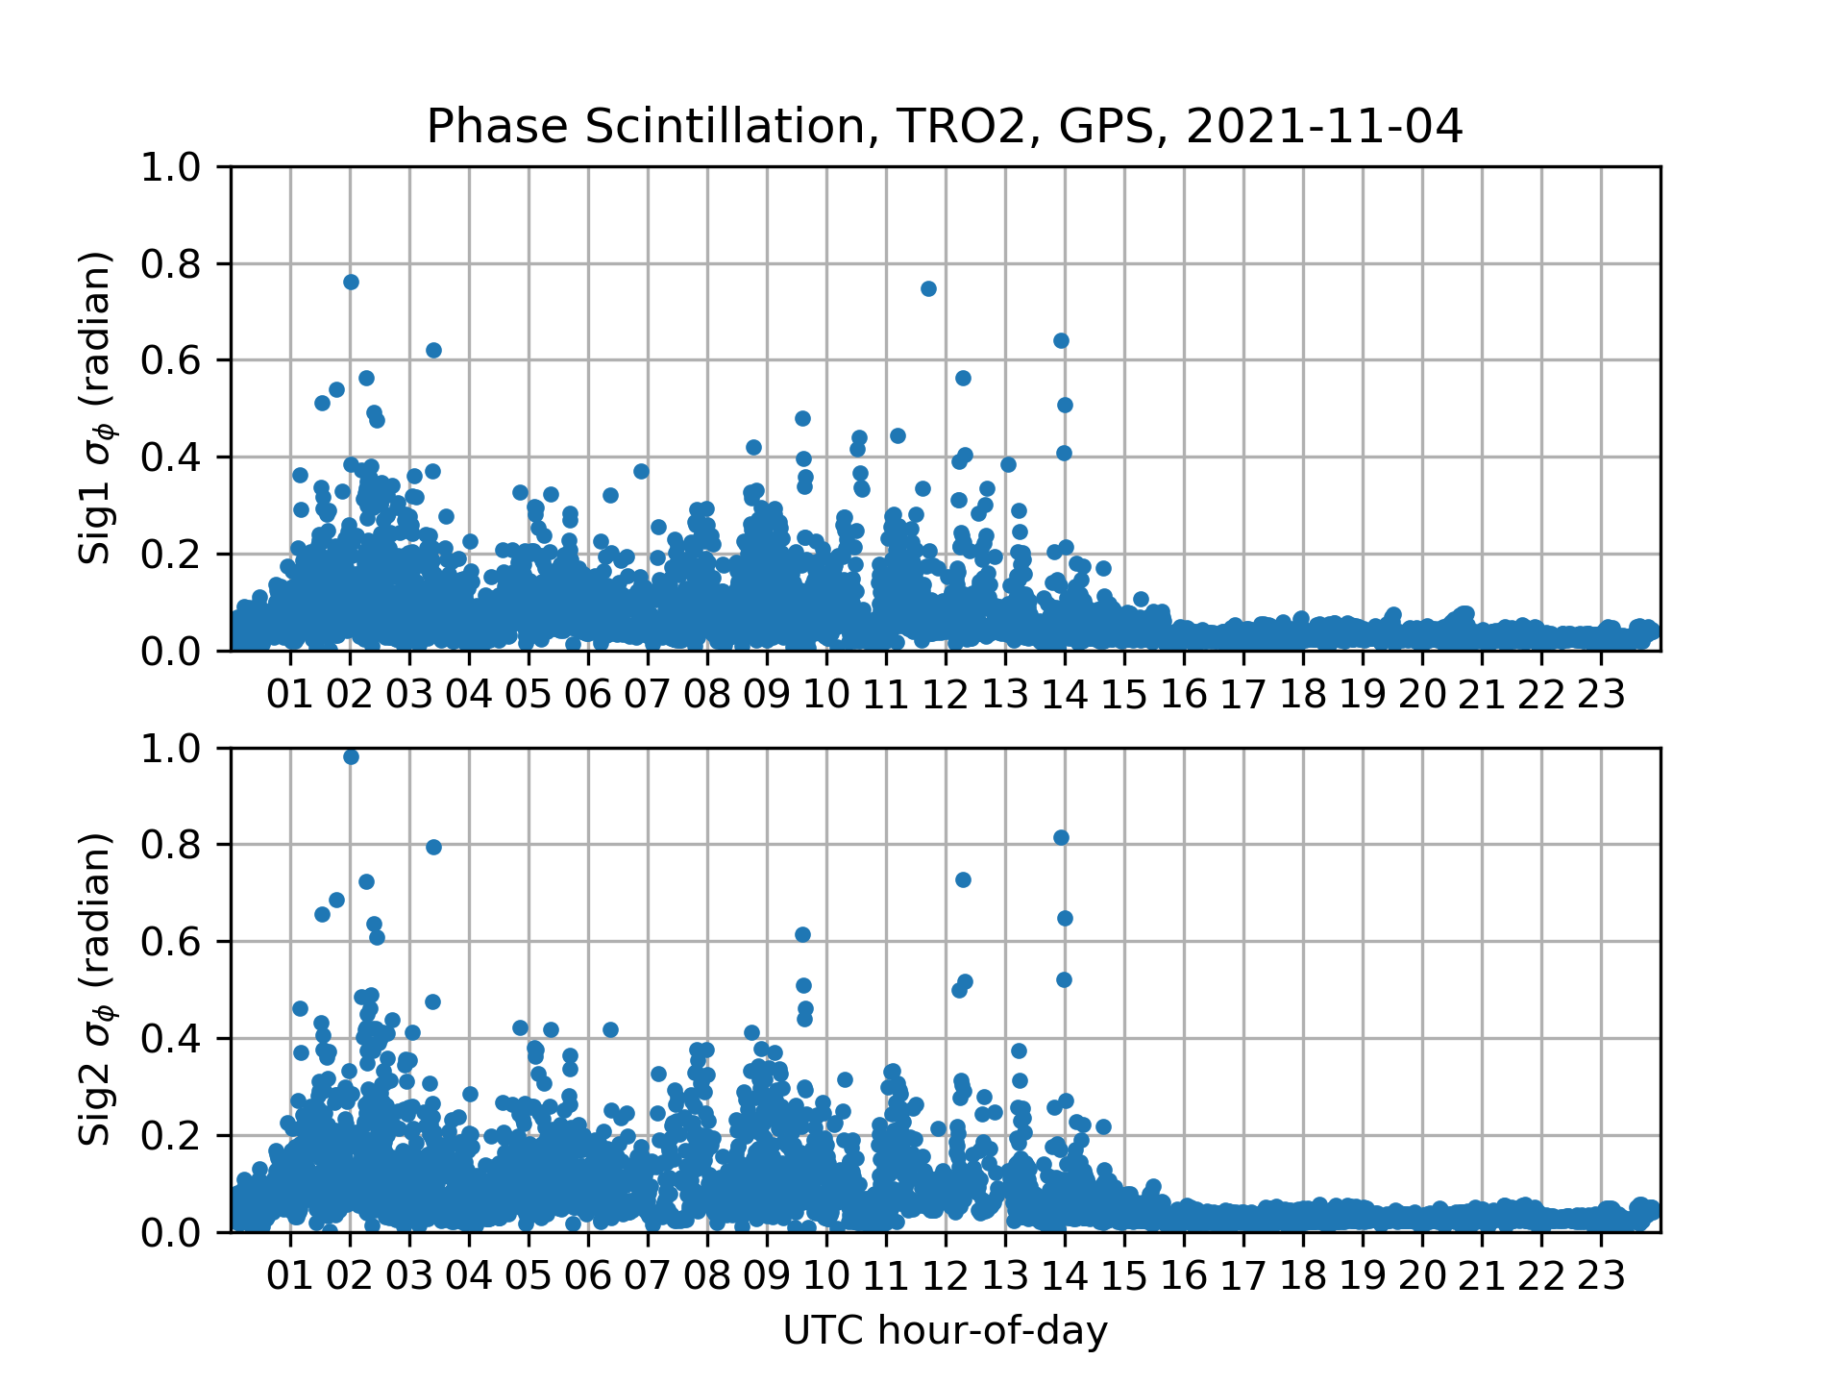Figure 1: Phase scintillation time series

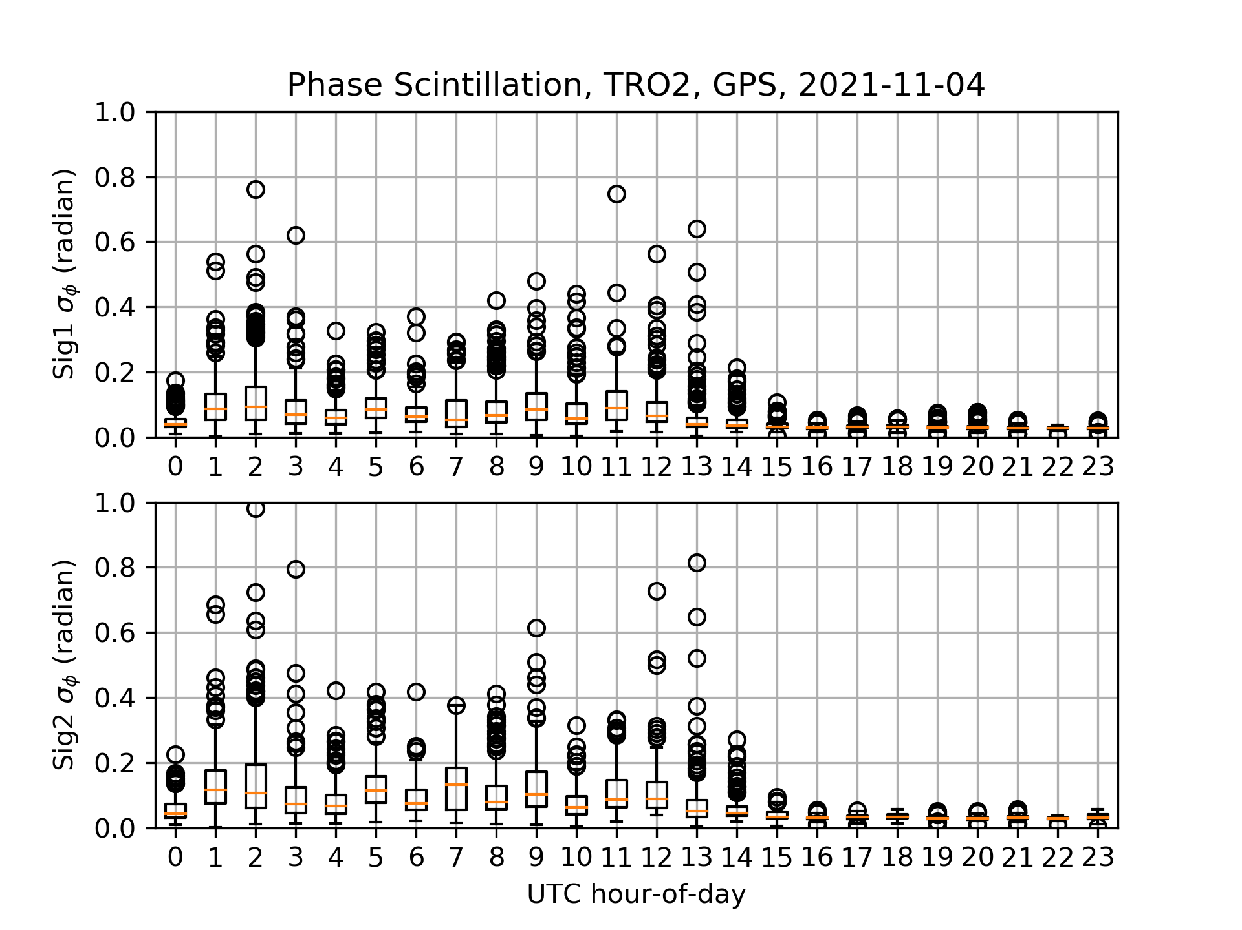Figure 2: Phase scintillation box-and-whiskers plot

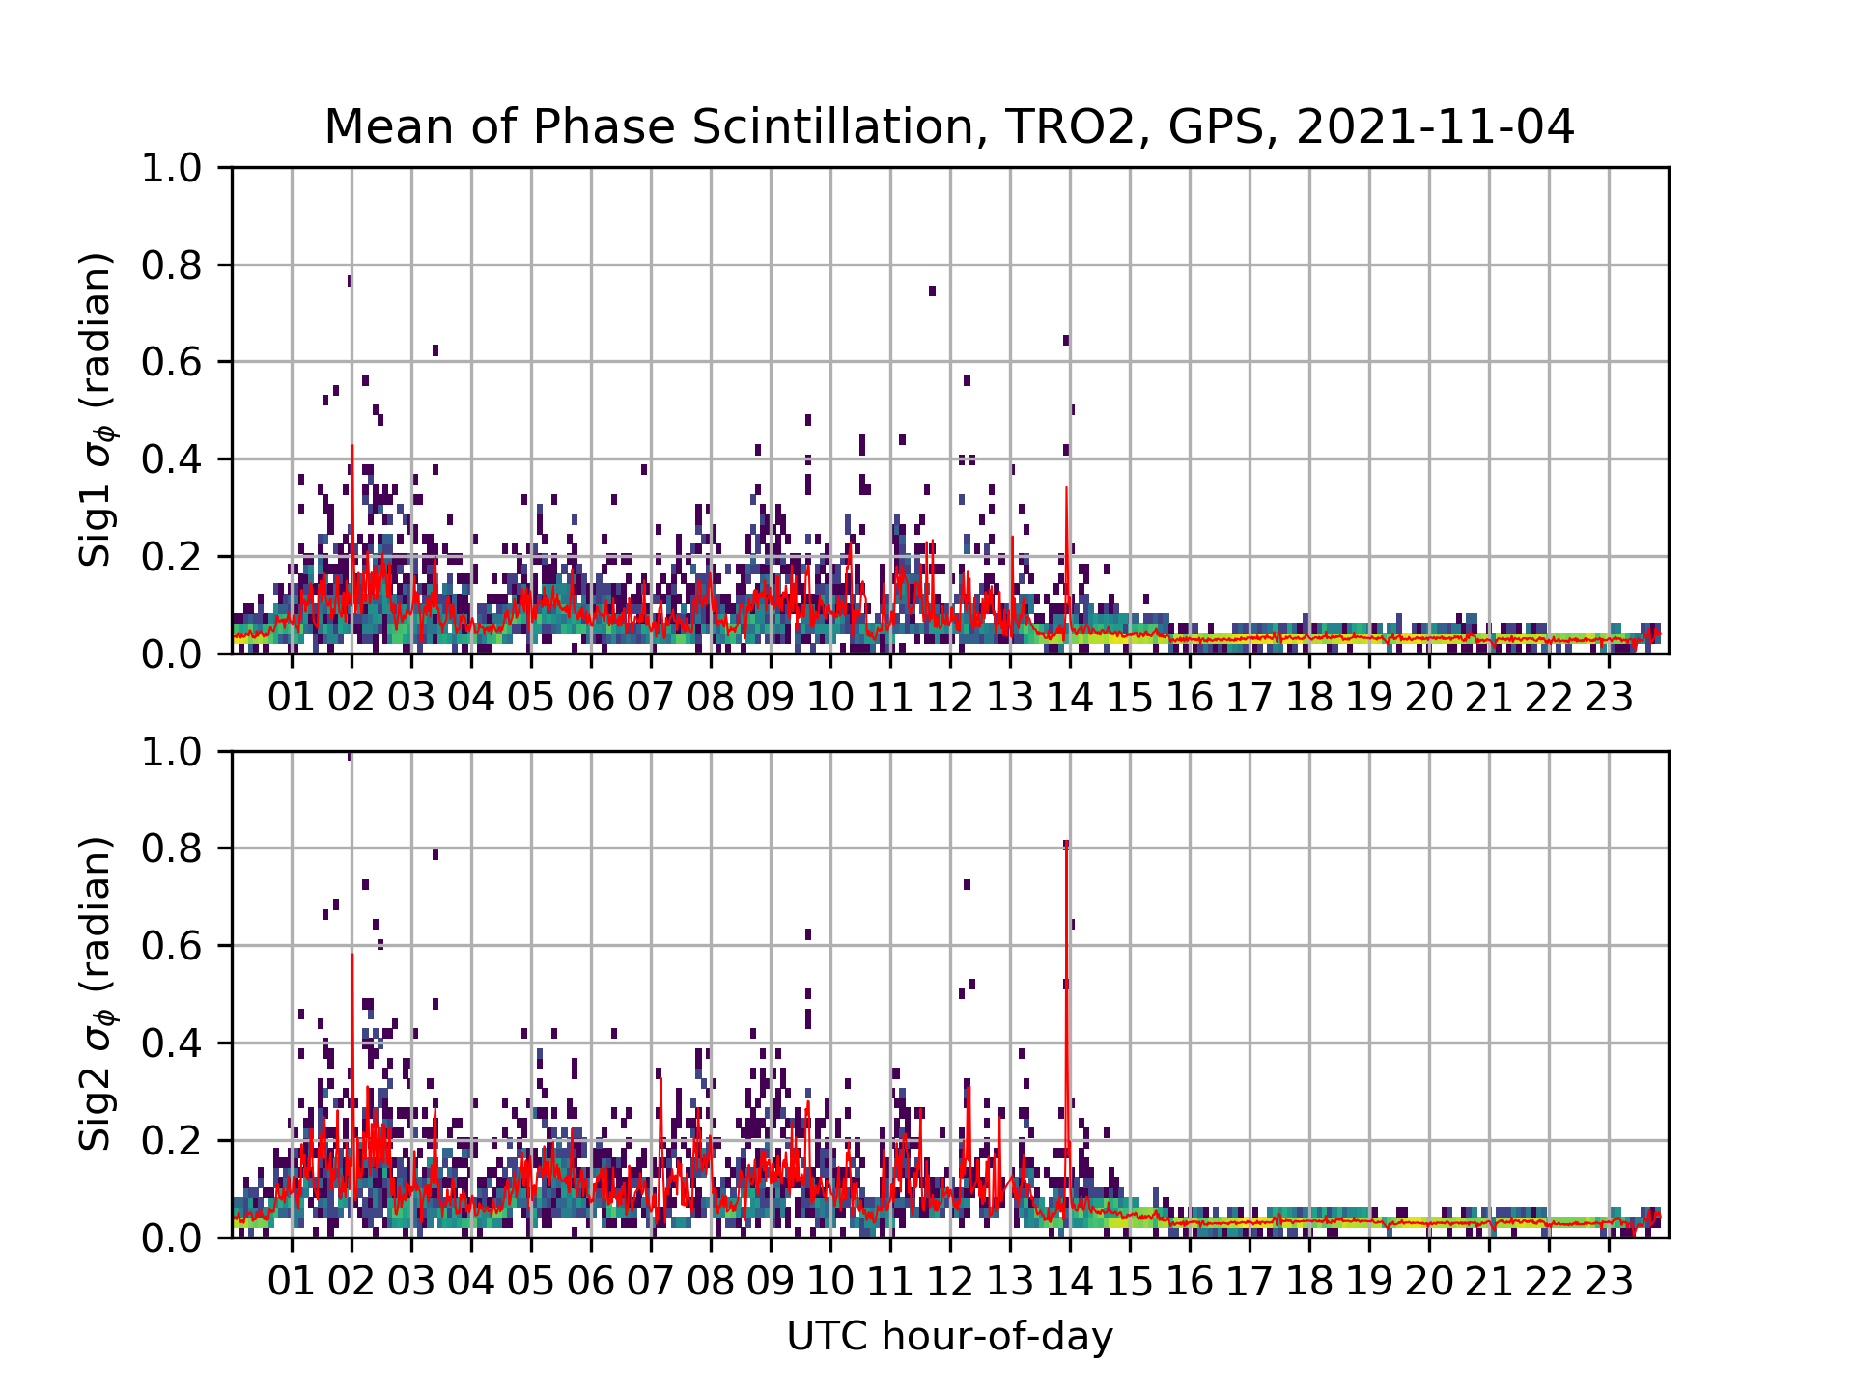Figure 3: Phase scintillation heat map + mean value at each time step.

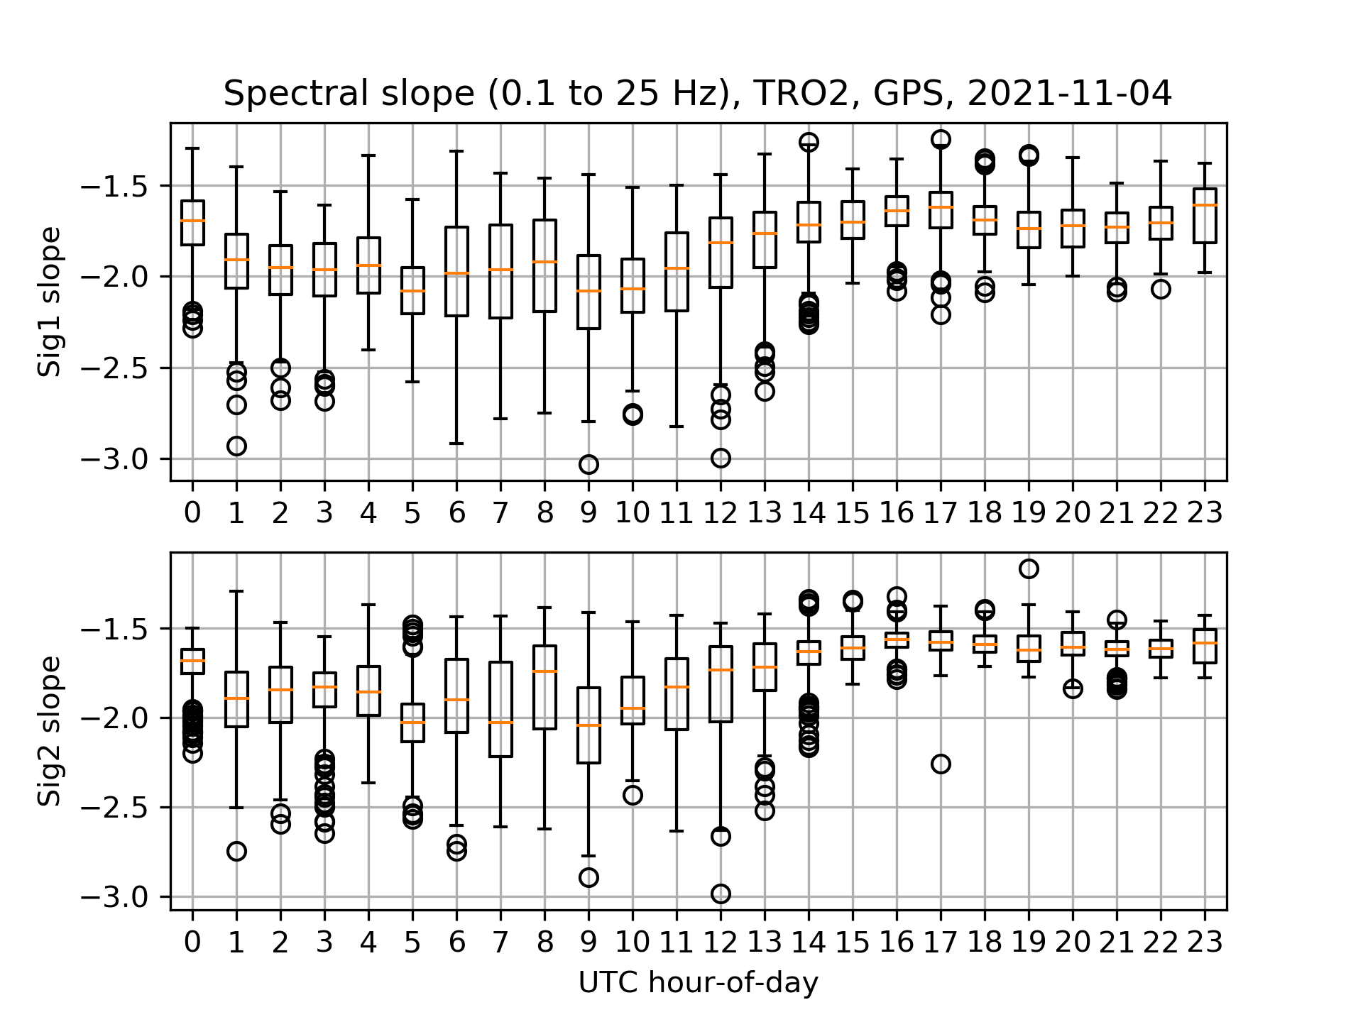Figure 4: Phase scintillation spectral slope box-and-whiskers plot

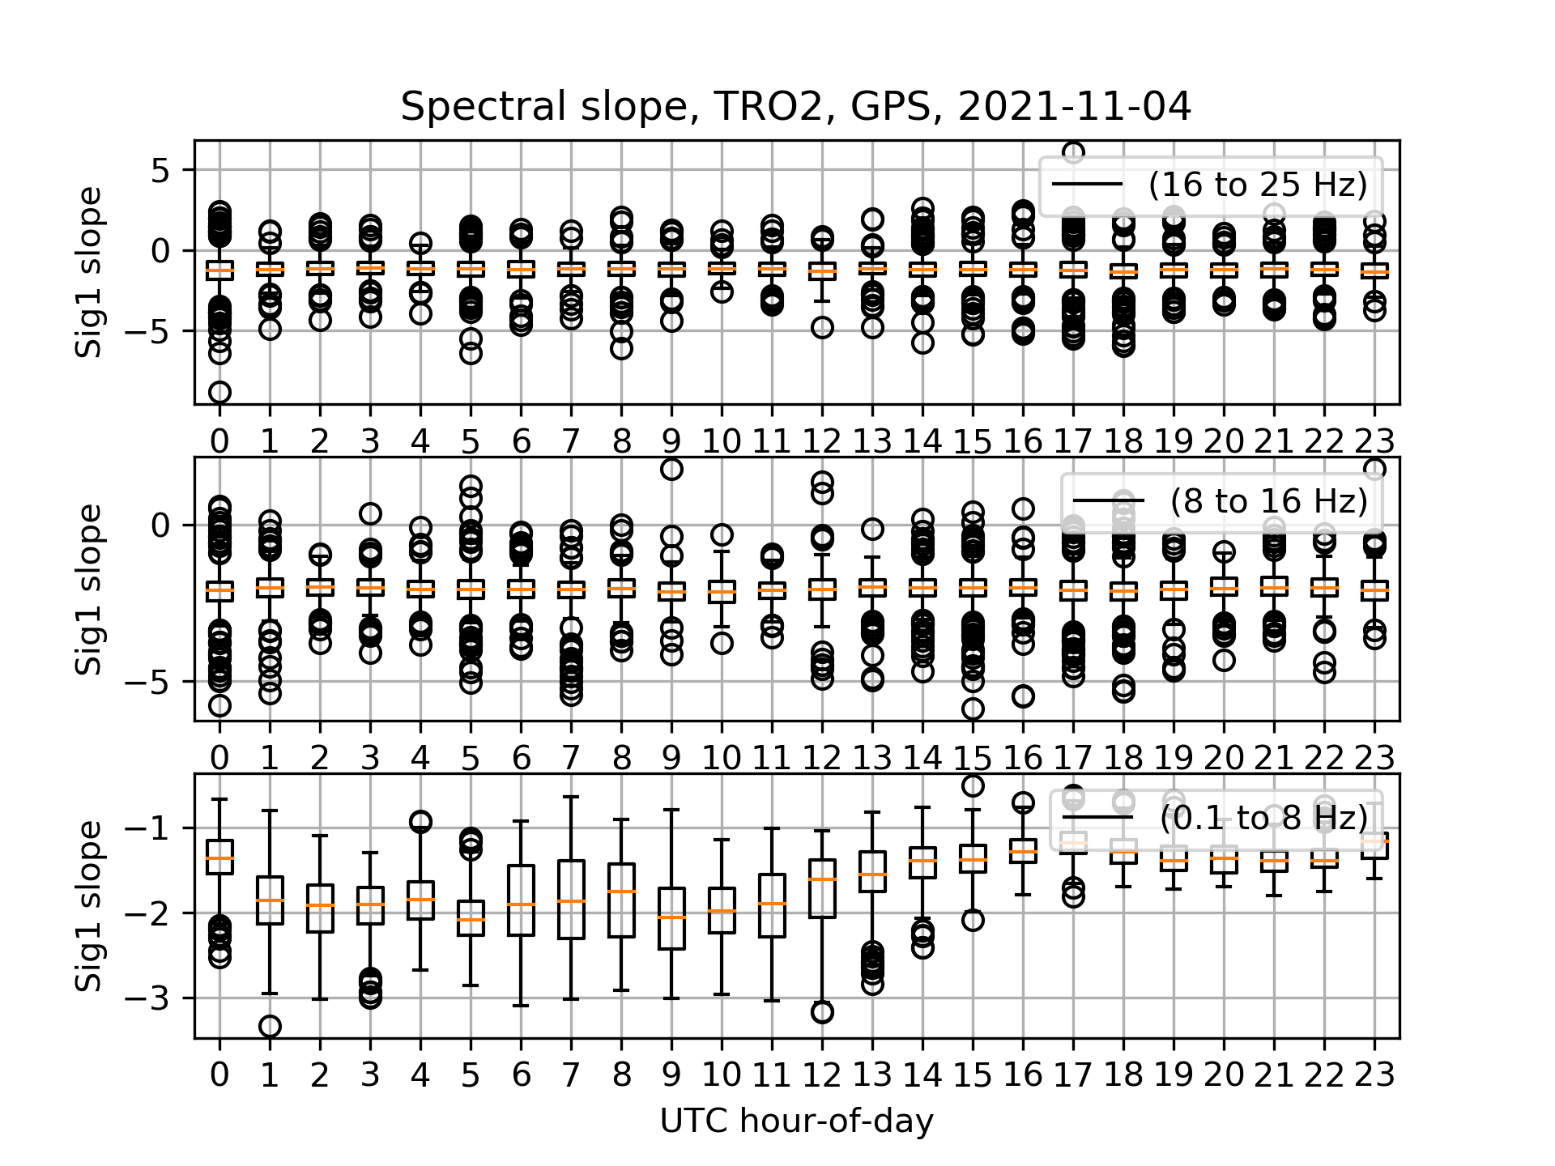Figure 5: Phase scintillation spectral slope box-and-whiskers plot, split by spectral frequency range.

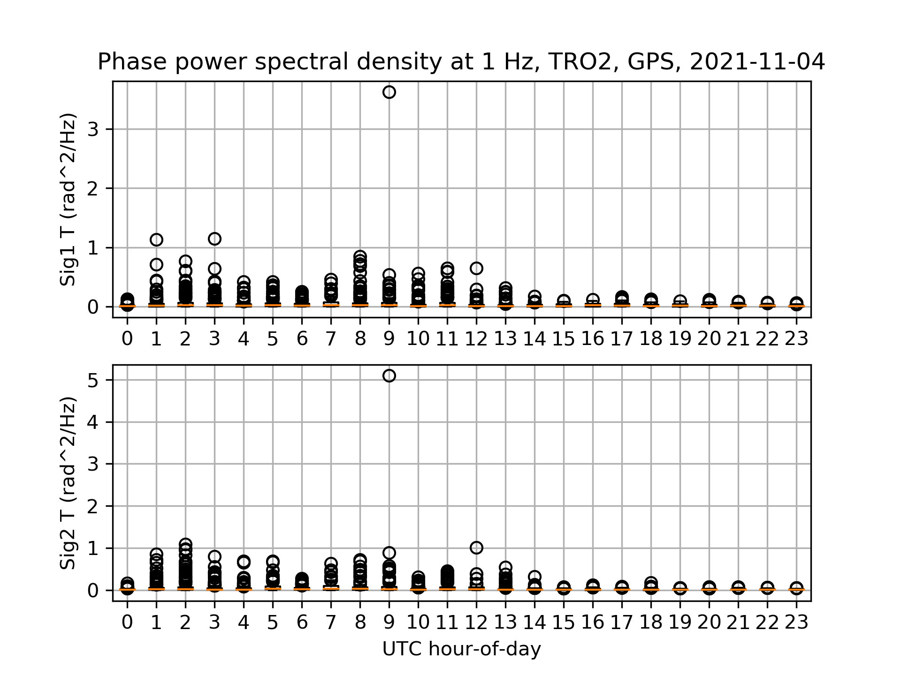Figure 6: Phase scintillation PSD at 1 Hz box-and-whiskers plot
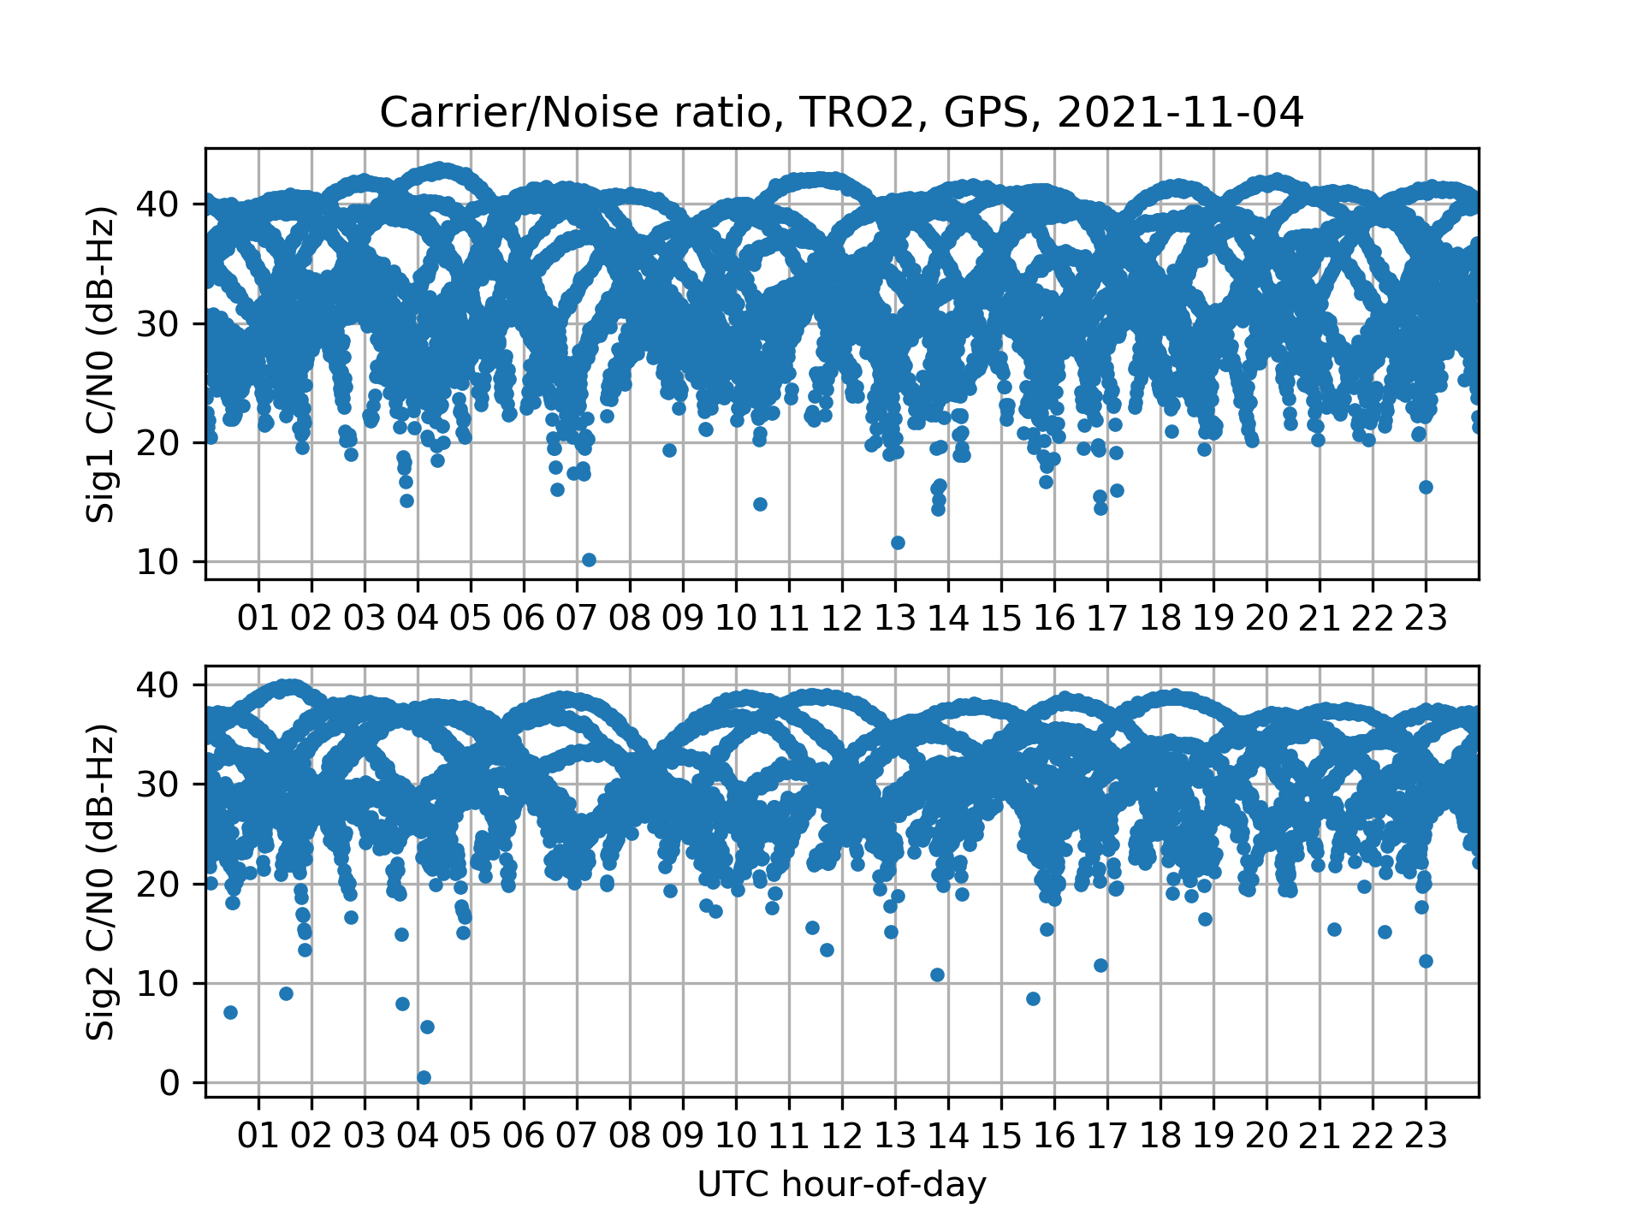Figure 7: Carrier/Noise ratio time series

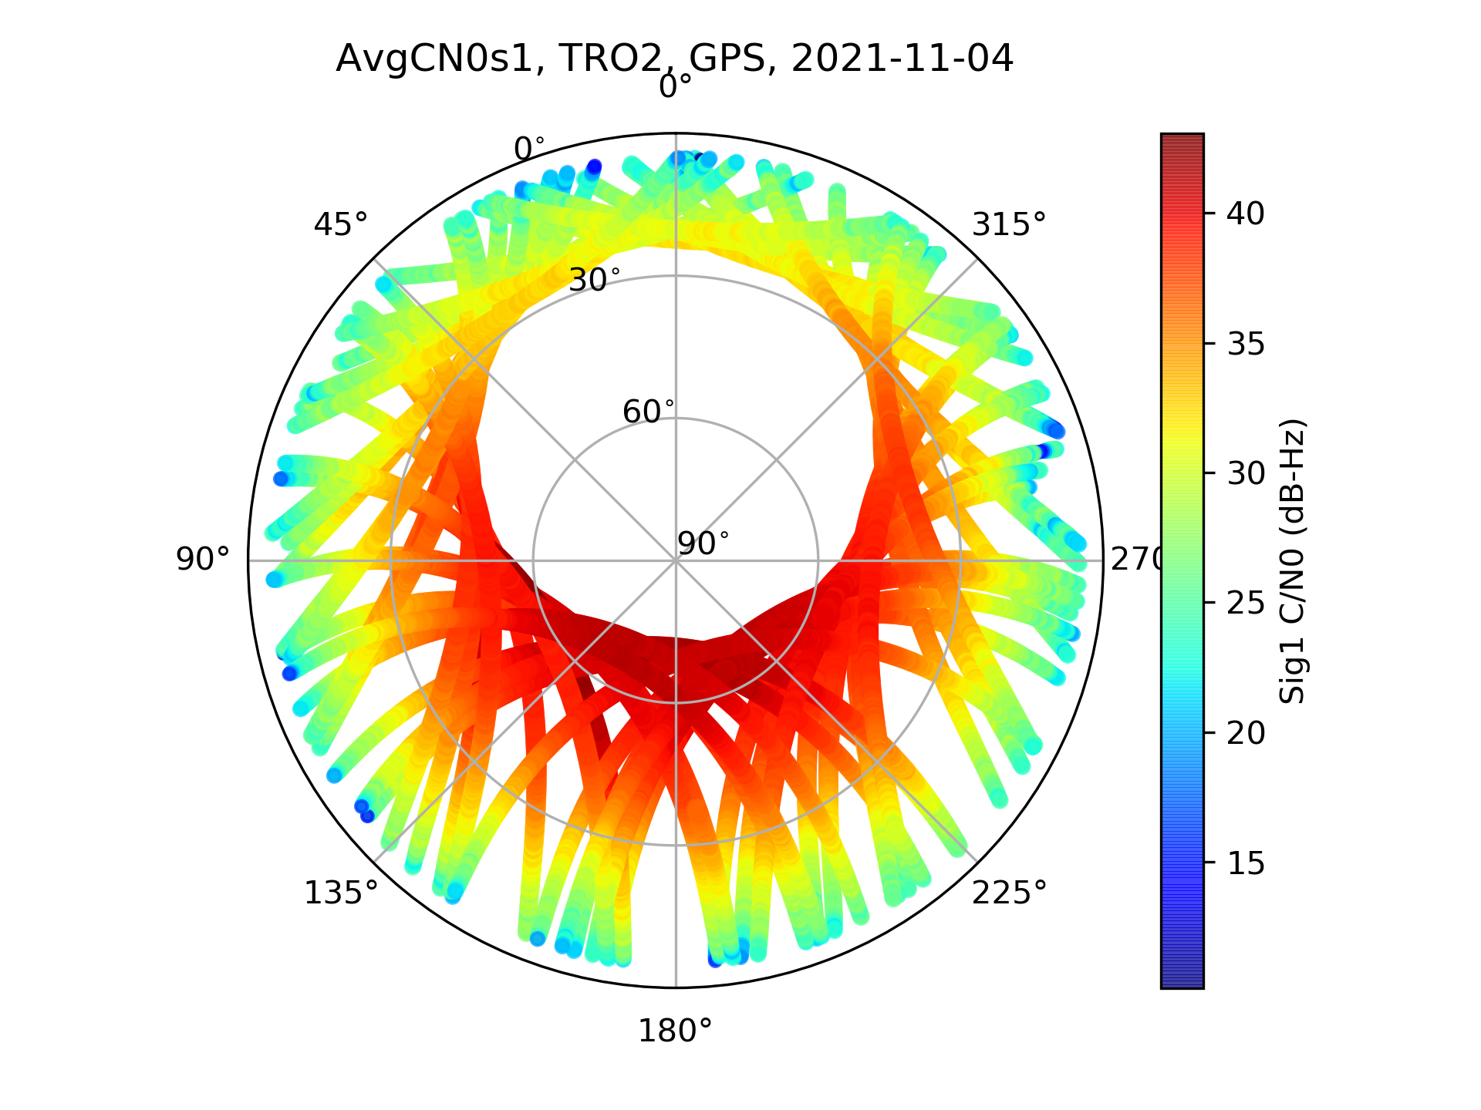Figure 8: Carrier/Noise ratio skyplot
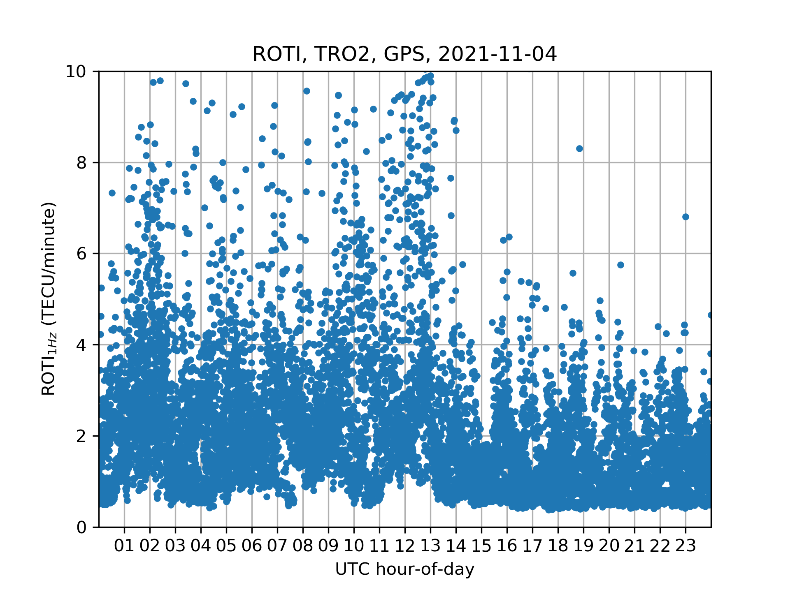Figure 9: Rate-Of-TEC-Index (ROTI) time series

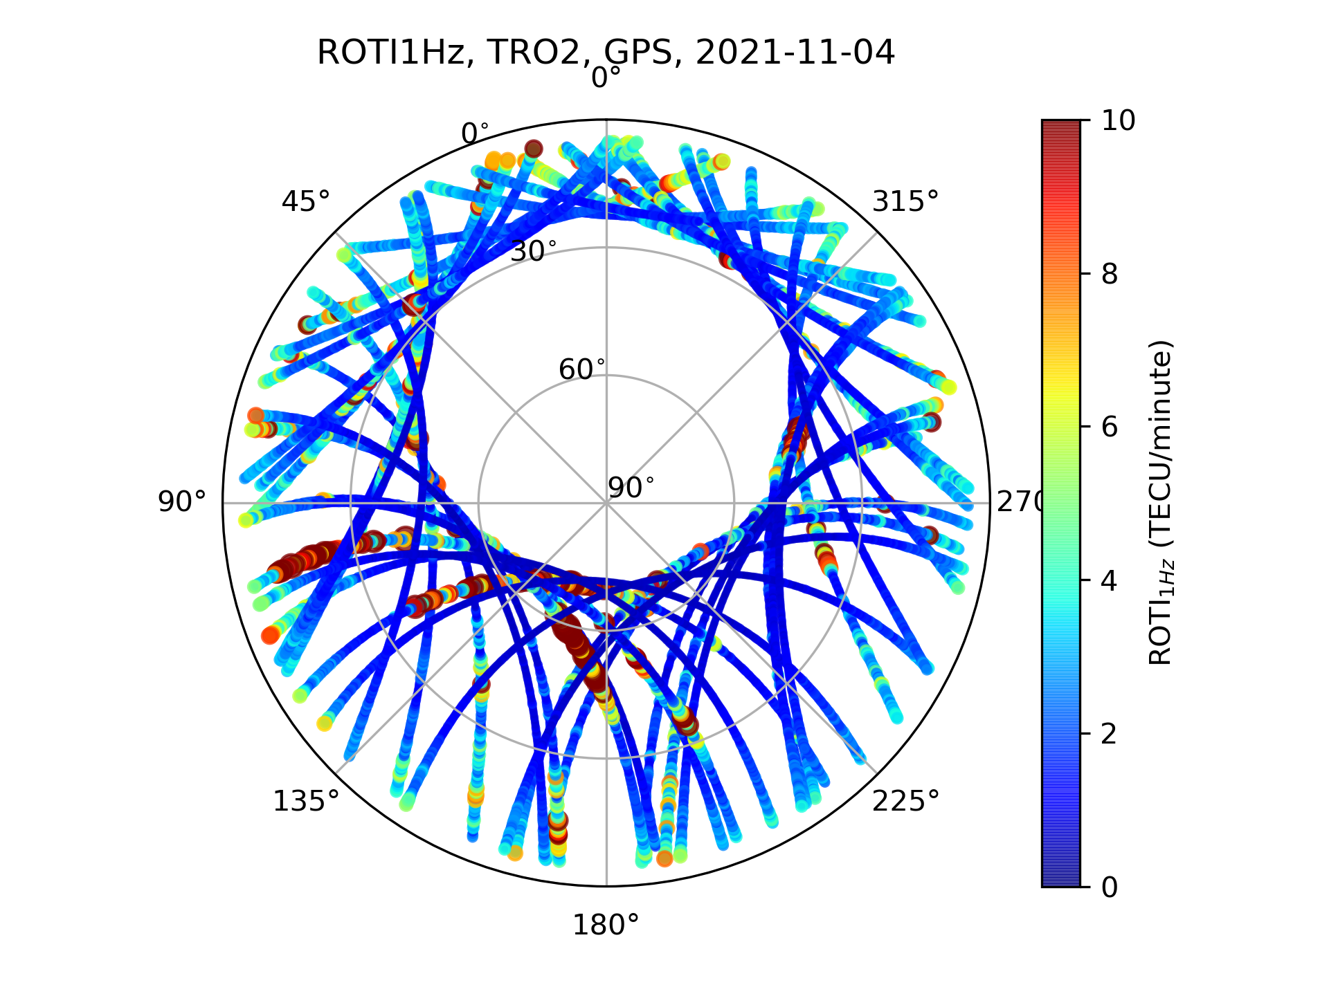Figure 10: Rate-Of-TEC-Index (ROTI) skyplot

Plotting script - Map plots
This format description is distributed with a python script that can be used to generate a selection of plots from this kind of file.
If run with the option "-h", it prints instructions for usage:
jacokn@A20020:~/git/BiScEF/Python/Plotting$ python3 MakeMapPlots.py -h
usage: MakeMapPlots.py [-h] [-G] [-R] [-E] [-C] [-S] [--sigmaPhi_1] [--sigmaPhi_2] [--S4_1] [--S4_2] [--CN0_1] [--CN0_2] [--ROTI] [--TEC] [--elevationCutoff ELEVATIONCUTOFF] [--minutesPerPlot MINUTESPERPLOT] [--outputPath OUTPUTPATH] [--outputFilenameBase OUTPUTFILENAMEBASE] filename [filename ...]

BiScEF map plotter

positional arguments:
filename Filename(s) of input data file(s)

optional arguments:
-h, --help show this help message and exit
-G, --GPS Include GPS in plots (default: False)
-R, --GLONASS Include GLONASS in plots (default: False)
-E, --Galileo Include Galileo in plots (default: False)
-C, --BeiDou Include BeiDou in plots (default: False)
-S, --SBAS Include SBAS in plots (default: False)
--sigmaPhi_1 Plot map(s) of sig1 sigma_phi (default: False)
--sigmaPhi_2 Plot map(s) of sig2 sigma_phi (default: False)
--S4_1 Plot map(s) of sig1 S4 (default: False)
--S4_2 Plot map(s) of sig2 S4 (default: False)
--CN0_1 Plot map(s) of sig1 C/N0 (default: False)
--CN0_2 Plot map(s) of sig2 C/N0 (default: False)
--ROTI Plot map(s) of 1Hz ROTI (default: False)
--TEC Plot map(s) of calibrated TEC (default: False)
--elevationCutoff ELEVATIONCUTOFF
Set elevation angle cutoff (default: 5)
--minutesPerPlot MINUTESPERPLOT
Minutes of data per plot. If it is set to zero, make one plot containing all data. (default: 5)
--outputPath OUTPUTPATH
Folder in which to save output plot files (default: ./)
--outputFilenameBase OUTPUTFILENAMEBASE
Base of output file name (string at start of filename) (data type and time will be appended to it by the script) (default: Plot)

NB: This script assumes that the file(s) contains data from one day (or less)

To plot data from multiple receivers, simply pass multiple filenames. Either one by one or using wildcard (*) characters to specify multiple files. An example of a call:

python3 MakeMapPlot.py -G -E --sigmaPhi_1 /pathtodata/*.nc

The following figures show examples of plots generated by the script.

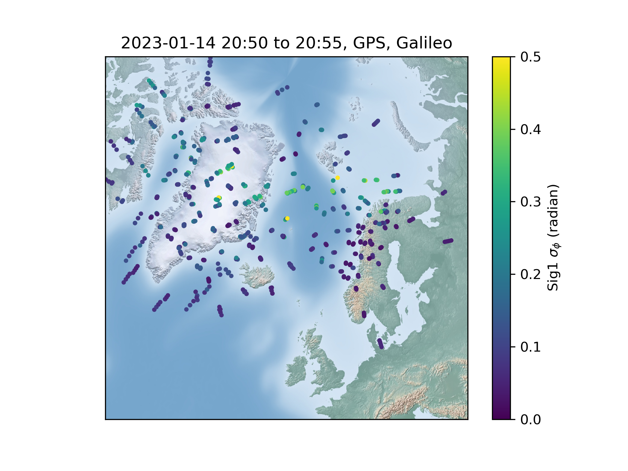Figure 11: Map of phase scintillation, from a network of receivers

Changelog
Version | Description | Date
1.0 | Initial release | 2023-11-16
1.1 | Added metadata field "License" | 2024-04-02

